FOR IMMEDIATE RELEASE
JULY 19, 2018

DEATH CAB FOR CUTIE UNVEIL NEW TRACK FROM “THANK YOU FOR TODAY”

8X GRAMMY® AWARD NOMINATED BAND HERALD NINTH STUDIO ALBUM
WITH “I DREAMT WE SPOKE AGAIN”

“THANK YOU FOR TODAY” PRE-ORDERS AVAILABLE NOW,
JOINED BY INSTANT GRAT DOWNLOADS OF
FIRST SINGLE “GOLD RUSH” AND “I DREAMT WE SPOKE AGAIN”

“GOLD RUSH” ASCENDING AT MULTI-FORMAT RADIO OUTLETS ACROSS AMERICA

HEADLINE SHOWS AND FESTIVAL PERFORMANCES SET THROUGH SUMMER

FALL TOUR BEGINS SEPTEMBER 24TH AT EUGENE, OR’S HULT CENTER

“THANK YOU FOR TODAY” ARRIVES EVERYWHERE ON FRIDAY, AUGUST 17TH

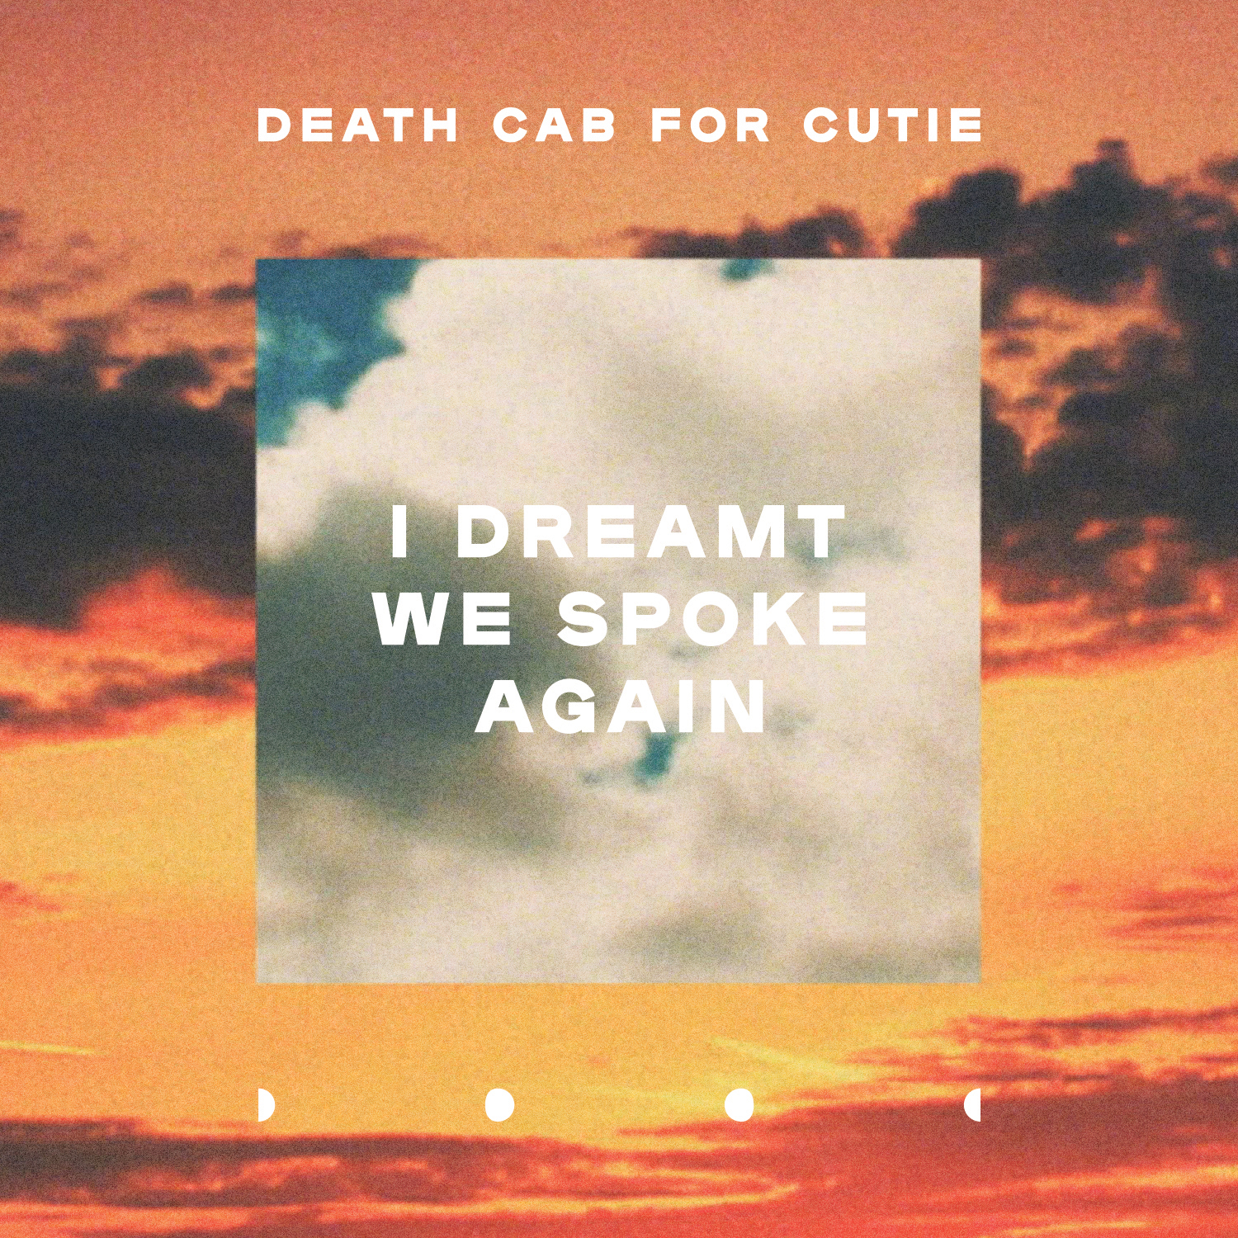

WATCH/POST “I DREAMT WE SPOKE AGAIN”: https://youtu.be/1aZUgUii4Sk
PRE-ORDER THANK YOU FOR TODAY: https://lnk.to/ThankYouforToday

Atlantic recording group Death Cab for Cutie has unveiled another highlight of their upcoming ninth studio album, “Thank You for Today.” First featured this spring in a special teaser clip heralding the new LP, “I Dreamt We Spoke Again” is available today at all DSPs and streaming services; an official lyric video is streaming HERE. “Thank You for Today” arrives at all music retailers and streaming services on Friday, August 17th and is available for pre-order now. All pre-orders are joined by instant grat downloads of “I Dreamt We Spoke Again” and the project’s first single, “Gold Rush,” also available today for individual purchase at all DSPs and streaming services HERE.

Released in June, “Gold Rush” has been met with a tremendous response from fans and critics alike, with Stereogum heralding the track “one of the best Death Cab singles in recent memory,” and NPR declaring “Death Cab for Cutie is back with some pretty great new music.” The song is quickly proving another multi-format radio smash for Death Cab for Cutie, currently ascending the top 10 at Triple A and the top 15 at Alternative radio outlets nationwide. “Gold Rush” is accompanied by a new companion visual, directed by Alex Southam (alt-J, Mumford & Sons) and streaming now HERE. In addition, Death Cab for Cutie recently performed “Gold Rush” on CBS’ The Late Show with Stephen Colbert, streaming HERE.

“Thank You for Today” was produced and mixed by Rich Costey (Fiona Apple, Franz Ferdinand, Muse), following his previous collaboration with Death Cab for Cutie on the band’s 2015 GRAMMY® Award-nominated “KINTSUGI.” The LP marks the first Death Cab for Cutie release to see long time bandmates Ben Gibbard, Nick Harmer, and Jason McGerr joined in the studio by new members Dave Depper (Menomena, Fruit Bats, Corin Tucker, Ray Lamontagne) and Zac Rae (My Brightest Diamond, Fiona Apple, Lana Del Rey, Gnarls Barkley). Depper and Rae have both been part of Death Cab’s touring band since 2015.

Death Cab for Cutie will celebrate “Thank You for Today” with a much-anticipated fall tour. The dates – which see the 8x GRAMMY® Award-nominated band playing intimate venues and theatres across North America – begin September 24th at Eugene, OR’s Hult Center for the Performing Arts and travel through mid-October (see attached itinerary). Support on most dates comes from Charly Bliss; Cold War Kids will support on September 27th. For complete details, please visit www.deathcabforcutie.com.

One dollar from each ticket purchased through the band’s website will go towards The Aurora Commons – a Seattle based non-profit organization which offers a safe space for unhoused neighbors to rest, prepare a meal, connect to resources, and collectively create a healthy and vibrant community.

Meanwhile, Death Cab for Cutie are currently poised to embark on a series of headline shows and festival performances, including special dates at Salt Lake City’s Red Butte Garden (August 2nd) and Boise, ID’s Summerfield Concerts at Memorial Stadium (August 3rd), both supported by the newly returned Pedro the Lion. The itinerary further includes Travelers Rest, curated by The Decemberists at Missoula, MT’s Big Sky Brewing Company Amphitheatre on August 4th and 5th, Long Beach, CA’s ALT 98.7 Summer Camp (August 12th), Life Is Beautiful Music & Art Festival in Las Vegas (September 21-23), Santiago, Chile’s Fauna Primavera (November 10th), Buenos Aires, Argentina’s Personal Fest 2018 (November 11th), and São Paulo, Brazil’s Popload Festival (November 15th) and Mexico City, Mexico’s Corona Capital 2018 (November 18th). As if all that weren’t enough, an epic European headline run begins January 24th, 2019 at Dublin, Ireland’s landmark Olympia Theatre and then makes stops across the United Kingdom, France, Belgium, the Netherlands, Germany, Denmark, Sweden, and Norway.

Death Cab for Cutie was born in 1997 when Western Washington University engineering student and budding guitarist-songwriter Benjamin Gibbard first united with guitarist-keyboardist-producer Chris Walla and bassist Nick Harmer to record a demo cassette dubbed “YOU CAN PLAY THESE SONGS WITH CHORDS.” Though Gibbard had initially conceived the tape as a solo project, the eight-song cassette proved both popular and aesthetically successful, prompting him to reconfigure Death Cab for Cutie as a full band. Death Cab for Cutie made their official live debut on November 22nd that same year, a performance recently uncovered and released as “FIRST SHOW, ACOUSTIC AT THE PACER HOUSE, BELLINGHAM WA. 11​/​22​/​97,” available now exclusively via Bandcamp; downloads begin at $4 with all of the band’s proceeds benefitting Seattle’s The Aurora Commons.

Immediately hailed as one of indie rock’s most compelling and creative collectives, Death Cab for Cutie’s milestone debut album, “SOMETHING ABOUT AIRPLANES,” arrived in 1998 via the Seattle-based independent label, Barsuk. The band enjoyed a long relationship with Barsuk before making their Atlantic Records debut with 2005’s fifth studio release, “PLANS.” The album proved the band’s popular breakthrough, earning RIAA platinum certification as well as spawning the chart-topping singles, “Soul Meets Body” and “I Will Follow You Into The Dark.” The latter track was honored with a GRAMMY® nomination as “Best Pop Performance By Duo Or Group With Vocals,” with “PLANS” receiving the nod as “Best Alternative Album.” “DIRECTIONS,” the 2006 DVD companion to “PLANS,” earned an additional GRAMMY® nod as “Best Longform Music Video.”

Now fully affirmed as an era-defining band, Death Cab for Cutie made a stunning #1 debut atop the SoundScan/Billboard 200 with 2008’s RIAA gold certified “NARROW STAIRS.” More critical acclaim and two further GRAMMY® nominations followed, including nods for “Best Alternative Album” and “Best Rock Song” (honoring the hit single, “I Will Possess Your Heart”). “THE OPEN DOOR” EP was released in 2009, earning DCFC a third consecutive GRAMMY® Award nomination for “Best Alternative Album.” “CODES AND KEYS” arrived in 2011 and made a top 3 entry on the SoundScan/Billboard 200 before receiving the band’s fourth straight GRAMMY® nomination for “Best Alternative Music Album.” “You Are A Tourist,” the album’s first single, also proved a multi-format radio smash, reaching #1 at both Triple A and Modern Rock outlets nationwide – Death Cab for Cutie’s first-ever #1 at the latter format.

Death Cab for Cutie’s eighth studio album, “KINTSUGI” made a remarkable chart debut upon its March 2015 release, debuting at #1 on Billboard’s “Top Alternative Albums” and “Top Rock Albums” charts, as well as #8 on the overall SoundScan/Billboard 200. Hailed by Magnet as perhaps “the best record of (Death Cab for Cuties’s) 17-year career,” the album was honored with a “Best Rock Album” nomination for the 58th Annual GRAMMY® Awards – the iconic band’s eighth overall nod.

For more news and information, please log on to www.deathcabforcutie.com.

Sheila Richman/Atlantic Records
212-707-3063 Sheila.Richman@atlanticrecords.com

Libby Kober/Atlantic Records
212-707-2562 Elizabeth.Kober@atlanticrecords.com

###

(TRACKLISTING ATTACHED)
(TOUR ITINERARY ATTACHED)
DEATH CAB FOR CUTIE
“THANK YOU FOR TODAY”
(Atlantic Records)
RELEASE DATE: FRIDAY, AUGUST 17TH

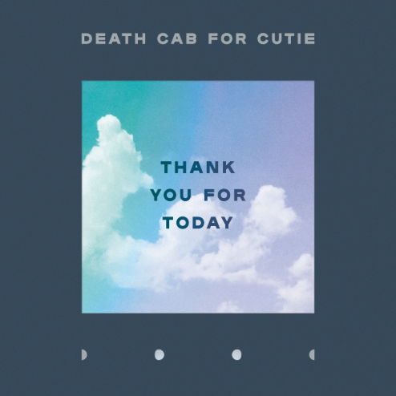
DOWNLOAD HI-RES ARTWORK

TRACKLISTING

1. I Dreamt We Spoke Again
2. Summer Years
3. Gold Rush
4. Your Hurricane
5. When We Drive
6. Autumn Love
7. Northern Lights
8. You Moved Away
9. Near/Far
10. 60 & Punk

# # #

DEATH CAB FOR CUTIE
WORLD TOUR 2018/2019

AUGUST
2 Salt Lake City, UT Red Butte Garden Amphitheatre ‡ *SOLD OUT*
3 Boise, ID Summerfield at Memorial Stadium ‡
4 Missoula, MT Travelers’ Rest
12 Long Beach, CA ALT 98.7 Summer Camp 2018

SEPTEMBER
21 Las Vegas, NV Life is Beautiful Music & Art Festival
24 Eugene, OR Hult Center for the Performing Arts *
25 Portland, OR Keller Auditorium * *SOLD OUT*
27 Berkeley, CA Greek Theatre Berkeley †
29 Phoenix, AZ The Van Buren * *SOLD OUT*

OCTOBER
1 Dallas, TX Bomb Factory *
2 Kansas City, MO Arvest Bank Theatre at The Midland *
3 Madison, WI The Sylvee *
5 St. Paul, MN Palace Theatre * *SOLD OUT*
6 St. Paul, MN Palace Theatre *
7 Chicago, IL Auditorium Theatre *
9 Upper Darby, PA Tower Theatre * *SOLD OUT*
10 Upper Darby, PA Tower Theatre *
12 Brooklyn, NY Kings Theatre *
13 Brooklyn, NY Kings Theatre *
14 Boston, MA Boch Wang Theatre *
15 Boston, MA Boch Wang Theatre *
17 Washington DC The Anthem *
18 Charlottesville, VA Sprint Pavilion *
19 Atlanta, GA Coca Cola Roxy Theater *
20 St. Augustine, FL St. Augustine Amphitheatre *
22 Miami, FL The Fillmore Miami Beach *
23 Orlando, FL Hard Rock Live *

NOVEMBER
10 Santiago, CH Fauna Primavera
11 Buenos Aires, AR Personal Fest 2018
15 São Paulo, BR Popload Festival
18 Mexico City, MX Corona Capital 2018

JANUARY
24 Dublin, IR Olympia Theatre
25 Manchester, UK Albert Hall
26 Glasgow, UK O2 Academy
28 Nottingham, UK Rock City
29 Leeds, UK O2 Academy
30 Bristol, UK O2 Academy

FEBRUARY
1 London, UK Eventim Apollo
2 Paris, FR Le Trianon
3 Antwerp, BE De Roma
5 Utrecht, NL Tivoli Vredenburg Grote Zaal
6 Cologne, DE Live Music Hall
7 Berlin, DE Astra Kulturhaus
9 Hamburg, DE Große Freiheit
10 Copenhagen, DK VEGA
11 Stockholm, SW Cirkus
12 Oslo, NO Sentrum Scene

* w/Charly Bliss
† w/Cold War Kids
‡ w/Pedro the Lion

ADDITIONAL DATES TO BE ANNOUNCED

www.deathcabforcutie.com

# # #

