FOR IMMEDIATE RELEASE

JULY 30, 2019

**DEATH CAB FOR CUTIE ANNOUNCE “THE BLUE EP” HERALDED BY FIRST TRACK “KIDS IN ‘99”**

**8X GRAMMY® AWARD NOMINATED BAND ANNOUNCE**

**TITLE + TRACKLIST OF FORTHCOMING EP**

**“THE BLUE EP” ARRIVES EVERYWHERE ON SEPTEMBER 6TH;**

**PRE-ORDERS AVAILABLE NOW**

**DEATH CAB FOR CUTIE FEATURED ON “DO YOU REMEMBER” –**

**FROM CHANCE THE RAPPER’S NEW ALBUM “THE BIG DAY”**

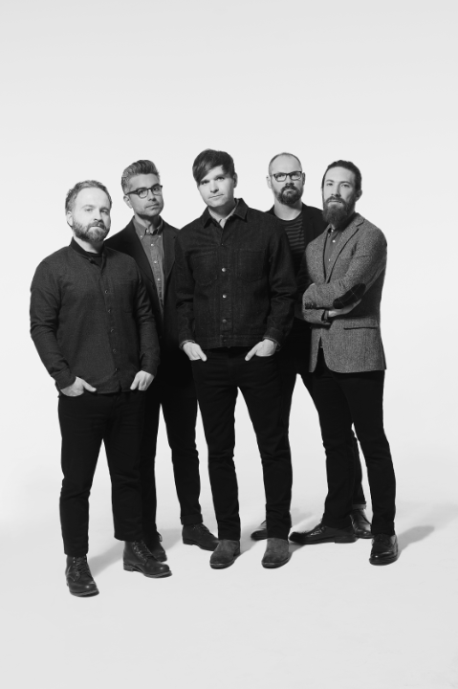

[*download hi-res press image here*](http://press.atlanticrecords.com/wp-content/uploads/2019/07/Death-Cab-for-Cutie-Credit-Eliot-Lee-Hazel-EP-1.jpg)

**LISTEN TO “KIDS IN ‘99”:** [**https://www.youtube.com/watch?v=qduFAr9b7uc**](https://www.youtube.com/watch?v=qduFAr9b7uc)

**PRE-ORDER:** [**https://death-cab-for-cutie.lnk.to/BlueEPPR**](https://death-cab-for-cutie.lnk.to/BlueEPPR)

8x GRAMMY® Award-nominated Atlantic recording group Death Cab for Cutie has officially announced the release of their upcoming EP – “The Blue EP” – which will arrive everywhere Friday, September 6th (tracklist attached). The announcement comes accompanied by the release of the first track off the project, “Kids in ‘99” – available today ([link](https://death-cab-for-cutie.lnk.to/Kidsin99PR)). “The Blue EP” is available for pre-order now at all DSP’s, streaming services, and the band’s online store ([here](https://death-cab-for-cutie.lnk.to/BlueEPPR)).

“Kids in ‘99” was written in tribute to three children who lost their lives in the 1999 Bellingham Olympic Pipeline explosion in Seattle, Washington. Death Cab for Cutie’s Ben Gibbard reflects on the inspiration behind this track: *“The Olympic Pipeline explosion in 1999 was a tragedy that really affected me while we were living in Bellingham. After all these years I felt it was worthy of its own folk song.”*

Along with all new tracks “Kids in ‘99” and “Blue Bloods” – produced by Peter Katis (The National, Interpol, Kurt Vile) – the EP also includes “To The Ground” and “Before The Bombs,” produced by Rich Costey during the recording sessions for the band’s critically acclaimed ninth studio album, [*Thank You for Today*](https://lnk.to/ThankYouforToday) and held for this planned subsequent EP. The fifth track on the project, “Man in Blue,” was self-produced by the band.

This past Friday, the band received critical acclaim for “Do You Remember,” a track from Chance the Rapper’s highly-anticipated new album (“The Big Day”) on which they are featured. [TIME](https://time.com/5635605/chance-the-rapper-the-big-day-best-songs/) highlighted the track in their “5 Best Songs of the Week,” exclaiming: “On ‘Do You Remember,’ a laid-back, nostalgic jam, rock band Death Cab for Cutie shows up to set a dreamy, throwback mood.”

The band recently wrapped the latest leg of their North American headline tour, including performances at iconic venues from New York’s **Forest Hills** to a sold-out show at the legendary **Red Rocks Amphitheatre**.The final leg of the tour will includestops in San Diego, Portland, and Redmond, WA as well as highly-anticipated shows at Sonoma Harvest Music Festival andLA’s **Hollywood Bowl**. This past weekend, Death Cab for Cutie performed at the annual Fuji Rock Festival, held at Naeba Ski Resort in Niigata Prefecture, Japan.

This May, Death Cab for Cutie co-curated and headlined a benefit with **ODESZA** at their shared alma mater – Western Washington State. Billed “Double Major,” the show was a homecoming for both bands, having formed in Bellingham when their members were students. In appreciation for the school and the city of Bellingham, net proceeds from the show were donated to WWU’s Alumni Association Scholarship Endowment. Additional info [here](https://doublemajorbellingham.com/).

Death Cab for Cutie was born in 1997 when Western Washington University engineering student and budding guitarist-songwriter Benjamin Gibbard first united with guitarist-keyboardist-producer Chris Walla and bassist Nick Harmer to record a demo cassette dubbed “YOU CAN PLAY THESE SONGS WITH CHORDS.” Though Gibbard had initially conceived the tape as a solo project, the eight-song cassette proved both popular and aesthetically successful, prompting him to reconfigure Death Cab for Cutie as a full band. Death Cab for Cutie made their official live debut on November 22nd that same year, a performance recently uncovered and released as “[FIRST SHOW, ACOUSTIC AT THE PACER HOUSE, BELLINGHAM WA. 11​/​22​/​97](http://atlantic.lnk.to/DCFC_PacerHouse),” available now exclusively via [Bandcamp](http://atlantic.lnk.to/DCFC_PacerHouse); downloads begin at $4 with all of the band’s proceeds benefitting Seattle’s [The Aurora Commons](https://www.auroracommons.org/).

Immediately hailed as one of indie rock’s most compelling and creative collectives, Death Cab for Cutie’s milestone debut album, “SOMETHING ABOUT AIRPLANES,” arrived in 1998 via the Seattle-based independent label, Barsuk. The band enjoyed a long relationship with Barsuk before making their Atlantic Records debut with 2005’s fifth studio release, “PLANS.” The album proved the band’s popular breakthrough, earning RIAA platinum certification as well as spawning the chart-topping singles, “Soul Meets Body” and “I Will Follow You Into The Dark.”  The latter track was honored with a GRAMMY® nomination as “Best Pop Performance By Duo Or Group With Vocals,” with “PLANS” receiving the nod as “Best Alternative Album.”  “DIRECTIONS,” the 2006 DVD companion to “PLANS,” earned an additional GRAMMY® nod as “Best Longform Music Video.”

Now fully affirmed as an era-defining band, Death Cab for Cutie made a stunning #1 debut atop the SoundScan/Billboard 200 with 2008’s RIAA gold certified “NARROW STAIRS.” More critical acclaim and two further GRAMMY® nominations followed, including nods for “Best Alternative Album” and “Best Rock Song” (honoring the hit single, “I Will Possess Your Heart”). “THE OPEN DOOR” EP was released in 2009, earning DCFC a third consecutive GRAMMY® Award nomination for “Best Alternative Album.” “CODES AND KEYS” arrived in 2011 and made a top 3 entry on the SoundScan/Billboard 200 before receiving the band’s *fourth* straight GRAMMY® nomination for “Best Alternative Music Album.”  “You Are A Tourist,” the album’s first single, also proved a multi-format radio smash, reaching #1 at both Triple A and Modern Rock outlets nationwide – Death Cab for Cutie’s first-ever #1 at the latter format.

Death Cab for Cutie’s eighth studio album, “KINTSUGI” made a remarkable chart debut upon its March 2015 release, debuting at #1 on Billboard’s “Top Alternative Albums” and “Top Rock Albums” charts, as well as #8 on the overall SoundScan/Billboard 200. Hailed by Magnet as perhaps “the best record of (Death Cab for Cuties’s) 17-year career,” the album was honored with a “Best Rock Album” nomination for the 58th Annual GRAMMY® Awards – the iconic band’s eighth overall nod.

For more news and information, please log on to [www.deathcabforcutie.com](http://www.deathcabforcutie.com).

Sheila Richman/Atlantic Records

212-707-3063 [Sheila.Richman@atlanticrecords.com](mailto:sheila.richman@atlanticrecords.com)

Libby Kober/Atlantic Records

212-707-2562 [Elizabeth.Kober@atlanticrecords.com](mailto:Elizabeth.Kober@atlanticrecords.com)

###

**DEATH CAB FOR CUTIE**

***The Blue EP***

Release Date: September 6th

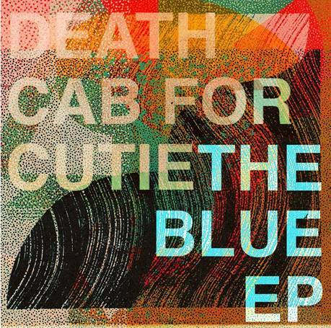

**TRACKLISTING**

1. To The Ground
2. Kids in ’99
3. Man In Blue
4. Before The Bombs
5. Blue Bloods

###

**DEATH CAB FOR CUTIE**

**TOUR DATES 2019**

|  |  |
| --- | --- |
|  |  |

**AUGUST**

1 Chicago, IL Metro (Official Lollapalooza Aftershow) (w/ Beach Bunny) **\*SOLD OUT\***

2 Chicago, IL Lollapalooza - Budlight Stage @ 6:45pm

9 San Digeo, CA The Observatory North Park (w/ Jenn Champion) **\*SOLD OUT\***

10 San Diego, CA The Observatory North Park (w/ Jenn Champion) **\*SOLD OUT\***

11 Los Angeles, CA Hollywood Bowl (w/ Car Seat Headrest)

**SEPTEMBER**

5 Vancouver, BC Malkin Bowl (w/ Jenn Champion)

6 Portland, OR Oregon Zoo Amphitheatre (w/ Car Seat Headrest) **\*SOLD OUT\***

7Redmond, WA Marymoor Amphitheater(w/ Car Seat Headrest) **\*SOLD OUT\***

8 Redmond, WA Marymoor Amphitheater(w/ Car Seat Headrest)

20 Saratoga, CA The Mountain Winery (w/ Hazel English)

21 Paso Robles, CA Vina Robles Amphitheatre (w/ Hazel English)

22 Glen Ellen, CA Sonoma Harvest Music Festival