**DEATH CAB FOR CUTIE RELEASE ANIMATED MUSIC VIDEO FOR**

**“GOOD HELP (IS SO HARD TO FIND)”**

**WATCH HERE:**

<https://youtu.be/O6e0sAMRioo>

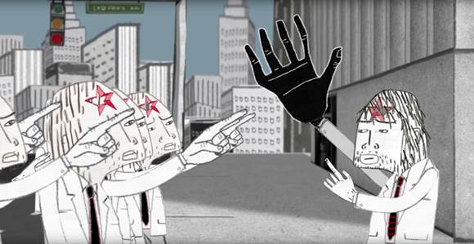

Death Cab For Cutie premiered the official music video for current single “Good Help (Is So Hard To Find) earlier today. Watch the animated video, directed by [Walter Robot](http://www.christopherlouie.me/), here: <https://youtu.be/O6e0sAMRioo>.On the making of the video, Walter Robot said: *“Crazy to think it started with "Grapevine Fires" 7 years ago. Ever since then, the band has been so gracious in all our collaborations. This one definitely feels more mature but also the oddest of the three. The idea started from a sketch Bill made of a dumb looking guy with a hole in his head."*

In more news, Death Cab for Cutie has unveiled a series of US live dates, including headline shows and major festival appearances. The co-headline dates –with CHVRCHES and guests Pure Bathing Culture – begins this summer (full itinerary below). The band is hitting a number of major festivals including Governors Ball, Bonnaroo, Lollapalooza, Firefly & more.

Death Cab Press Materials:

<http://press.atlanticrecords.com/death-cab-for-cutie/>

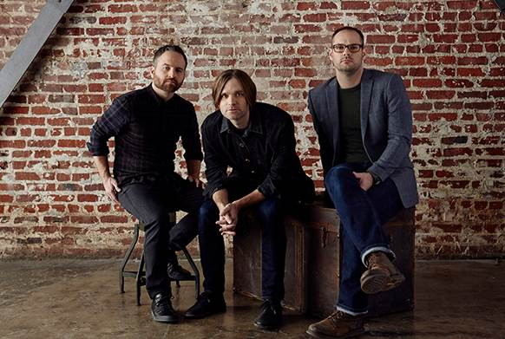

**+ SUMMER TOUR DATES INCLUDING CO-HEADLINING AMPITHEATRES WITH CHVRCHES  BELOW:**

**w/ CHVRCHES †**

***KINTSUGI* OUT NOW**

**MAY**

**6** Missoula, MT Adams Center

*w/ The Helio Sequence*

**28** Napa, CA BottleRock Napa Valley

**JUNE**

**5** New York, NY Governors Ball Music Festival

**7** Cleveland, OH Jacobs Pavilion at Nautica †

*+ Pure Bathing Culture*

**8** Canandaigua, NY Constellation Brands-Marvin Sands Performing Arts Center †

*+ Pure Bathing Culture*

**9-12** Manchester, TN Bonnaroo Music & Arts Festival

**10** Richmond, VA The National (with Pure Bathing Culture)

*+ Pure Bathing Culture*

**11** Asheville, NC Thomas Wolfe Auditorium (with Pure Bathing Culture)

*+ Pure Bathing Culture*

**14** St. Augustine, FL St. Augustine Amphitheatre †

*+ Pure Bathing Culture*

**15** Charleston, SC Volvo Car Open Stadium †

*+ Pure Bathing Culture*

**16** Charlotte, NC Uptown Amphitheatre at NC Music Factory †

*+ Pure Bathing Culture*

**16-19** Dover, DE Firefly Music Festival

**JULY**

**7** Council Bluffs, IA Stir Cove

*+ Thao & The Get Down Stay Down*

**15-17** Louisville, KY Forecastle 2016

**16-17** Birmingham, AL Sloss Music and Arts Festival