DEATH CAB FOR CUTIE UNVEILS “GOLD RUSH” LYRIC VIDEO –
FEATURING BEN GIBBARD

“Death Cab for Cutie is back with some pretty great new music.” – NPR

“…simmering…a rumbling alt-rock ballad…” – ROLLING STONE

“…one of the best Death Cab singles in recent memory, one that finds them aging gracefully and allowing their sound to smartly evolve, in contrast to the city they’re singing about.” – STEREOGUM

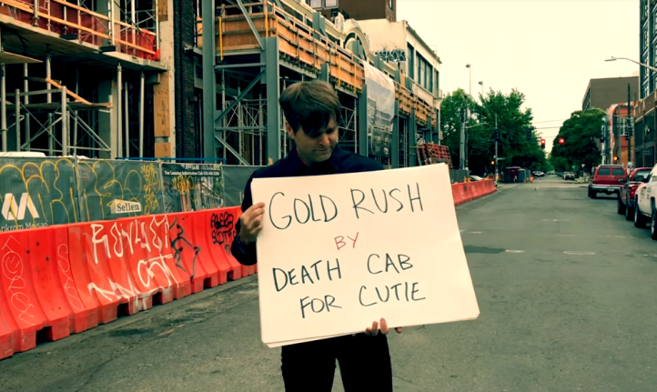

WATCH “GOLD RUSH” LYRIC VIDEO: HERE
PRE-ORDER “THANK YOU FOR TODAY”: https://lnk.to/ThankYouforToday

8x Grammy Award nominated band Death Cab for Cutie announce the debut of an official lyric video for “Gold Rush” – the first single off their forthcoming ninth studio album “Thank You for Today,” out everywhere August 17th. In a nod to the song’s message – a requiem for an ever disappearing urban skyline – the video features Ben Gibbard flipping through the track’s lyrics in front of a new construction site. The visual was shot by Death Cab for Cutie bassist Nick Harmer.

Says Gibbard of the inspiration for the track: “I’ve had this realization only recently that so many of my memories are tied to my geography. And when that geography changes, it’s as if you’re not only coming to terms with the passage of time, but it’s as if you’re losing those people and that time in your life all over again. Cities are in constant flux, and I’m not claiming victimhood in this, but the speed at which Seattle is changing, and people of color and creative communities are being pushed out, is alarming.”

The band made their debut television performance of the single last week on “The Late Show with Stephen Colbert” – watch HERE. They followed that performance with a headline set during Seattle’s Paramount Theatre 90th Anniversary Celebration, which was lauded by the Seattle Times as “a euphoric release… sonic eloquence.”

Death Cab for Cutie will celebrate their new album with a much anticipated fall tour. The dates – which see the band playing intimate venues and theatres across North America – begin September 24th at Eugene, OR’s Hult Center for the Performing Arts and travel through mid-October. Due to popular demand, second shows have already been added in Philadelphia and Boston. Last week, the band announced a UK/European tour, set to kick off at the top of next year (see attached itinerary for full set of dates).

DEATH CAB FOR CUTIE
TOUR 2018

AUGUST
2 Salt Lake City, UT Red Butte Garden Amphitheatre ~ *SOLD OUT*
3 Boise, ID Summerfield at Memorial Stadium ~
4-5 Missoula, MT Travelers’ Rest
11 San Diego, CA 91X X-Fest 2018
12 Long Beach, CA ALT 98.7 Summer Camp 2018

SEPTEMBER
21 Las Vegas, NV Life is Beautiful Music & Art Festival
24 Eugene, OR Hult Center for the Performing Arts *
25 Portland, OR Keller Auditorium *
27 Berkeley, CA The Greek Theatre at UC Berkeley †
29 Phoenix, AZ The Van Buren * *SOLD OUT*

OCTOBER
1 Dallas, TX Bomb Factory *
2 Kansas City, MO Arvest Bank Theatre at The Midland *
3 Madison, WI The Sylvee *
5 St. Paul, MN Palace Theatre *
7 Chicago, IL Auditorium Theater *
9 Upper Darby, PA Tower Theater * *SOLD OUT*
10 Upper Darby, PA Tower Theater *
12 Brooklyn, NY Kings Theatre *
13 Brooklyn, NY Kings Theatre *
14 Boston, MA Boch Center Wang Theatre *
15 Boston, MA Boch Center Wang Theatre *
17 Washington DC The Anthem *
18 Charlottesville, VA Sprint Pavilion *
19 Atlanta, GA Coca Cola Roxy Theater *
20 St. Augustine, FL St. Augustine Amphitheatre *
22 Miami, FL The Fillmore Miami Beach *
23 Orlando, FL Hard Rock Live *

NOVEMBER
10 Santiago, CH Fauna Primavera
11 Buenos Aires, AR Personal Fest 2018
15 São Paulo, BR Popload Festival
18 Mexico City, MX Corona Capital

JANUARY
24 Dublin, IE Olympia Theatre
25 Manchester, UK Albert Hall
26 Glasgow, UK O2 Academy Glasgow
28 Nottingham, UK Rock City
29 Leeds, UK O2 Academy Leeds
30 Bristol, UK O2 Academy Bristol

FEBRUARY
1 London, UK Eventim Apollo
2 Paris, FR Le Trianon
3 Antwerp, BEL De Roma
5 Utrecht, NL Tivoli / Vredenburg Grote Zaal
6 Cologne, GER Live Music Hall
7 Berlin, GER Astra
9 Hamburg, GER Grosse Freiheit
10 Copenhagen, DK Vega
11 Stockholm, SE Cirkus
12 Oslo, NO Sentrum Scene

~ w/ Pedro the Lion
* w/ Charly Bliss
† w/ Cold War Kids

ADDITIONAL DATES TO BE ANNOUNCED
www.deathcabforcutie.com

