**DEATH CAB FOR CUTIE UNVEIL “WHEN WE DRIVE” MAXI SINGLE**

**PACKAGE INCLUDES ACOUSTIC VERSION + REMIXES FROM**

**tUnE-yArDs + chong the nomad**

[**BUY/STREAM**](https://death-cab-for-cutie.lnk.to/WhenWeDriveab)

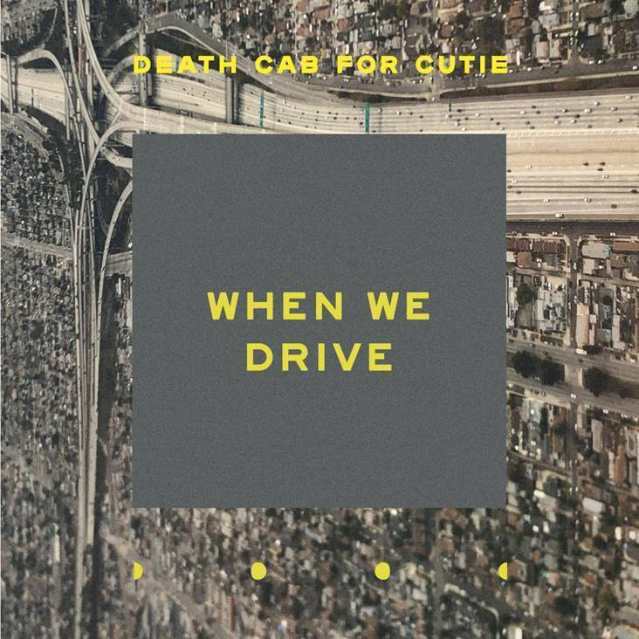

***TRACKLIST:***

**When We Drive (Studio Version)**

**When We Drive (Acoustic Version)**

**When We Drive (tUnE-yArDs Remix)**

**When We Drive (chong the nomad Remix)**

8x GRAMMY® Award-nominated Atlantic recording group [**Death Cab for Cutie**](https://deathcabforcutie.com/) have released a maxi single of “[**When We Drive**](https://death-cab-for-cutie.lnk.to/WhenWeDriveab),” originally off their critically acclaimed ninth studio album *Thank You for Today*. The package includes the original studio version, an acoustic, and two unique remixes – one from indie pop duo **tUnE-yArDs** and another from Seattle-based multi-instrumentalist and producer **chong the nomad**.

This weekend, the band kicked off their highly anticipated summer tour in Pittsburgh – a tour which will include stops at North America’s most iconic venues, from New York’s **Forest Hills** to LA’s **Hollywood Bowl** to an already sold out night at the legendary **Red Rocks Amphitheatre**. Across various dates, support on the tour will come from **Jenny Lewis**, **Lala Lala**, **Mitski**, and **Car** **Seat** **Headrest** (full itinerary below).

Last month, Death Cab co-curated and headlined a benefit with **ODESZA** at their shared alma mater – Western Washington State. Billed “Double Major,” the show was a homecoming for both bands, having formed in Bellingham when their members were students. The benefit also featured a performance from “When We Drive” remixer **chong the nomad**. In appreciation for the school and the city of Bellingham, net proceeds from the show were donated to WWU’s Alumni Association Scholarship Endowment. Additional info [here](https://doublemajorbellingham.com/).

**DEATH CAB FOR CUTIE ON TOUR:**

Monday, June 10 – Starland Ballroom – Sayreville, NJ

Tuesday, June 11 – Thompson’s Point – Portland, ME [support from Jenny Lewis]

Wednesday, June 12 – Shelburne Museum Green – Shelburne, VT [support from Jenny Lewis] **sold out**

Friday, June 14 – College Street Music Hall – New Haven, CT [support from Jenny Lewis] **sold out**

Saturday, June 15 – Forest Hills Stadium – New York, NY [support from Jenny Lewis]

Sunday, June 16 – Albright-Knox Art Gallery – Buffalo, NY

Tuesday, June 18 – Masonic Temple Theatre – Detroit, MI [support from Jenny Lewis]

Wednesday, June 19 – Harrisburg University – Harrisburg, PA

Thursday, June 20 – TD Echo Beach – Toronto, ON

Friday, June 21 – Ommegang Brewery – Cooperstown, NY [support from Jenny Lewis]

Saturday, June 22 – Firefly Music Festival – Dover, DE

Tuesday, June 25 – Red Rocks – Denver, CO [support from Mitski] **sold out**

Sunday, July 7 – Iroquois Amphitheater – Louisville, KY [support from Lala Lala]

Monday, July 8 – Stifel Theatre – St. Louis, MO [support from Lala Lala]

Tuesday, July 9 – Vetter Stone Amphitheater – Mankato, MN [support from Lala Lala]

Saturday, July 13 – Edmonton EXPO Centre – Edmonton, AB

Thursday, August 1 – Metro – Chicago, IL **sold out**

Friday, August 2 – Lollapalooza – Chicago, IL

Friday, August 9 – The Observatory North Park – San Diego, CA **sold out**

Saturday, August 10 – The Observatory North Park – San Diego, CA **sold out**

Sunday, August 11 – Hollywood Bowl – Los Angeles, CA [support from Car Seat Headrest]

Friday, September 6 – Oregon Zoo Amphitheatre – Portland, OR **sold out**

Saturday, September 7 – Marymoor Amphitheater – Redmond, WA **sold out**

Sunday, September 8 – Marymoor Amphitheater – Redmond, WA