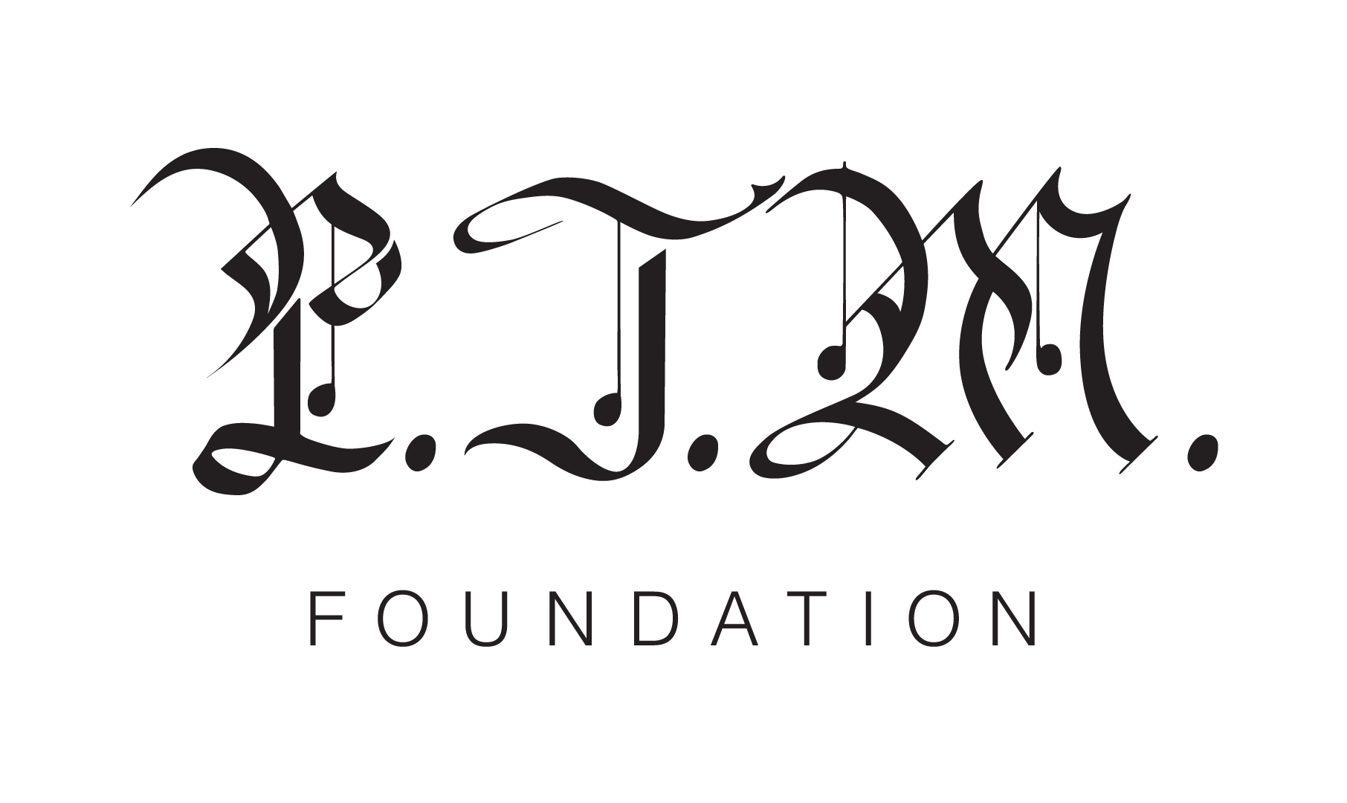
GRAMMY AWARD WINNING BAND PORTUGAL THE MAN'S PTM FOUNDATION ANNOUNCES $20,000 GIFT TO NAVAJO WATER PROJECT ALONGSIDE RELEASE OF NEW SONG, “WHO’S GONNA STOP ME” FEATURING “WEIRD AL” YANKOVIC

The band’s latest fundraising effort comes days before the release of their new song and companion music video and includes a limited-edition t-shirt with all proceeds benefiting the expansion of water access in Native American communities

Photo Credit: Maclay Heriot

Thoreau, NM | October 7, 2020 - Today, PTM Foundation, the charitable arm of GRAMMY Award-winning alternative rock band Portugal The Man, announces a fundraising campaign and $20,000 match program to support human rights nonprofit DigDeep’s Indigenous-led Navajo Water Project in expanding water access on the Navajo Nation across New Mexico, Arizona and Utah, where over 30% of residents are living without clean, running water in their homes.

“Lack of running water has been a historical problem and has been exacerbated by the COVID-19 pandemic. The Navajo Water Project has been working in emergency response mode and these new funds are immensely critical at this time,” says Emma Robbins, Director of the Navajo Water Project. “We are strengthened by the generosity and support of Portugal The Man and the PTM Foundation.”

On the campaign, Portugal The Man’s John Gourley says, “this campaign is an opportunity for us to help raise awareness, highlight Indigenous artists and activists, and fundraise in support of water access for communities of Indigenous Peoples, who are 19 times less likely to have running water than non-Natives. Over 2 million Americans have no access to running water. We’re taking action because the Government won’t. We can’t just sit back and watch our friends get sick and die. It’s enough.”

In line with today’s announcement, the band has also announced the release of “Who’s Gonna Stop Me” featuring “Weird Al” Yankovic, out this Monday, October 12, alongside a powerful companion music video. “Who’s Gonna Stop Me” arrives on Indigenous Peoples’ Day, to honor the histories, cultures, contributions, and resilience of contemporary Native peoples by highlighting over a dozen Indigenous leaders. A limited-edition t-shirt commemorating Indigenous Peoples Day and the release of the “Who’s Gonna Stop Me?” music video is now available for purchase on the band’s website, with all proceeds going towards fundraising efforts to be split between DigDeep’s Navajo Water Project and the Confederated Tribes of Warm Springs in the band’s home state of Oregon. The band will match fan donations up to $20,000.

Launched earlier this year, PTM Foundation serves as the band’s primary vehicle to engage, advocate for, and reinvest in the communities they grew up in and currently belong to and care for. PTM Foundation’s work is focused on universal issues related to human rights, community health and the environment, with an emphasis on causes directly impacting Indigenous Peoples. They have previously contributed to efforts for Get Out the Native Vote and COVID-19 Relief Native Community Relief Grant Program.

ABOUT DIGDEEP: DigDeep is a human rights nonprofit working to ensure that every American has access to clean, running water. DigDeep is the winner of the 2018 US Water Prize for its indigenous-led Navajo Water Project, which has installed solar-powered running water systems in nearly 300 homes on the Navajo Nation. In November 2019, DigDeep and the US Water Alliance co-released the “Closing the Water Access Gap in the United States: A National Action Plan” report, which revealed that over 2.2 million people in the USA are living without running water or sanitation inside their homes. This report was the culmination of 2 years of research, and the first-ever nationwide look at water poverty in the USA.

For more information on DigDeep or its regional projects, please visit digdeep.org, appalachiawaterproject.org or navajowaterproject.org, and follow on Twitter (@DigDeepH2O), Facebook and Instagram (@DigDeepWater).

Press Contact for DigDeep:
Alyssa Musket
alyssa@upcausepr.com

ABOUT PORTUGAL THE MAN: Composed of band members John Gourley, Zach Carothers, Kyle O’Quin, Eric Howk, Jason Sechrist and Zoe Manville, Portugal. The Man soared to new heights in 2017 with the release of their RIAA certified-gold album, Woodstock, and the astounding success of their infectious single, “Feel It Still,” which earned the rock band from Alaska by way of Portland, OR a plethora of new accolades. However, beneath the shine of their GRAMMY award for “Best Pop Duo/Group Performance,” a 5X RIAA platinum single certification, a mind-blowing 20-week residency at #1 on alternative radio and an inescapable presence in the Top 40 airwaves, lies the group’s long-standing passion for social justice; that is the intersection on which Portugal. The Man thrives. Throughout their career, the band has consistently exemplified how to deeply commit to both artistry and activism. This dynamic is what inspired them to publicly launch their own PTM Foundation this year, which is focused on universal issues related to human rights, community health and the environment, with an emphasis on causes directly impacting Indigenous Peoples. Their continued passion for activism has since led to partnerships with various other organizations as well such as Keep Oregon Well (Mental Health), March for Our Lives (Gun Reform) and Protect Our Winters (Climate Change).

ABOUT PTM FOUNDATION: Launched earlier this year, PTM Foundation serves as the band’s primary vehicle to engage, advocate for, and reinvest in the communities they grew up in and currently belong to and care for. PTM Foundation’s work is focused on universal issues related to human rights, community health and the environment, with an emphasis on causes directly impacting Indigenous Peoples. They have previously contributed to efforts for Get Out the Native Vote and COVID-19 Relief Native Community Relief Grant Program. For more information on Portugal The Man & PTM Foundation, please visit: www.portugaltheman.com and http://www.ptmfoundation.org/.

Press Contacts for Portugal The Man & PTM Foundation:
Jason Davis – jason.davis@atlanticrecords.com
Libby Kober – libby.kober@atlanticrecords.com

