ED SHEERAN’S ‘=’ DEBUTS AT #1 ON BILLBOARD 200

GLOBAL SUPERSTAR CELEBRATES 4TH CONSECUTIVE #1 ALBUM ON THE HEELS OF STUNNING PERFORMANCES ON SATURDAY NIGHT LIVE

‘=’ TOPS THE CHARTS IN 14 COUNTRIES AROUND THE WORLD AND COUNTING

MULTI-GRAMMY AWARD WINNER CURRENTLY HAS TWO SINGLES IN THE TOP 10 ON THE BILLBOARD HOT 100

DOWNLOAD/STREAM ‘=‘ HERE

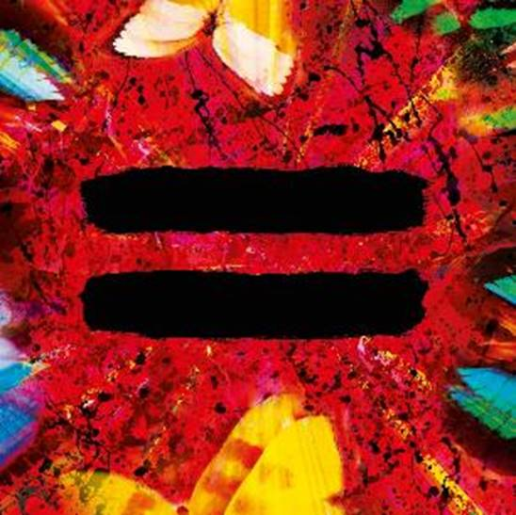

WATCH SATURDAY NIGHT LIVE PERFORMANCES:
“SHIVERS” | “OVERPASS GRAFFITI”
+ “THE DIONNE WARWICK SHOW” SKETCH
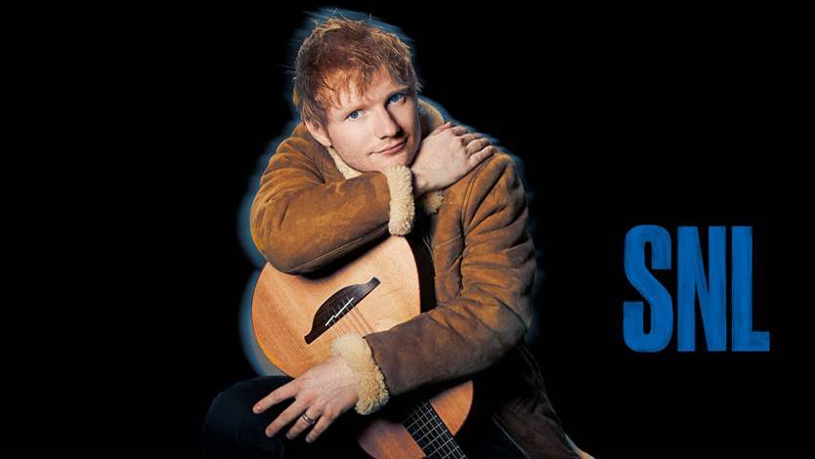
Photo Credit: @maryellenmatthewsnyc

“‘=’ should be regarded as Sheeran’s watershed moment.”
- USA TODAY

“…equally rooted in old-school melody and beat-derived new-century songwriting.”
- ROLLING STONE

“…Sheeran has come out with a record that shows growth lyrically and musically, but still holds true to his moving storytelling and distinctive instrumentation that longtime fans have loved from the start.”
- BILLBOARD

Ed Sheeran has debuted at #1 on the Billboard 200 with his just released album ‘=.’ The achievement marks the multiple-GRAMMY award winner’s 4th consecutive album to top the chart, following 2019’s ‘No. 6 Collaborations Project,’ 2017’s ‘÷,’ and 2014’s ‘x.’ ‘=’ has also proven to be a global phenomenon hitting #1 in 13 other countries around the world and counting, including his native UK and Australia, where he’s logged the biggest sales week of the year.

To celebrate the arrival of ‘=.’ Sheeran returned to the famed “Saturday Night Live” stage this past weekend as the show’s musical guest for the 3rd time. In addition to stunning performances of his latest single “Shivers” and “Overpass Graffiti,” he also participated in a hilarious comedy sketch featuring host Kieran Culkin and the legendary Dionne Warwick (WATCH HERE).

Just hours after the release of his long-awaited 4th studio album, ‘=,’ Sheeran premiered the official music video for “Overpass Graffiti” (WATCH HERE), which saw him collaborating once again with award-winning director Jason Koenig. Written and produced by Sheeran, Johnny McDaid and Fred Gibson, “Overpass Graffiti” is a heady, synth-rich ode to '80s pop.

‘=’ is highlighted by the chart-topping, lead single “Bad Habits” and follow-up “Shivers,” which are simultaneously sitting in the top 10 of Billboard’s Hot 100 chart. The tracks were also featured in his recent NPR “Tiny Desk Concert,” streaming online now (WATCH HERE).

Sheeran continues his media blitz with appearances as a virtual guest on “The Kelly Clarkson Show” today before sitting down in studio for a chat on “The Tonight Show Starring Jimmy Fallon” (check local listing).

A 4x GRAMMY award winner, Sheeran was recently recognized with a raft of award show nominations, highlighted by an American Music Awards nomination for Favorite Male Pop Artist, a pair of People’s Choice Awards nominations for Male Artist of 2021 and Song of 2021 (“Bad Habits”), and five MTV EMA nominations including Best Artist and Best Song (“Bad Habits”), and Best Video (“Bad Habits”).

For all press inquiries, please contact:
Glenn Fukushima - GlennFukushima@elektra.com
Jason Davis - Jason.Davis@atlanticrecords.com

* * *

DOWNLOAD NEW PRESS IMAGES & ALBUM ARTWORK HERE

PRESS IMAGE PHOTO CREDIT: DAN MARTENSEN
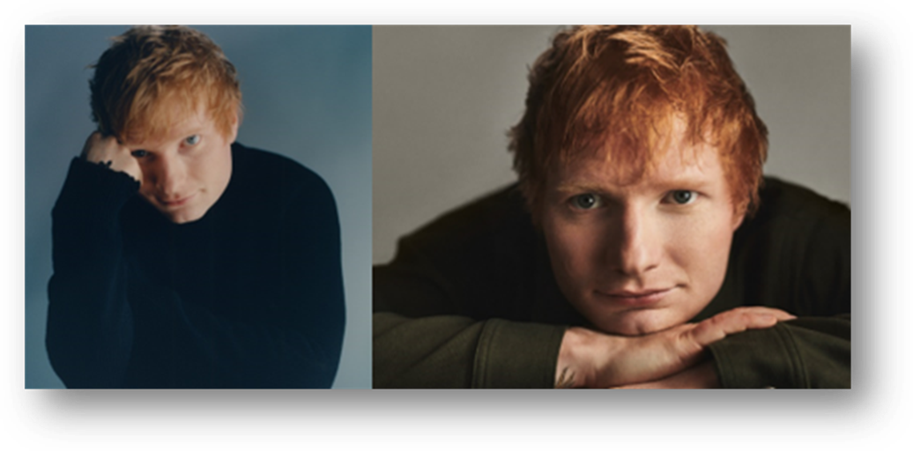

ABOUT ED SHEERAN:
Ed Sheeran is an era-defining artist. From record-breaking sales across his recorded music and live performances, and a plethora of award wins to his name, the British singer-songwriter is the boundless talent behind some of the biggest songs in history. The 4x GRAMMY award winner has consistently resonated with fans across the world with his peerless songcraft and exceptional music palate. With four multiplatinum, critically acclaimed albums under his belt – ‘+’ (2011), ‘x’ (2014), ‘÷’ (2017) and ‘No.6 Collaborations Project’ (2019) - Sheeran has amassed more than 60 billion streams and sold over 50 million albums, globally to date; he is also one of only six artists to have three songs – “Thinking Out Loud,” “Perfect,” and “Shape Of You” - earn RIAA Diamond-certification, for sales equivalents exceeding 10 million in the US alone. An unparalleled live performer, Sheeran’s most recent, two-year ÷ world tour made history becoming the most-attended and highest-grossing tour of all time.

# # #

