FOR IMMEDIATE RELEASE

NOVEMBER 11, 2018

**BRUNO MARS ENDS "24K MAGIC WORLD TOUR" TONIGHT IN HOMETOWN AND WILL PROVIDE MEALS FOR 24,000 HAWAI'I RESIDENTS IN NEED ON THANKSGIVING**

***EPIC 200-DATE GLOBAL TOUR ENDS AT ICONIC ALOHA STADIUM WITH HISTORIC THIRD SOLD-OUT SHOW***

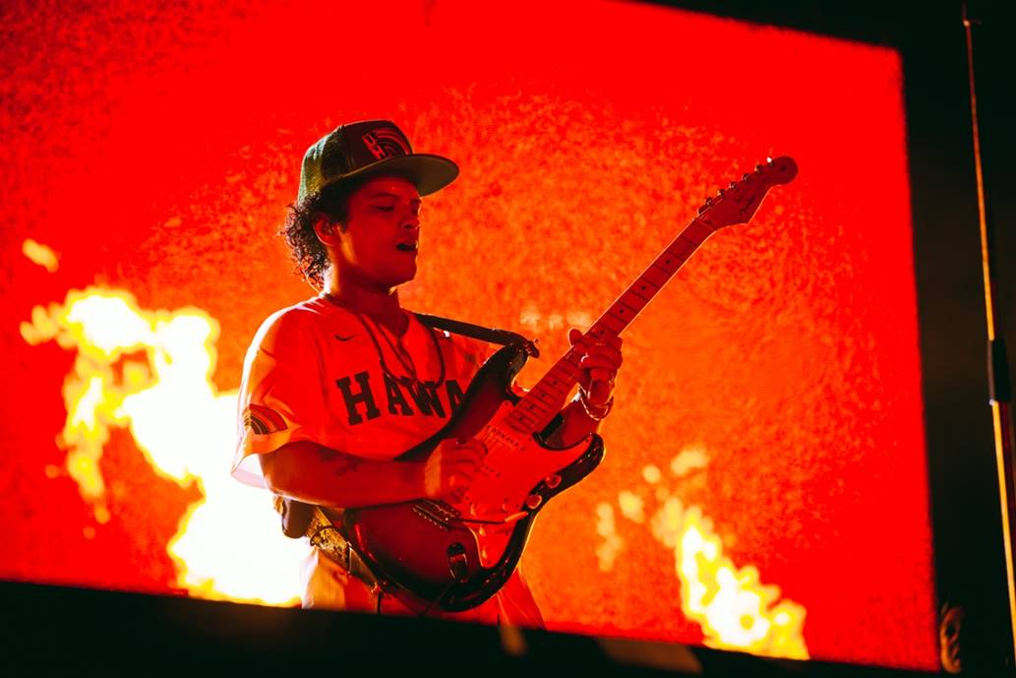

[*Download High Res Photos*](https://warnermusicgroup.box.com/s/mwrc0o5qn9au3l6t02z3cuscukbfitxr)

**HONOLULU, HI**– Bruno Mars will end his historic “24K Magic World Tour” tonight in his hometown of Honolulu, HI and will provide meals to 24,000 Hawai‘i residents in need during the Thanksgiving holiday. The number- 24,000- is a nod to the name of Mars’ world tour and the title of his multi-Grammy Award-winning Album of the Year “24K Magic.*”*This year, Mars will provide aid to The Salvation Army - Hawaiian & Pacific Islands Division's 48th annual Thanksgiving Dinner meal program, single-handedly expanding its reach across the state by covering the costs to provide meals to an additional 24,000 people in need of a complete Thanksgiving holiday meal. In addition, Mars’ donation will allow the program to include, for the first time, more residents who are homebound.

Tonight, November 11th, Mars closes his astounding nearly two-year, 200-date global trek with the final night of his sold-out three-night homecoming stand at Aloha Stadium in Honolulu, HI. Mars made history becoming the first artist to sell-out three back-to-back performances at Aloha Stadium, surpassing both U2 and Michael Jackson’s two-night stands. The “24K Magic World Tour” began in 2017 and spanned across North America, Latin America, Europe, Australia, New Zealand, Asia, and the U.K.

The "24K Magic World Tour" celebrates Mars’ multi-platinum album, "[24K Magic](http://smarturl.it/24kmagic)" (<http://smarturl.it/24kmagic>), released in November 2016 via Atlantic Records. "24K Magic" swept the 2018 GRAMMY Awards, winning all major categories including Album of the Year, Song of the Year, and Record of the Year, as well as R&B Album of the Year. Mars made his donation to The Salvation Army - Hawaiian and Pacific Islands Division through the Hawai'i Community Foundation.

**About The Salvation Army Thanksgiving Dinner Program**

Each year, The Salvation Army provides a free Thanksgiving dinner to families across the state, including serving over 2,000 attendees at Blaisdell Center on O‘ahu. Over 900 volunteers support the effort through donations of time, resources, and treasure. To participate, visit [www.hawaii.salvationarmy.org/hawaii/thanksgivingdinner](http://www.hawaii.salvationarmy.org/hawaii/thanksgivingdinner).

**About Bruno Mars**

Eleven-time GRAMMY Award winner and twenty seven-time GRAMMY Award nominee **Bruno Mars**is a celebrated singer, songwriter, producer, and musician who has sold over 200 million singles worldwide, making him one of the best-selling artists of all time. Mars recently swept the 60th Annual GRAMMY Awards, taking home seven awards including Album of the Year (*24K Magic)*, Record of the Year (“24K Magic”), Song of the Year (“That’s What I Like”), Best R&B Performance (“That’s What I Like”), Best R&B Song (“That’s What I Like”), Best R&B Album (*24K Magic)*, and Best Engineered Album, Non-Classical (*24K Magic)*.

Mars’ 60th Annual GRAMMY wins make him only the tenth artist to win the “Big 3” (Album of the Year, Record of the Year, and Song of the Year), following Simon and Garfunkel, Eric Clapton, Norah Jones, and Adele.

Bruno’s critically acclaimed and RIAA certified double-platinum album *24K Magic*marked his highest first week sales debut, remaining in the Top 10 on the Billboard 200 for an impressive 44 consecutive weeks. The lead hit single “24K Magic” is certified four times Platinum by the RIAA and the follow-up smash, “That’s What I Like” is certified six-times platinum.  “That’s What I Like” also climbed to No. 1 on the Billboard Hot 100, marking Mars’ seventh Hot 100 chart-topper and his first No. 1 on the Hot R&B Songs chart, where it remained at the top-spot for 19 consecutive weeks. His smash collab with Cardi B, “Finesse,” recently skyrocketed to #3 on the Billboard Hot 100. The track surged up the chart from its #35 debut, and follows Michael Jackson’s “Black or White” as the second #35 to #3 jump in the Hot 100’s history. The remix also marks Mars’ fifteenth Hot 100 top 10 and fourteenth Hot 100 top 5.

Additionally, Mars is now the first male and third act overall to have at least three top 5 Hot 100 hits from each of his first three albums, following only Mariah Carey and Beyoncé. Bruno is also the first artist to have two songs spend 24 or more weeks in the Hot 100's Top 5 (“That's What I Like” and “Uptown Funk”). He is the only artist in the past year to have both a four-time and six-time platinum single from the same album. Also, Mars is one of the few artists to have written and produced all of his No. 1 hits and has had a No. 1 song on the Hot 100 from each of his first three studio albums.

With seven Hot 100 No. 1’s, Mars is ranked No. 1 among male artists with the most Hot 100 No. 1s for this decade, extending his lead over Justin Bieber, Drake, Eminem, and The Weeknd. Mars has been traveling the globe on his massive 24K Magic World Tour, which sold more than 1 million tickets in a single day. In 2015, Bruno dominated music charts with the hit single “Uptown Funk,” which took home three GRAMMY Awards, including Record of the Year.