DROPS SURPRISE FAN TRACK ‘AFTERGLOW’
AVAILABLE NOW ON ALL DSPS
LISTEN HERE
WATCH SHEERAN’S ACCOMPANYING PERFORMANCE VIDEO
DIRECT LINK: https://www.youtube.com/watch?v=_NGQfFCFUn4&feature=youtu.be
DOWNLOAD ED’S SELF-CREATED ARTWORK/PRESS IMAGE
DIRECT LINK: https://warnermusicgroup.box.com/s/s4ycm131ole2vk2ghgmyn3orr5g8czzz
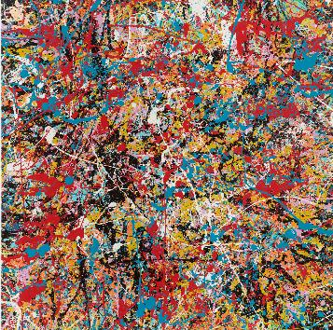
Ed Sheeran has dropped a brand-new, surprise track titled ‘Afterglow’ especially for his fans – the track is available now on all DSPs (listen here). Alongside Ed’s self-created artwork, he has also unveiled a one-take performance video for the song, which you can view here.
Ed Sheeran says – “Hey guys. Afterglow is a song I wrote last year that I wanted to release for you. It’s not the first single from the next album, it’s just a song I love, and hope you love too. Enjoy ! Have a safe and happy festive break and New Year’s. Back to dad land for me now, ciao x”
Recently unveiled as the most-streamed British artist of 2020 in the UK, Sheeran - who is currently on an extended break - wrote the track with David Hodges and FRED (the latter also produced the track together with Ed Sheeran). Co-production comes from PARISI.

CONTACT: Glenn Fukushima Jason Davis
GlennFukushima@elektra.com Jason.Davis@atlanticrecords.com

