FOR IMMEDIATE RELEASE

MARCH 7, 2019

AVA MAX RETURNS WITH ANTHEMIC NEW SINGLE “SO AM I”

RISING POP SENSATION UNVEILS FOLLOW-UP TO GLOBAL HIT “SWEET BUT PSYCHO”

WATCH THE OFFICIAL VIDEO FOR “SO AM I” HERE

“SWEET BUT PSYCHO” ENTERS TOP 10 AT USA POP RADIO AND
HOLDS #1 SPOT AT EUROPEAN RADIO FOR 8TH WEEK IN A ROW
WHILE ASCENDING BILLBOARD’S “HOT 100”

“SO AM I” AVAILABLE TODAY AT ALL DSPS AND STREAMING SERVICES HERE

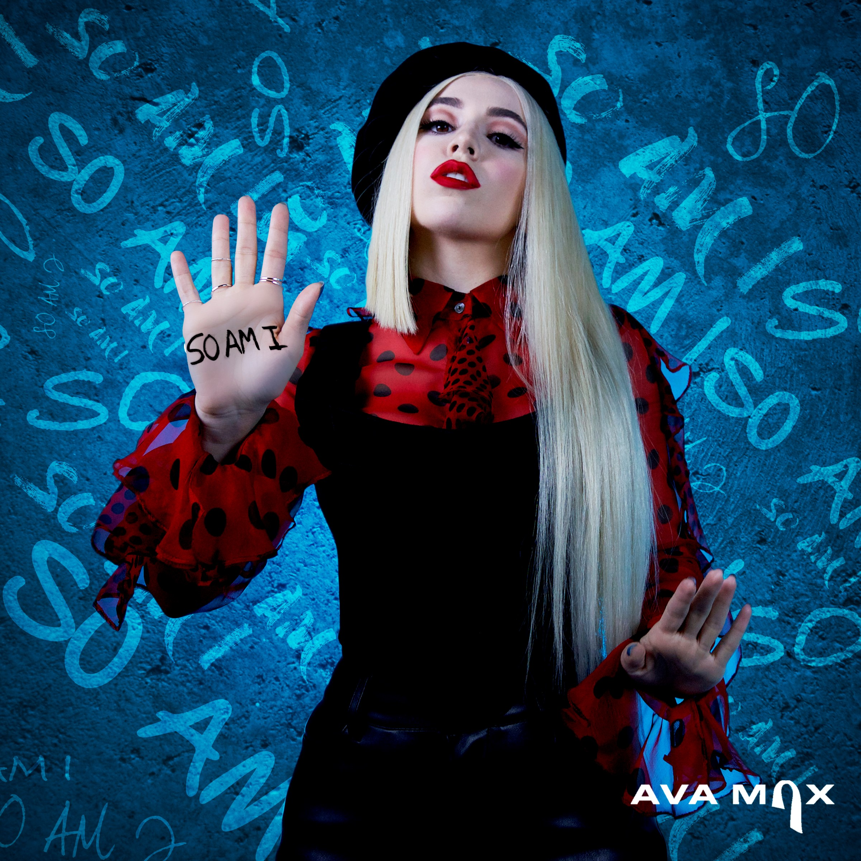
*Download Hi-Res Artwork + Video Stills*

2019’s newest pop sensation Ava Max has unveiled her eagerly awaited new single “So Am I.” The irresistibly catchy pop anthem is available now at all DSPs and streaming services (listen HERE) with the powerful companion video – which promotes a message of inclusivity and acceptance – premiering today via YouTube (watch HERE).

“’So Am I’ is about loving yourself, being different, being an outcast and not fitting in the format that society wants to put us in – just celebrating what really makes you different,” says Ava of the new single. “Whenever I’m feeling down, I remind myself that my flaws make me perfect, because in reality there is no perfect.”

“So Am I” is the rising pop star’s follow-up to her worldwide smash single, “Sweet but Psycho.” Produced by GRAMMY® Award-nominated super-producer Cirkut (Maroon 5, Miley Cyrus, The Weeknd) and co-written with Madison Love (Camila Cabello), “Psycho” – which reached #1 on both Spotify’s “United States Viral 50” and Billboard’s “Dance Club Songs” – recently entered the top 10 at USA Pop Radio while ascending to top 30 on the Billboard’s “Hot 100.” The stateside success of “Sweet but Psycho” follows the track’s remarkable popularity abroad where it has held the #1 spot at European Radio for eight weeks in a row, spent four consecutive weeks atop the UK Singles Chart, and scored #1 rankings on charts in nearly 20 countries. The international hit also gained 3x platinum certifications in Norway and Sweden, 2x platinum certifications in Australia, Netherlands, Ireland, and Switzerland, platinum certifications in Denmark, Finland, Canada, the U.K., and Italy, and gold certifications in Mexico, New Zealand, South Africa, Austria, Portugal, Germany, Poland and France. “Sweet but Psycho” – which has earned more than 750 million streams and overall global sales consumption in excess of 2 million – is joined by an equally popular companion video, directed by Shomi Patwary (Beyoncé, The Weeknd) and now boasting over 178 million views via Ava Max’s official YouTube channel HERE.

Having spent the past six weeks atop Billboard’s “Emerging Artists” chart, Ava has received glowing features in such outlets as Vanity Fair, Billboard, and PAPER, the latter naming her among its “100 People Taking Over 2019.” In a recent profile, V Magazine praised “Sweet but Psycho” writing, “By re-appropriating language used to gaslight women, Ava Max creates an unlikely feminist anthem, written by and for someone who has nothing to hide, who, furthermore, has fought for herself to be seen completely.” The promising young songstress kicked off the new year making her U.S. TV debut with stunning performances of “Sweet but Psycho” on both CBS’ The Late Late Show with James Corden and NBC’s The TODAY Show.

Currently nominated as a “Rising Star” by the UK’s Global Awards, Ava Max arrived last April with “My Way” which Billboard called “an impressive debut” – watch the official companion video HERE. “My Way” instantly established Ava Max as one of modern pop’s most intriguing new songstresses following her stellar featured performance on 2017’s hit single, “Clap Your Hands (Feat. Ava Max),” by LA-based producer Le Youth. Max has also released collaborations including Vice & Jason Derulo’s “Make Up (Feat. Ava Max),” David Guetta’s “Let It Be Me (Feat. Ava Max),” and fellow Atlantic recording artist Witt Lowry’s “Into Your Arms (Feat. Ava Max).”

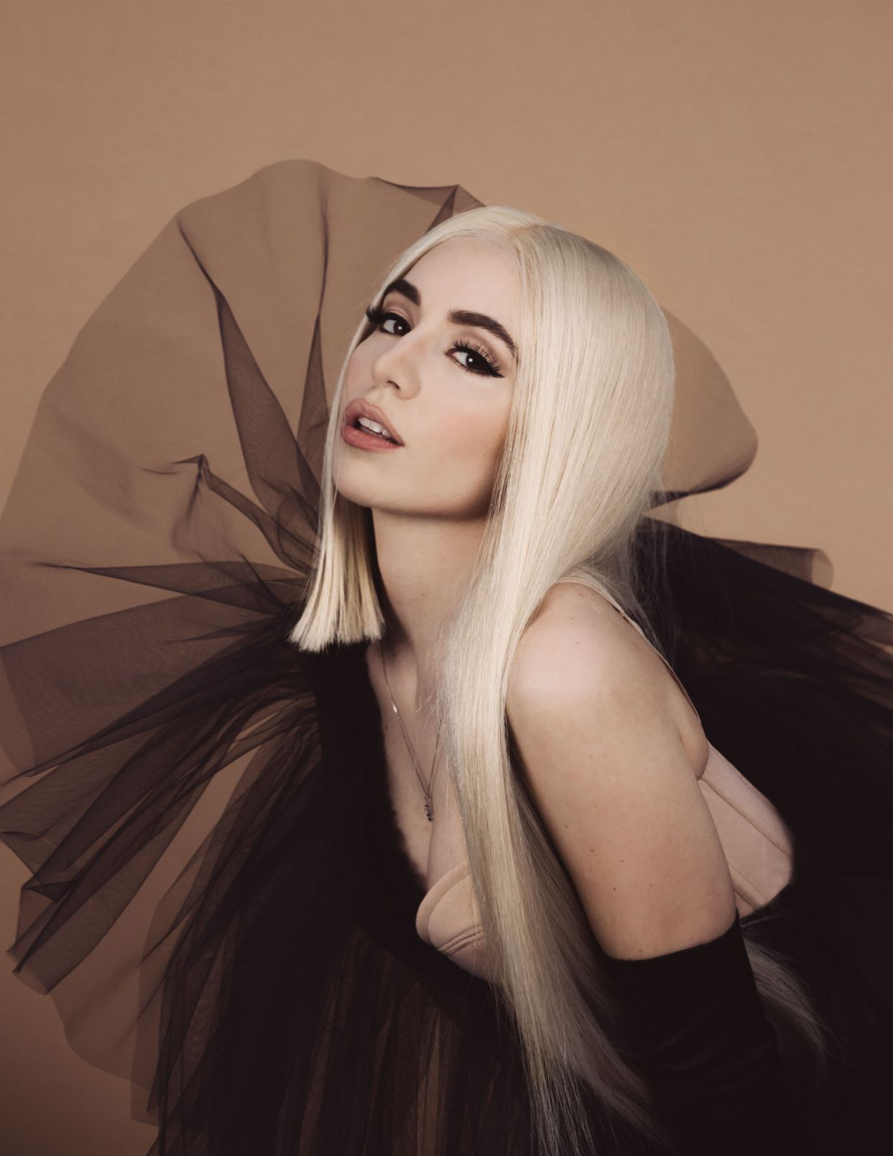
(Press Photo Credit: Lauren Dunn – download high res)

ABOUT AVA MAX:
Crafting pop anthems with a much-needed dose of fiery female empowerment, Ava Max is a unique new talent, blessed with a seismic voice, an individualistic high fashion mindset, and an undeniable knack for cinematic, theatrical popcraft. The daughter of Albanian immigrants, Max was born in Wisconsin but raised in Virginia where she began blowing away audiences long before even entering high school. Determined from a young age to grace the stage and equipped with a vibrant voice passed down by her opera singer mother, Max honed her skills performing at multiple singing competitions. Inspired by her parents’ courageous escape from the political turmoil that plagued their home country; she eventually made the move to Los Angeles to pursue her calling.

CONNECT WITH AVA MAX:
OFFICIAL I INSTAGRAM I TWITTER I FACEBOOK I SOUNDCLOUD I PRESS TOOLS

CONTACT:
Andrew George | andrew.george@atlanticrecords.com

