FOR IMMEDIATE RELEASE
JANUARY 22, 2021

FAOUZIA AND JOHN LEGEND TAP OFENBACH FOR
EXPLOSIVE HOUSE REMIX OF “MINEFIELDS”

POWERHOUSE SINGER/SONGWRITER AND GLOBAL SUPERSTAR
RECRUIT WITH CHART-TOPPING FRENCH DJ DUO FOR HIGH-ENERGY HOUSE REMIX

LISTEN TO “MINEFIELDS (OFENBACH REMIX)” HERE
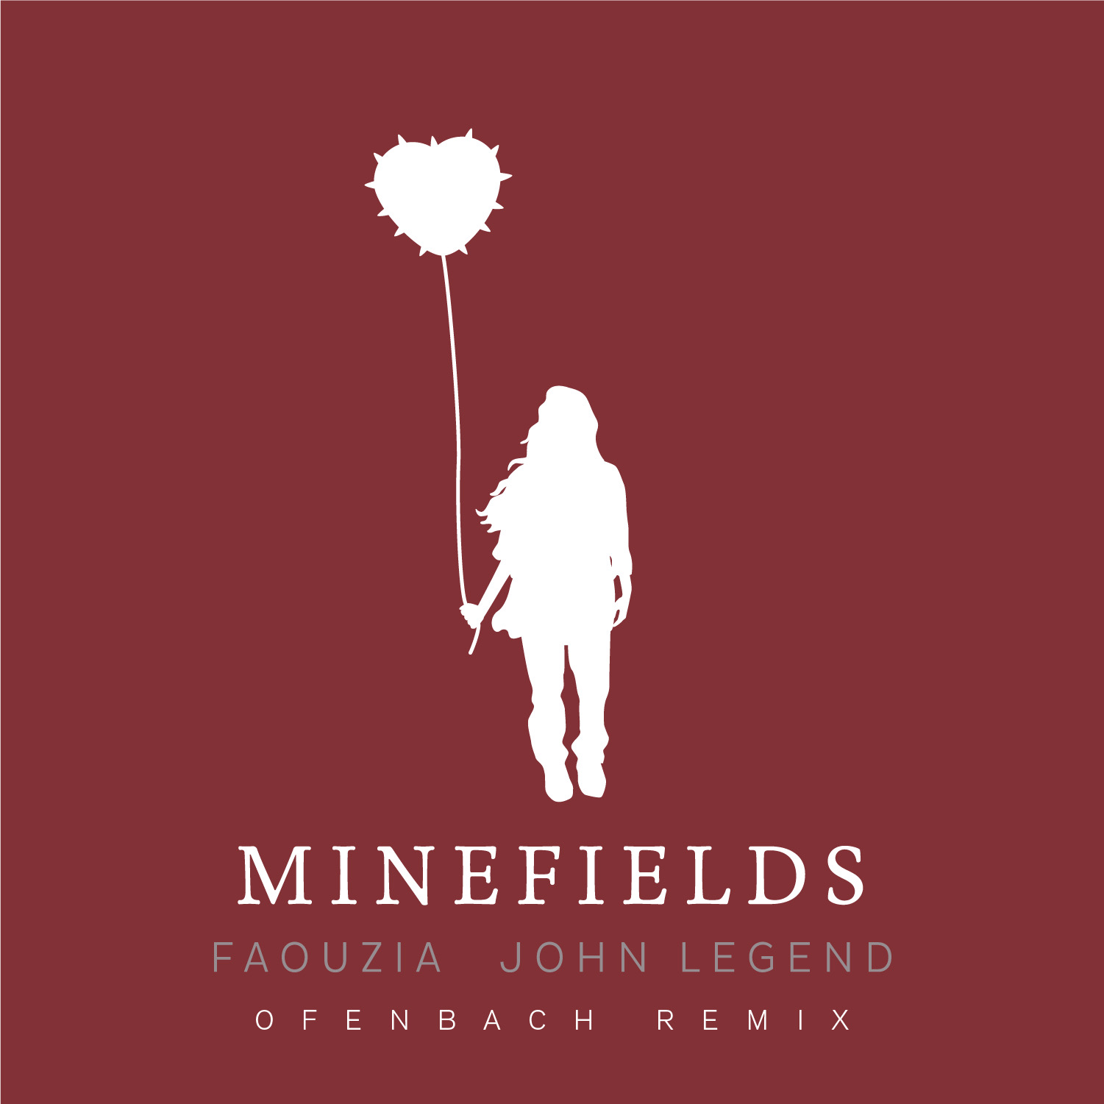
DOWNLOAD ARTWORK HERE

Acclaimed powerhouse vocalist Faouzia and 11x GRAMMY Award winner John Legend have recruited DJ duo Ofenbach (Dua Lipa, Portugal. The Man) for an pulsating and bass-driven house remix of their recent single “Minefields” – listen to “Minefields (Ofenbach Remix)” HERE.

The romantic and poignant original track was co-written by Faouzia, Sam Martin (One Direction, Julia Michaels, Nick Jonas), Ali Tamposi (Beyoncé, Selena Gomez, Dua Lipa), J Kash (Britney Spears, Ke$ha, Avril Lavigne) and multi-platinum producer Johnny Goldstein (Black Eyed Peas, Tyga, Ozuna) and features the multi-GRAMMY nominated and multi-platinum artist Charlie Puth on piano. Last week saw the release of the stellar remix from Platinum-selling Australian DJ Hook n Sling (Lana Del Rey, Calvin Harris, Kygo) – listen HERE.

“Minefields” adds to Faouzia’s impressive list of collaborations including “I Dare You (كنتحداك),” with 3x GRAMMY Award-winning global superstar Kelly Clarkson, “I Fly” with chart-topping DJ duo Galantis featured on the hit soundtrack, SCOOB! THE ALBUM and “Battle” which was found on David Guetta’s chart-topping smash album, 7.

Stay tuned for more from this rising superstar…

WHAT CRITICS ARE SAYING ABOUT “MINEFIELDS”
“this would be my new favorite song even if I weren’t having sex with john…”
– CHRISSY TEIGEN

“a powerful ballad…”
– ROLLING STONE

“bombastic new track…”
– BILLBOARD

“The ballad features silky smooth vocals from both performers...”
– USA TODAY

“a gorgeous ballad…”
– E! NEWS

“The singers' effortless harmonies lend to the song's intense emotional charge, leaving you hopeful that love truly can conquer all.”
– REFINERY 29

“Though Faouzia has yet to release a full-length project, the singer has already caught the attention of many big names in music.”
– UPROXX


DOWNLOAD PRESS PHOTOS HERE

ABOUT FAOUZIA:
When Faouzia (pronounced FOH-ZE-UH) steps up to a microphone, a mile-deep delivery emanates from her 5’2” frame lifted by Arabic trills informed from Moroccan heritage, lifelong pop reverence culled during a childhood in Canada, and diligence indebted to over a decade of classical training. This collision of cultures, eras, and styles asserts the trilingual 20-year-old singer, songwriter, and multi-instrumentalist as a fresh force for popular music and culture affirmed by millions of views and streams, and acclaim courtesy of Billboard, Idolator, Ladygunn, Ones To Watch, and more within only just a few years. The rising superstar has appeared on ELLE’s coveted ‘Song Association’ series and an episode of Seventeen’s “Tik Tok Reacts,” along with an acapella performance of “Tears of Gold” on Genius’ Verified and acoustic performance of “Secrets” on Genius’ OPEN MIC. Faouzia, who was recently named one of People’s best emerging artists, recently made her debut television appearance on The Kelly Clarkson Show with a collaborative performance of Clarkson’s “I Dare You.”

Faouzia transmits a message as robust, real, and relatable as her voice is. “I’d love for listeners to get what they need from my voice,” says Faouzia, “If they feel healed or happy, that would be amazing. I hope it’s a safe place for them. I’m just a normal girl trying to be the best version of myself and help others do the same. I care a lot.” Speaking on her unique voice, Faouzia says: “It’s always funny to see people’s reactions when I start singing,” she smiles, “I’m glad I’ve got this oxymoron combination of a big voice and a little body. I always push myself because of it. When I was growing up, I often felt as if I wasn’t being listened to—like a ghost. Then, I would sing, and everybody would stop and listen. Now, I’ve got a message I want everyone to listen to.”

Faouzia recently signed with Atlantic Records and made her major label debut earlier this year with her extraordinary EP, STRIPPED. With over 250 million streams worldwide, 1 million YouTube subscribers, 1.8 million Instagram followers and 2 million Tik Tok followers Faouzia has cemented herself as a surefire artist to watch. Stay tuned for more new music from this rising superstar!

CONNECT WITH FAOUZIA
WEBSITE | TWITTER | FACEBOOK | INSTAGRAM | YOUTUBE | TIK TOK

FOR FAOUZIA PRESS INQUIRIES, PLEASE CONTACT:
Jessica Nall / Jessica.Nall@atlanticrecords.com

