FOR IMMEDIATE RELEASE
OCTOBER 28, 2021

FAOUZIA WILL NEVER BE YOUR “PUPPET”

ACCLAIMED GLOBAL POP POWERHOUSE SHARES FIERCE NEW SINGLE

EAGERLY AWAITED HEADLINE SHOWS SLATED FOR
LOS ANGELES’ THE ROXY AND NYC’S BOWERY BALLROOM

LISTEN TO “PUPPET” HERE
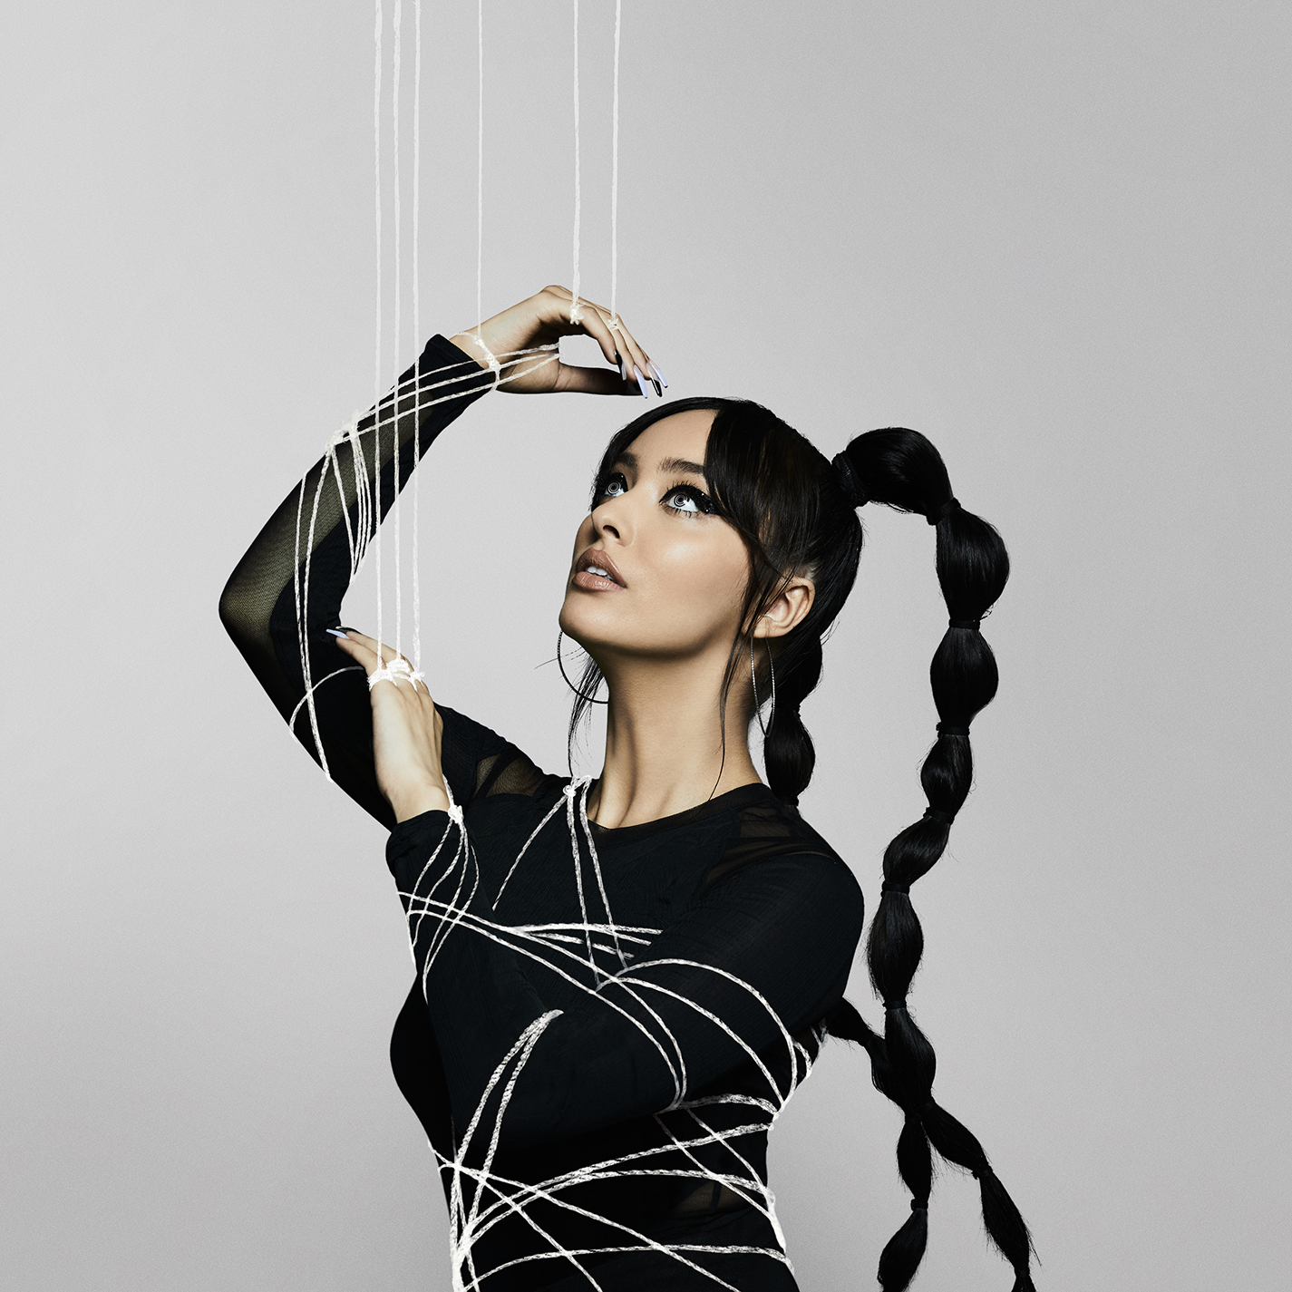
DOWNLOAD ARTWORK HERE

Internationally acclaimed Moroccan-Canadian singer/songwriter/multi-instrumentalist, Faouzia, has released her latest empowerment anthem, “Puppet” – available everywhere now HERE.

“‘Puppet’ is a song about challenging relationship dynamics as a woman, taking charge, and shamelessly being yourself,” says Faouzia. “I want young girls around the world to know that they don’t need to change who they are for anyone, and that someone that loves you shouldn’t ask you to be someone you’re not. If anyone tries to knock you down, or force you to conform, use that as motivation to stand up taller and only surround yourself with those that want to prop you up and support you. Throughout the song, the word “ حرية” is chanted, Arabic for “freedom.” As the world continues down a difficult path daily, this message is more necessary than ever.”

Written by Faouzia and co-written and produced by The Monarch (Saweetie, Noa Kirel) and Johnny Goldstein (Galantis, David Guetta & Little Mix, Black Eyed Peas), “Puppet” was first heralded over the summer with a series of social media teases, earning over 2.1 million views across all posts. Faouzia is slated to play her first-ever US headline shows at Los Angeles, CA’s The Roxy on November 12th and New York City’s Bowery Ballroom on November 18th where she will perform “Puppet” live for the first time.
Limited tickets remain for both shows. For more information, please visit www.faouziaofficial.com.

“Puppet” follows Faouzia’s summer pop anthem, “Hero,” which arrived with an Ariel Michelle-directed (Loren Gray, FLETCHER) video that has earned over 4 million views. Currently boasting over 21 million worldwide streams in less than 4 months, “Hero” proved a breakthrough release for Faouzia, landing her on the DSP covers of Apple Music’s New Music Daily, Spotify Canada’s New Music Friday, Amazon Music’s Girl Squad, and more. Named among PEOPLE’s “Talented Emerging Artists Making Their Mark on the Musical Landscape,” the 21-year-old artist also made an exclusive visit to Genius’s influential Verified series, following earlier appearances including ELLE’s Song Association, Seventeen’s Tik Tok Reacts, Cosmopolitan’s TikTok Reacts and Refinery 29’s Spill It. Faouzia recently made her television debut on The TODAY Show + The Kelly Clarkson Show alongside John Legend for stunning performances of their rising single “Minefields.”

Currently boasting over 155 million streams, “Minefields” continues to rise, still streaming over 3 million times per week after almost a year after release. Upon release, the powerful track received widespread acclaim from Rolling Stone labeling the track “a powerful ballad,” E! joined in hailing it as “gorgeous” and USA Today lauded the “silky smooth vocals from both performers.” The track recently surpassed 158.8k creates on TikTok from fans around the world and continues to gain momentum on the platform.

A true global artist, Faouzia has found fans in VOGUE Arabia, GQ Middle East, Gazelle Magazine, and more. Faouzia recently appeared at the Global Citizen event where the International Rescue Committee Ambassador committed to helping Afghan refugees. The Canadian-Moroccan artist was also featured in a YouTube Canada campaign “Every Day, Canadians Count on YouTube.”

With over 570 million global streams, Faouzia has a combined social reach of over 7.5 million followers. Boasting over 1.67 million YouTube subscribers, 1.9 million Instagram followers and more than 2.6 million Tik Tok followers, Faouzia has cemented herself as a surefire artist to watch. With collaborations with John Legend, Kelly Clarkson, David Guetta, and more, the landmark star has been praised in global publications spanning VOGUE, ELLE, Rolling Stone, Seventeen, Billboard, and Uproxx, to name but a few. Currently hard at work on her eagerly awaited debut album, Faouzia remains focused on turning her unbridled self-expression into a powerful outlet for her audience.

“My favorite thing is hearing that one of my songs helped someone feel motivated or empowered, or even helped them to have a good cry – which sometimes is all you need,” she says. “I really believe that immersing yourself in music can help you through the tough times in life, and I always hope that my songs can do that for everyone.”

PRAISE FOR FAOUZIA
“One of the most powerful new voices you’ll hear this year.” – BILLBOARD

“Faouzia is the Next Big Thing” – BUSTLE

“Faouzia is poised to become pop music’s next breakout star.” – HYPEBAE

“There are no two ways about it, Faouzia is destined for pop stardom. The 20-year-old Moroccan-born, Canadian-bred tour de force crafts sweeping, cinematic pop like it's second nature.” – ONES TO WATCH

“Certain voices illicit deeper feelings and awe-stricken reactions than others, and many of those people become modern-day ‘legends’ in our society... One such voice that demands to be heard belongs to Faouzia.” – LADYGUNN

“Just twenty years old, the Moroccan-Canadian artist both writes and performs with a polish far beyond her years… The rising multi-hyphenate knows what she wants to say and is saying so with confidence — playing the role of protagonist to a tee.” – CONSEQUENCE

“Her star continues to rise…” – ENTERTAINMENT TONIGHT

“Faouzia has already made waves in her young career…” – UPROXX

“Faouzia is ready to take the world by storm…” – IDOLATOR

# # #

CONNECT WITH FAOUZIA
WEBSITE | TWITTER | FACEBOOK | INSTAGRAM | YOUTUBE | TIK TOK

FOR PRESS INQUIRIES, PLEASE CONTACT:
Jessica Nall / Jessica.Nall@atlanticrecords.com

