A BOOGIE WIT DA HOODIE & DON Q TAP LIL UZI VERT FOR “FLOOD MY WRIST”

FIRST SINGLE FROM UPCOMING HIGHBRIDGE THE LABEL COMPILATION

NEW SONG ARRIVES ALONGSIDE PICTURE PERFECT-DIRECTED VISUAL OUT NOW

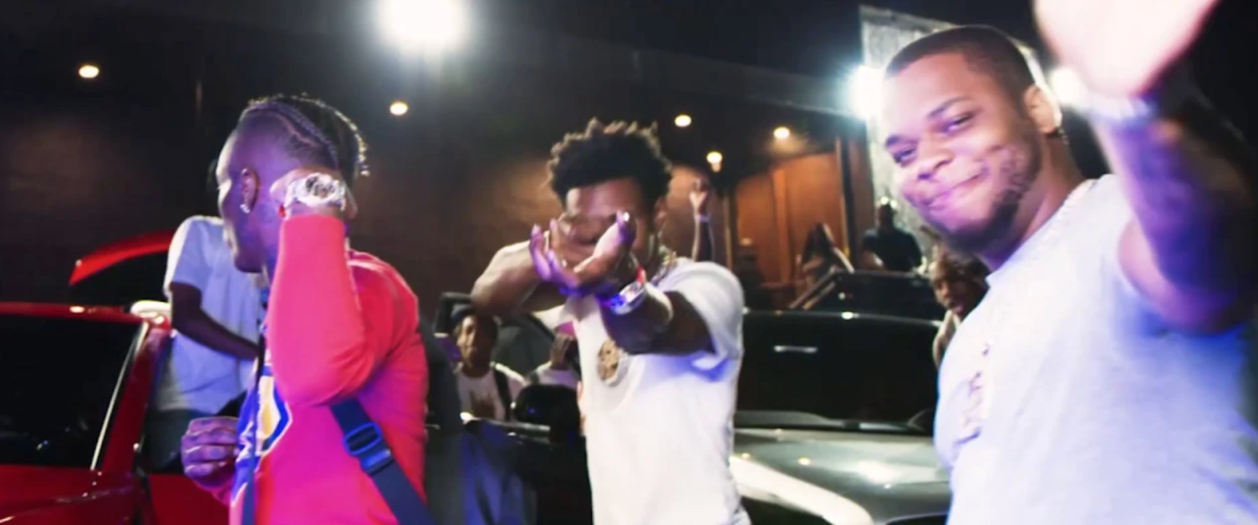

Multi-platinum superstar A BOOGIE WITH THE HOODIE and rising rapper DON Q reunite for “Flood My Wrist (feat. Lil Uzi Vert),” out today via Atlantic Records/Highbridge The Label. The Nick Mira and Doe Pesci-produced summertime anthem is the first single from the forthcoming Highbridge The Label compilation project, due out soon.

Featuring frequent A Boogie collaborator, Lil Uzi Vert, “Flood My Wrist” arrives today alongside a colorful companion video, directed by Picture Perfect.

Rising to fame in 2016 with the release of his debut mixtape ARTIST, A Boogie Wit Da Hoodie founded Highbridge The Label, named after his hometown; the Highbridge neighborhood of The Bronx in New York City. Founded by the chart-topping superstar and entrepreneur, alongside Quincy “QP” Acheampong and Sambou “Bubba” Camara, Highbridge The Label is more than a label; it’s a movement. The Highbridge The Label roster includes rising rappers Don Q and Trap Manny, as well as singer Enisa.

PRESS CONTACTS:
JASON DAVIS | JASON.DAVIS@ATLANTICRECORDS.COM (A BOOGIE WIT DA HOODIE)
ARIANA WHITE | ARIANA.WHITE@ATLANTICRECORDS.COM (DON Q)

# # #

