Forest Blakk announces debut EP Minutes
available for pre-order now with new track “Tread Lightly”

Atlantic singer/songwriter to SUPPORT
NEEDTOBREATHE ON FALL NORTH AMERICAN TOUR

Minutes EP arrives August 3rd via Atlantic Records

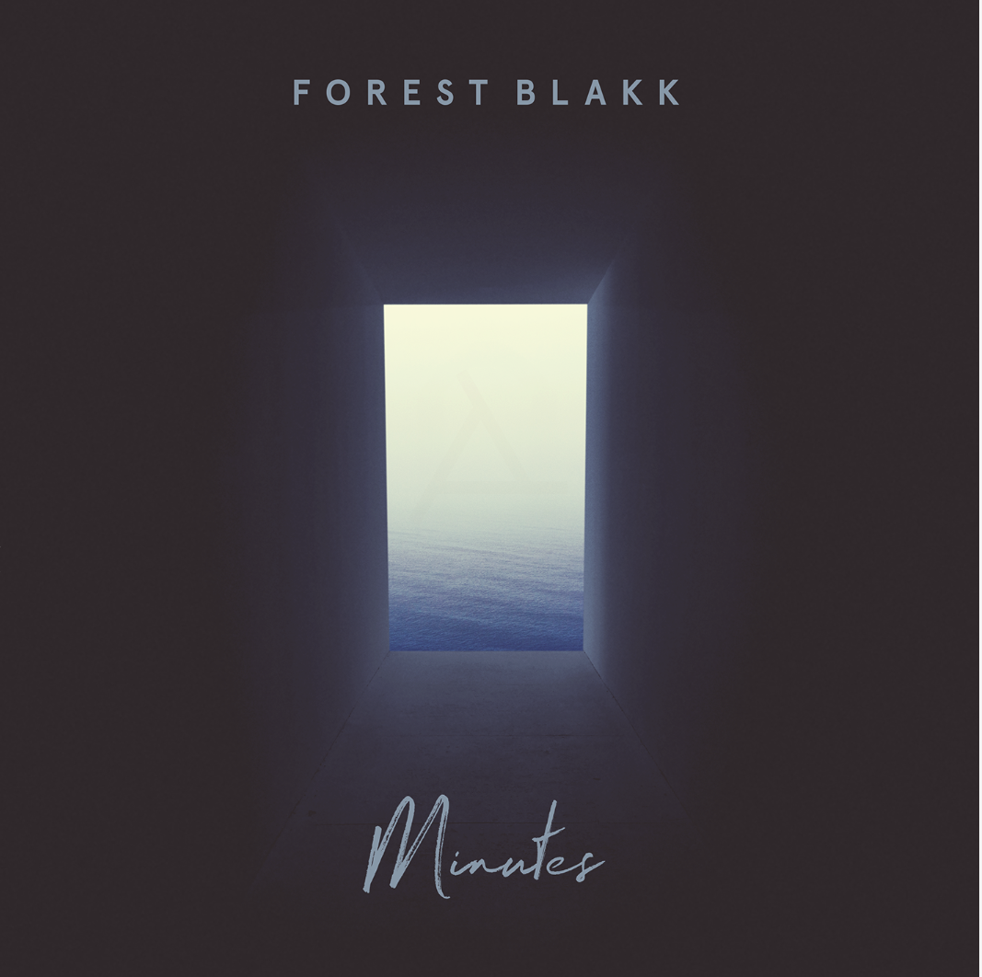

WATCH/POST “TREAD LIGHTLY” – https://youtu.be/bhcsmwXFCOI
PRE-ORDER MINUTES EP – https://Atlantic.lnk.to/MinutesEPPR

Atlantic singer/songwriter Forest Blakk has announced his debut EP Minutes, out August 3rd and available for pre-order today along with new track “Tread Lightly.” Deemed an “artist on the rise” by Billboard, Blakk’s debut six-track collection also features previously released songs “Love Me” (which has accumulated over 10 million streams worldwide) and “Where I First Found You.”

Blakk is set to hit the road this September supporting NEEDTOBREATHE for 15 dates along their North American tour, with more live dates to be announced soon.

###

Before Forest Blakk could sing about loss and love, he had to pull himself back from the brink. Raised by parents with a history of drug use, he has hair-raising tales of his childhood, including an assassination attempt on his father on the family’s front stoop, rooms full of cash, and constant uprooting to places like Jamaica and Florida.

Blakk underwent a spiritual and physical transformation that enabled him to carve a new musical direction that he calls “urban folk,” blending his identity as a city kid with his attraction to artists like Don Henley and Joe Cocker, whose soulfulness and emotionality resonate with him. Now he’s the kind of nimble songwriter who etches new facets into the surfaces of tried and true terrain. His piano- and acoustic-driven songs are ballads about loss, whether it’s letting go of someone you’re still in love with (his debut single “Love Me”) or physically losing someone through death; the reincarnation of love (“Where I First Found You”); or feeling love through lust. “It’s not as simple as just putting words on paper for me,” Blakk says. “It has to connect. Every single line in every song has to mean something.”

Blakk is deeply invested in empowering others to be visible, especially those who feel invisible, as he did as a kid. That his songs are as open-hearted and hopeful as they are is a testament to his personal resilience.

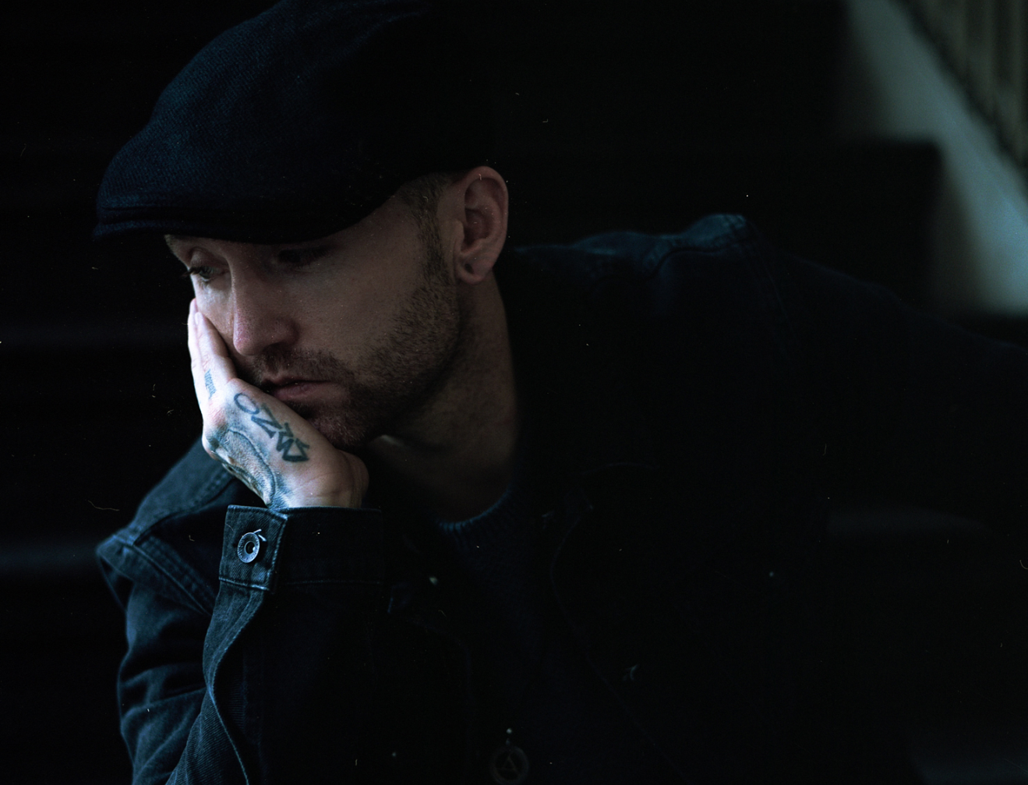
DOWNLOAD HIGH-RES IMAGE

“FOREVER ON YOUR SIDE” TOUR
ALL DATES SUPPORTING NEEDTOBREATHE:
September 4 – Cincinnati, OH @ Riverbend Music Center
September 5 – Cleveland, OH @ Jacobs Pavilion at Nautica
September 7 – Minneapolis, MN @ The Armory
September 8 – Chicago, IL @ Huntington Bank Pavilion at Northerly Island
September 9 – Kansas City, MO @ Starlight Theatre
September 10 – Lincoln, NE @ Pinewood Bowl Theater
September 12 – Morrison, CO @ Red Rocks Amphitheatre
September 14 – Portland, OR @ Rose Quarter
September 15 – Seattle, WA @ CenturyLink Field
September 16 – Abbotsford, BC @ Abbotsford Entertainment & Sports Centre
September 18 – Oakland, CA @ Fox Theatre
September 19 – Paso Robles, CA @ Vina Robles Amphitheatre
September 21 – San Diego, CA @ Cal Coast Credit Union Open Air Theatre
September 22 – Los Angeles, CA @ Greek Theatre
September 23 – Phoenix, AZ @ Comerica Theatre

CONNECT:
TWITTER | FACEBOOK | INSTAGRAM | YOUTUBE | FORESTBLAKK.COM

CONTACT:
ted.sullivan@atlanticrecords.com

