FOR IMMEDIATE RELEASE
May 1, 2020

FOREST BLAKK ANNOUNCES SIDEWAYS EP

NEW SINGLE “I WISH I KNEW” AVAILABLE NOW

TRIUMPHANT SINGER/SONGWRITER TO JOIN THE GOO GOO DOLLS
FOR 2020 SUMMER TOUR; SIDEWAYS EP ARRIVES JUNE 12TH

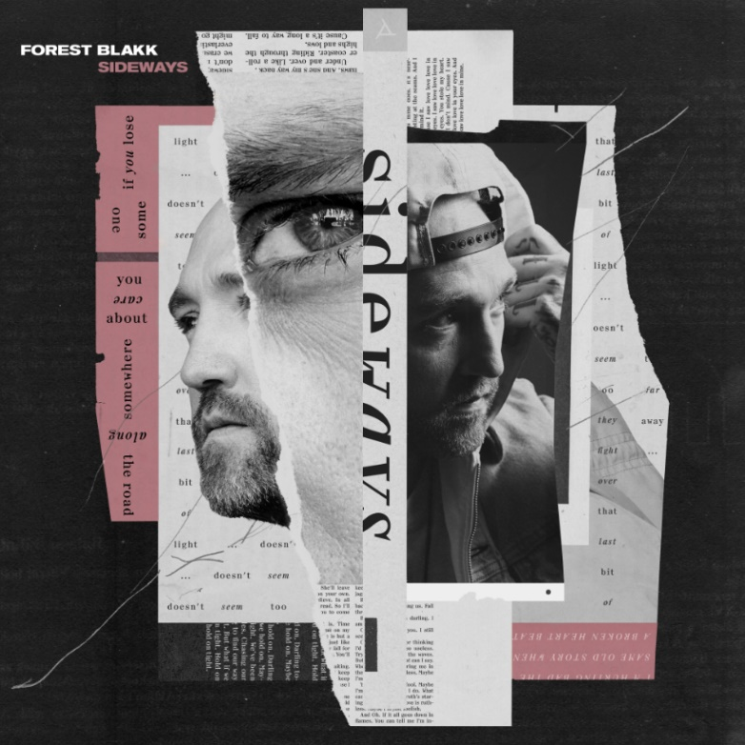
DOWNLOAD HIGH-RES ARTWORK HERE

LISTEN TO “I WISH I KNEW”: https://forestblakk.lnk.to/IWIKVideoPR
PRE-ORDER SIDEWAYS EP: https://forestblakk.lnk.to/SidewaysPR

Singer/songwriter Forest Blakk has announced his sophomore EP, Sideways, arriving June 12th via Atlantic Records. The collection is heralded today by the emotional new single “I Wish I Knew,” co-written alongside Will IDAP (Train, Florida Georgia Line) & Nick Long (King Princess).

“’I Wish I Knew’ is for all of us who have ever longed to change the past. It’s for those of us wishing we could retrace our steps in the hope of doing things differently. Maybe you would have hugged her a little longer, maybe you would have kissed him one more time, or maybe we would have said the words, ‘I love you’ enough for them to make their way back home to our hearts in one piece. I don’t know if that would have changed anything, I wish I knew!” – FOREST BLAKK

The new song and EP announcement follow the release of “Put Your Hands Up,” Blakk’s uplifting anthem of resilience co-penned with Carl Ryden (Ricky Martin, David Guetta) and co-produced by Ollie Green (Freya Ridings, Gavin James), which debuted in October on an episode of ABC’s Grey’s Anatomy. This summer will also see Blakk embark on tour supporting The Goo Goo Dolls alongside Lifehouse on their “Miracle Pill Summer Tour,” kicking off July 23rd in Boise, ID (full routing below).

Deemed an “artist on the rise” by Billboard, Blakk’s debut EP Minutes featured the standout single “Love Me” and saw editorial support via Parade, Alternative Press, Ones To Watch and more. A compelling live performer, Blakk has toured extensively supporting NEEDTOBREATHE, Gavin James and more.

***

Before Forest Blakk could sing about loss and love, he had to pull himself back from the brink. Raised by parents with a history of drug use, he has hair-raising tales of his childhood, including an assassination attempt on his father on the family’s front stoop, rooms full of cash, and constant uprooting to places like Jamaica and Florida.

Blakk underwent a spiritual and physical transformation that enabled him to carve a new musical direction that he calls “urban folk,” blending his identity as a city kid with his attraction to artists like Don Henley and Joe Cocker, whose soulfulness and emotionality resonate with him. Now he’s the kind of nimble songwriter who etches new facets into the surfaces of tried and true terrain. Blakk is deeply invested in empowering others to be visible, especially those who feel invisible, as he did as a kid. That his songs are as open-hearted and hopeful as they are is a testament to his personal resilience.

Sideways EP
1. I Wish I Knew
2. Forever And A Day
3. Sideways
4. I Saw Love
5. Foolish
6. Put Your Hands Up
7. Hold On Tight

The Goo Goo Dolls – “Miracle Pill Summer Tour”
w/ special guests Lifehouse & Forest Blakk
7.23 – Boise, ID – Ford Idaho Center Amphitheater
7.26 – Portland, OR – Oregon Zoo Amphitheater
7.28 – Salt Lake City, UT – USANA Amphitheatre
7.29 – Morrison, CO – Red Rocks Amphitheatre
7.31 – Maryland Heights – MO – Saint Louis Music Park
8.1 – Lincoln, NE – Pinewood Bowl Theater
8.3 – Kansas City, MO – Starlight Theatre
8.5 – Huber Heights, OH – Rose Music Center
8.6 – Indianapolis, IN – The Amphitheater at White River State Park
8.7 Chicago, IL – Huntington Bank Pavilion at Northerly Island
8.9 – Sterling Heights, MI – Michigan Lottery Amphitheatre at Freedom Hill
8.10 – Toronto, ON – Budweiser Stage
8.12 – Cleveland, OH – Jacobs Pavilion at Nautica
8.13 – Vienna, VA – Wolf Trap
8.15 – Holmdel, NJ – PNC Bank Arts Center
8.16 – Syracuse, NY – St. Joseph’s Health Amphitheater at Lakeview
8.18 – Boston, MA – Rockland Trust Bank Pavilion
8.19 – Gilford, NH – Bank of New Hampshire Pavilion
8.21 – Darien Center, NY – Darien Lake Amphitheater
8.22 – Philadelphia, PA – TD Pavilion at the Mann
8.23 – Saratoga Springs, NY – Saratoga Performing Arts Center
8.25 – Raleigh, NC – Red Hat Amphitheater
8.26 – Jacksonville, FL – Daily’s Place
8.28 – Charlotte, NC – Charlotte Metro Credit Union Amphitheatre
8.29 – Nashville, TN – Ascend Amphitheater
8.30 – Atlanta, GA – Cadence Bank Amphitheatre at Chastain Park
9.1 – Houston, TX – Smart Financial Centre at Sugar Land
9.2 – Irving, TX – The Pavilion at Toyota Music Factory
9.5 – Los Angeles, CA – The Greek Theatre

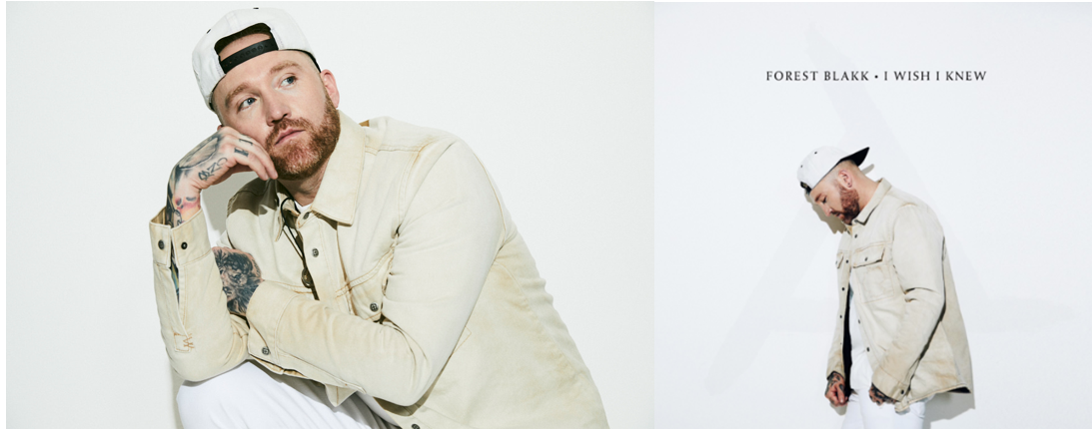
DOWNLOAD HIGH-RES IMAGES HERE

CONNECT:
TWITTER | FACEBOOK | INSTAGRAM | YOUTUBE | FORESTBLAKK.COM

CONTACT:
ted.sullivan@atlanticrecords.com

