FOR IMMEDIATE RELEASE

SEPTEMBER 30, 2020

**FOREST BLAKK UNVEILS “IF YOU LOVE HER”**

**NEW SINGLE & MUSIC VIDEO OUT NOW!**

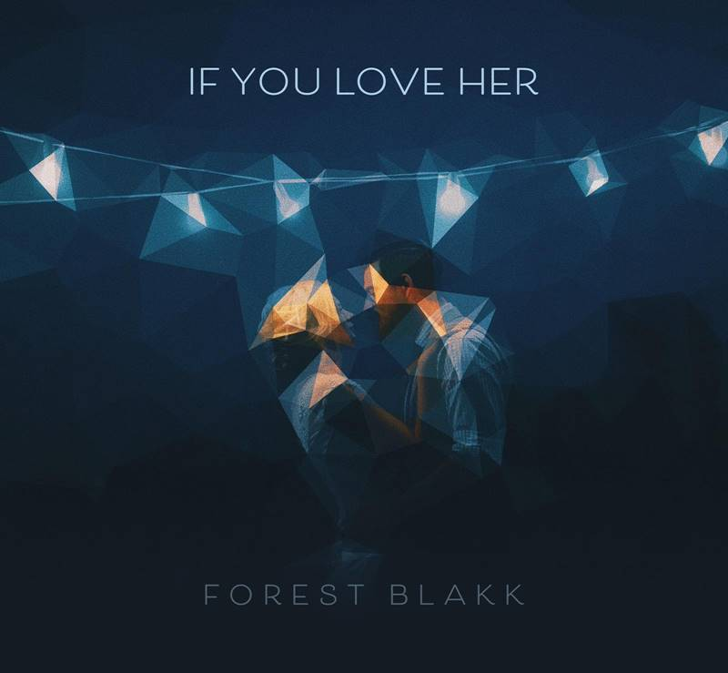

[DOWNLOAD HIGH-RES ARTWORK HERE](http://press.atlanticrecords.com/forest-blakk/)

**WATCH:** <https://forestblakk.lnk.to/IYLHVideoPR>

**STREAM:** <https://forestblakk.lnk.to/IfYouLoveHerPR>

Singer/songwriter **Forest Blakk** has unveiled new single “**If You Love Her**” – available now via **Atlantic Records**. The track arrives alongside a beautifully moving **James** **Fitzgerald**-directed video, starring **Tom Vaughan-Lawlor** (**Marvel**’s ***Avengers: Infinity War***, ***Dublin Murders***) and **Caoimhe O’Malley** (**Dublin Murders**, & **The CW**’s ***Reign***).

“**If You Love Her**” follows the release of stand-alone track “**Foolish**” and sophomore EP ***Sideways***, the latter of which saw Blakk collaborate with the likes of **Will** **IDAP** (**Train**, **Florida** **Georgia** **Line**), **Nick Long** (**King Princess**), **Carl Ryden** (**Ricky Martin**, **David Guetta**), **Ollie** **Green** (**Freya** **Ridings**, **Gavin** **James**) & more to tell a love story through an incredibly realistic and candid lens. The 6-track collection included singles “**I Wish I Knew**” (deemed an *“introspective look at love and love lost”* by **American Songwriter**) and uplifting anthem of resilience “**Put Your Hands Up**,” which debuted last year on an episode of **ABC**’s ***Grey’s Anatomy***.

Deemed an *“artist on the rise”* by **Billboard**, Blakk’s debut EP ***Minutes*** featured the standout single “**Love Me**” and saw editorial support via **Parade**, **Alternative Press**, and **Ones To Watch**. A compelling live performer, Blakk has toured extensively supporting **NEEDTOBREATHE**, **Gavin James** and more. He is also set to re-join **The Goo Goo Dolls** alongside **Lifehouse** for their “**Miracle Pill Summer 2020 Tour**,” following the proactive rescheduling of shows due to COVID-19.

**CONNECT:**

[TWITTER](https://twitter.com/forestblakk) | [FACEBOOK](https://www.facebook.com/forestblakk) | [INSTAGRAM](https://www.instagram.com/forestblakk) | [YOUTUBE](https://www.youtube.com/channel/UC9vKX9Hz5dGVrhD5v3-UnAQ) | [FORESTBLAKK.COM](http://forestblakk.com/)

**CONTACT:**

[ted.sullivan@atlanticrecords.com](mailto:ted.sullivan@atlanticrecords.com)