FOR IMMEDIATE RELEASE

OCTOBER 11, 2019

**Forest Blakk debuts new single “Put Your Hands Up”**

**Atlantic singer/songwriter’s uplifting new song**

**featured ON last night’s episode oF *Grey’s Anatomy***

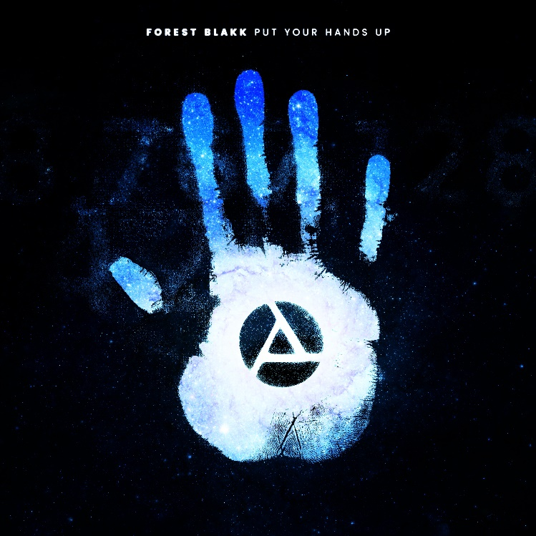

**STREAM “PUT YOUR HANDS UP”:** [LINK](https://atlantic.lnk.to/PutYourHandsUpPR)

Singer/songwriter **Forest Blakk** has released his uplifting new single “**Put Your Hands Up**” – available now via **Atlantic Records**. The track made it’s debut last night on an episode of **ABC**’s ***Grey’s Anatomy***, marking the first release from Blakk since last year’s acclaimed EP [***Minutes***](http://atlantic.lnk.to/MinutesEPAW). “**Put Your Hands Up**,” co-penned with **Carl Ryden** (**Ricky Martin**, **David Guetta**) and co-produced by **Ollie** **Green** (**Freya** **Ridings**, **Gavin** **James**), pairs inspiring lyrics with mounting chants for what is sure to become an anthem of resilience.

Deemed an *“artist on the rise”* by **Billboard**, Blakk’s debut EP [***Minutes***](http://atlantic.lnk.to/MinutesEPAW)featured standout single “[**Love Me**](https://youtu.be/31ZgP3u0B6o)” (which has accumulated over 22 million streams worldwide) and saw editorial support via **Parade**, **Alternative Press, Ones To Watch** and more. A compelling live performer, Blakk spent early 2019 on tour supporting **Gavin James** following performances last year in support of **NEEDTOBREATHE** along their North American tour. Blakk is currently in the studio, putting the finishing touches on his forthcoming sophomore EP arriving early next year.

***

Before **Forest Blakk** could sing about loss and love, he had to pull himself back from the brink. Raised by parents with a history of drug use, he has hair-raising tales of his childhood, including an assassination attempt on his father on the family’s front stoop, rooms full of cash, and constant uprooting to places like Jamaica and Florida.

Blakk underwent a spiritual and physical transformation that enabled him to carve a new musical direction that he calls “urban folk,” blending his identity as a city kid with his attraction to artists like **Don Henley** and **Joe Cocker**, whose soulfulness and emotionality resonate with him. Now he’s the kind of nimble songwriter who etches new facets into the surfaces of tried and true terrain. His piano- and acoustic-driven songs are ballads about loss, whether it’s letting go of someone you’re still in love with (his debut single “**Love Me**”) or physically losing someone through death; the reincarnation of love (“**Where I First Found You**”); or feeling love through lust. “It’s not as simple as just putting words on paper for me,” Blakk says. “It has to connect. Every single line in every song has to mean something.”

Blakk is deeply invested in empowering others to be visible, especially those who feel invisible, as he did as a kid. That his songs are as open-hearted and hopeful as they are is a testament to his personal resilience. His spoken word releases “**Find Me**” and “**Swipe Right**” have proven to be incredibly powerful, with the latter even featuring a direct number to Blakk for listeners to call if they are feeling invisible.

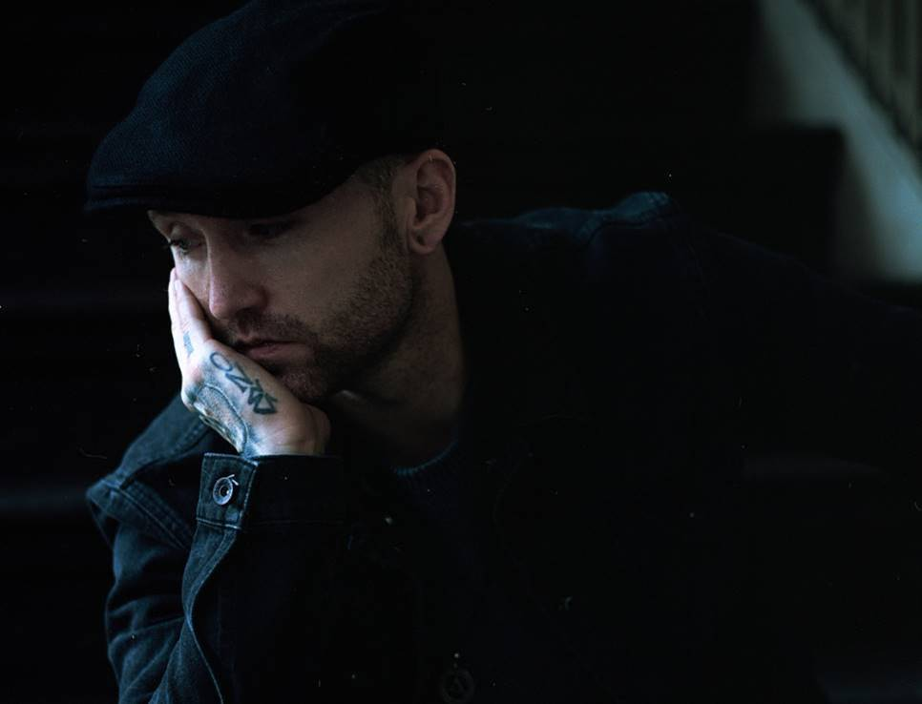

[DOWNLOAD HIGH-RES IMAGE](http://press.atlanticrecords.com/wp-content/uploads/2018/07/Forest-Love-Me-Press-Shot.jpg)

**CONNECT:**

[TWITTER](https://twitter.com/forestblakk) | [FACEBOOK](https://www.facebook.com/forestblakk) | [INSTAGRAM](https://www.instagram.com/forestblakk) | [YOUTUBE](https://www.youtube.com/channel/UC9vKX9Hz5dGVrhD5v3-UnAQ) | [FORESTBLAKK.COM](http://forestblakk.com/)

**CONTACT:**

[ted.sullivan@atlanticrecords.com](mailto:ted.sullivan@atlanticrecords.com)