FOR IMMEDIATE RELEASE
JUNE 26, 2020

FOREST BLAKK RELEASES SIDEWAYS EP

6-TRACK SOPHOMORE EP AVAILABLE NOW VIA ATLANTIC RECORDS,
ALONGSIDE STRIKING TITLE-TRACK VISUALIZER

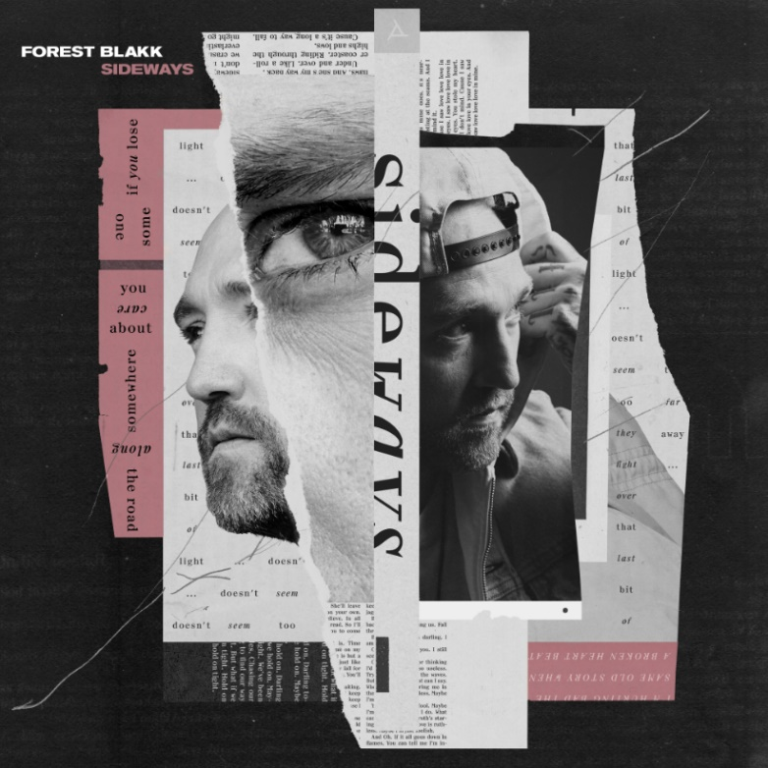
DOWNLOAD HIGH-RES ARTWORK HERE

WATCH “SIDEWAYS” VISUALIZER: https://youtu.be/qADmf9i-ir8
STREAM SIDEWAYS EP: https://forestblakk.lnk.to/SidewaysPR

Singer/songwriter Forest Blakk has released his eagerly anticipated sophomore EP, Sideways – available now via Atlantic Records alongside a striking visualizer for the standout title-track.

Sideways marks an exciting and reflective new chapter for Blakk, seeing him collaborate with the likes of Will IDAP (Train, Florida Georgia Line), Nick Long (King Princess), Carl Ryden (Ricky Martin, David Guetta), Ollie Green (Freya Ridings, Gavin James) & more to tell a love story through an incredibly realistic and candid lens. The 6-track collection includes previously released singles “I Wish I Knew” (deemed an “introspective look at love and love lost” by American Songwriter) and Blakk’s uplifting anthem of resilience “Put Your Hands Up,” which debuted last year on an episode of ABC’s Grey’s Anatomy.

“Sometimes things fall apart while others fall into place. That’s really what this whole EP is about. ‘Sideways’ is my love story, my heartbreak, and everything in-between.” – FOREST BLAKK

Deemed an “artist on the rise” by Billboard, Blakk’s debut EP Minutes featured the standout single “Love Me” and saw editorial support via Parade, Alternative Press, and Ones To Watch. A compelling live performer, Blakk has toured extensively supporting NEEDTOBREATHE, Gavin James and more. He is also set to re-join The Goo Goo Dolls alongside Lifehouse for their “Miracle Pill Summer 2020 Tour,” following the proactive rescheduling of shows due to COVID-19.

***

Before Forest Blakk could sing about loss and love, he had to pull himself back from the brink. Raised by parents with a history of drug use, he has hair-raising tales of his childhood, including an assassination attempt on his father on the family’s front stoop, rooms full of cash, and constant uprooting to places like Jamaica and Florida.

Blakk underwent a spiritual and physical transformation that enabled him to carve a new musical direction that he calls “urban folk,” blending his identity as a city kid with his attraction to artists like Don Henley and Joe Cocker, whose soulfulness and emotionality resonate with him. Now he’s the kind of nimble songwriter who etches new facets into the surfaces of tried and true terrain. Blakk is deeply invested in empowering others to be visible, especially those who feel invisible, as he did as a kid. That his songs are as open-hearted and hopeful as they are is a testament to his personal resilience.

Sideways EP
1. I Wish I Knew
2. Forever And A Day
3. Sideways
4. I Saw Love
5. Put Your Hands Up
6. Hold On Tight

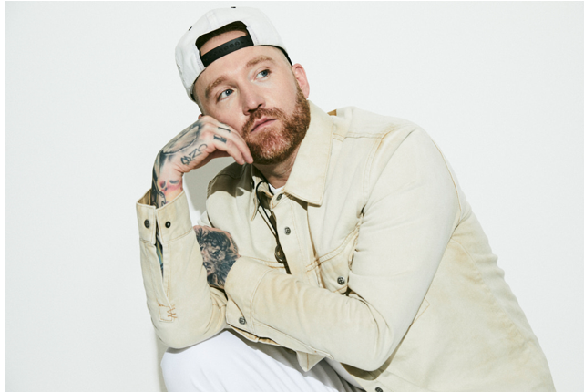
DOWNLOAD HIGH-RES IMAGES HERE

CONNECT:
TWITTER | FACEBOOK | INSTAGRAM | YOUTUBE | FORESTBLAKK.COM

CONTACT:
ted.sullivan@atlanticrecords.com

