GOODY GRACE LOOKS BACK ON HIS JOURNEY ON “USED TO BE”

Vulnerable new song debuts alongside reflective companion visual
featuring never-before-seen footage from Goody’s personal archives

Acclaimed Canadian singer/songwriter/producer prepping
forthcoming new mixtape due out this Fall

WATCH “USED TO BE” MUSIC VIDEO
Directed by Adam Faze; produced by Must B Nice

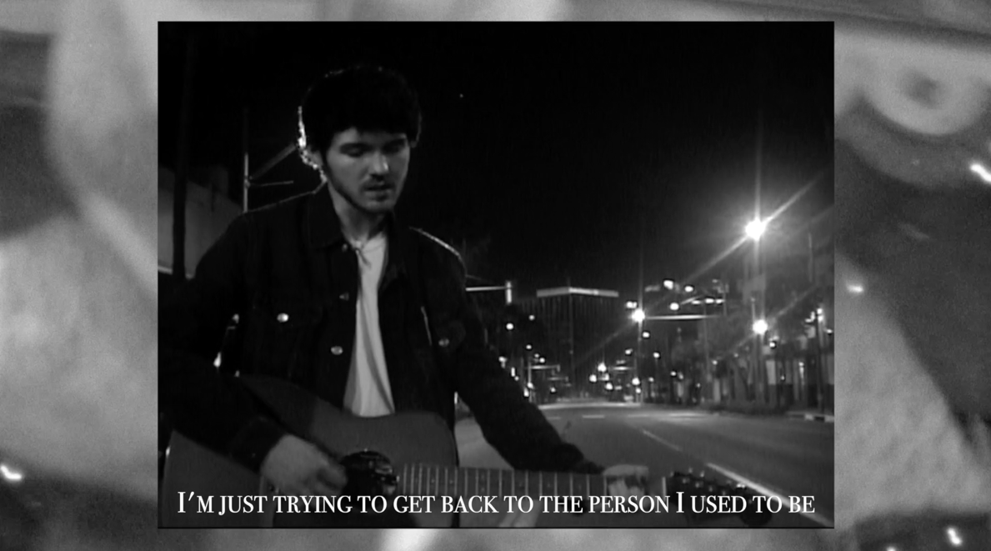

(Los Angeles, CA – July 30, 2020) “Used To Be,” the latest release from rising Canadian singer/songwriter/producer Goody Grace, is out today via Atlantic Records. The vulnerable song arrives alongside a split screen visual directed by longtime friend/collaborator Adam Faze (produced by Must B Nice) and sees Goody performing the song with just his acoustic guitar in the middle of a quiet street, paired with never-before-seen footage captured over the last 3 years. The song is set to appear on Goody’s forthcoming new mixtape, due out this Fall.

DOWNLOAD/STREAM “USED TO BE”
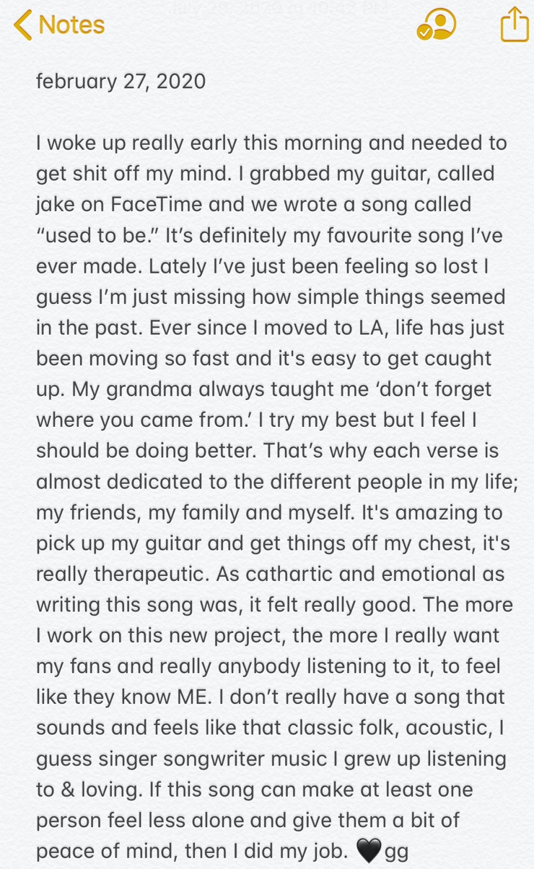

“Used To Be” follows the release of both the middle-finger-to-the-sky anthem “If I Want To” and “Scumbag” featuring pop/punk legends and Goody’s childhood heroes, blink 182. Last week, Goody teamed up with fellow Canadians, acclaimed DJ/producer Takis and chart-topping rapper Tory Lanez for the upbeat, summery single “Wait For Me.”

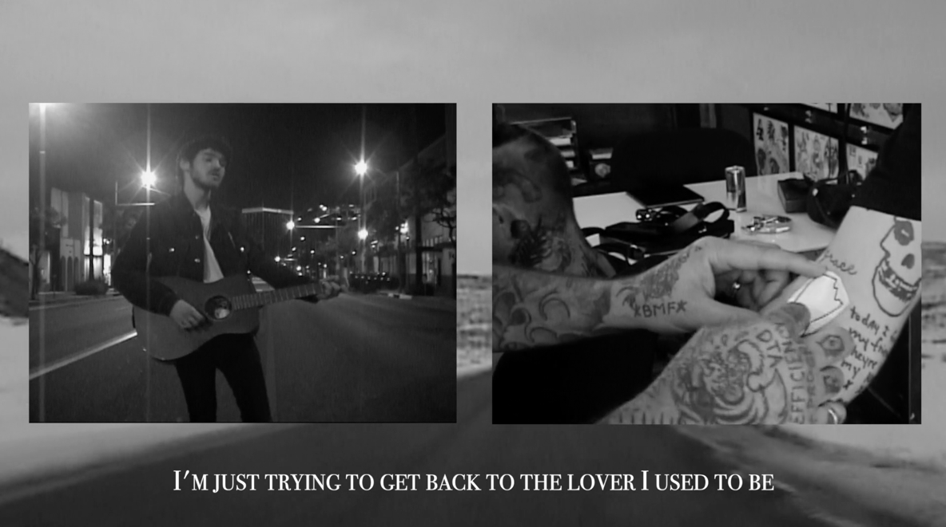

“USED TO BE” LYRICS
(Verse 1)
I’m sorry that I showed up late
Ain’t been keeping track of time
I got so much on my plate
Trying not to lose my mine
Sorry if I say some shit that I mean
I’m just trying to get back to the friend that I used to be

I’m sorry I don’t let you in
It’s a little dark inside
What would happen if you say
Everything behind these eyes
I’ve seen some things I swear to god I wish that I could unsee
I’m just trying to get back to the lover I used to be

(Hook)
‘Cause I’m throwing punches at demons I can’t even see
And I’m putting trust into things that I don’t believe
Sometimes when I look in the mirror it ain’t even me
I’m just trying to get back to the person I used to be

(Verse 2)
I’m sorry that I woke you up
Know I shouldn’t do these drugs
Only you could understand
Just how hard I am to love
I know that you can still see the happy child in me
I’m just trying to get back to the son that I used to be

(Hook)
‘Cause I’m throwing punches at demons I can’t even see
And I’m putting trust into things that I don’t believe
Sometimes when I look in the mirror it ain’t even me
I’m just trying to get back to the person I used to be
Yea, I’m just trying to get back to the person I used to be

* * *

Earlier this year, the 23 year-old singer/songwriter/producer made his national television debut on Jimmy Kimmel Live! performing “Scumbag” alongside blink 182. “Scumbag” has since gone on to dominate Alternative Radio nationwide as the #1 most added song to the format upon its release. The single has received a number of enticing reworks including remixes from DJ MAKJ and viral sensation Absofacto, along with Goody’s intimate acoustic rendition and stripped-down performance of the track, now streaming on VEVO.

* * *

ABOUT GOODY GRACE
Watched over by Halloween, The Smiths, and The Beatles posters and with a Misfits button perennially fastened to his jacket, Goody Grace first concocted an artful hybrid of pop, punk, hip-hop, and folk back in his Selkirk, Manitoba childhood bedroom—roughly 3,170 miles from Los Angeles. Raised by a single mom and grandmother, he hopped on a plane for the first time in 2015 and left the snowy forests of Canada behind for the Southern California sunshine, with just his guitar. Within a few years’ time, Goody has turned his dreams into a reality and is quickly becoming one of the most promising young artists of the decade.

Goody’s 2018 debut INFINITE EP boasted “Two Shots” (feat. gnash), which has amassed over 57 million streams to date. He maintained momentum on a string of singles throughout the following year, including “Too High” (feat. Jesse Rutherford) and “Girls In The Suburbs Singing In Smiths Songs” (feat. G-Eazy). Between touring alongside the likes of blink 182, G-Eazy, The Neighbourhood, Machine Gun Kelly, Charlotte Lawrence, Hoodie Allen, LANY, and Anne-Marie, to name a few, the Canadian tunesmith lit up stages at Bonnaroo, Lollapalooza, and Firefly. Not to mention, he’s garnered praise from Billboard, TIME, Flaunt, Ones To Watch and Alternative Press who claimed, “In a time dominated by genre-smearing artists looking to make the next wild and weird hit, artists can get lost in the obsession to be the most unique. Goody Grace is an artist who actually sticks out of the crowd, because he isn’t trying to.”

Connect with Goody Grace:
WEBSITE | INSTAGRAM | TWITTER | FACEBOOK | YOUTUBE | PRESS ASSETS

# # #

For press inquiries, please contact:
Jessica Nall – Jessica.Nall@atlanticrecords.com
Jason Davis – Jason.Davis@atlanticrecords.com

