FOR IMMEDIATE RELEASE
JUNE 18TH, 2021
MULTI-PLATINUM SUPERSTAR GUCCI MANE CELEBRATES FATHER’S DAY WITH ICE DADDY
STACKED PROJECT INCLUDES FEATURES FROM LIL BABY, LIL UZI VERT, POOH SHIESTY, AND MORE
17-TRACK ALBUM EXECUTIVE PRODUCED BY SON, ICE DAVIS
UPCOMING PERFORMANCE OF “LIKE 34 & 8” ON THE TONIGHT SHOW STARRING JIMMY FALLON

STREAM/DOWNLOAD ‘ICE DADDY’ HERE

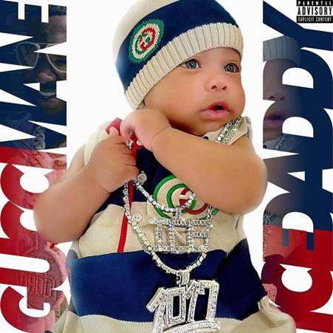

DOWNLOAD PRESS IMAGES HERE

GRAMMY® Award-nominated, multi-platinum superstar Gucci Mane is celebrating Father’s Day early with today’s release of his latest studio album, ICE DADDY. Executive produced by Gucci Mane’s 6-month-old son, Ice Davis, the stacked album includes features from Lil Baby, Lil Uzi Vert, Pooh Shiesty, E-40, 2 Chainz, and more. Highlights include the previously-released “Shit Crazy (feat. Big 30)”, and “Like 34 & 8 (feat. Pooh Shiesty).” ICE DADDY is available now via all DSPs and streaming services HERE.

Global 1017 Records’ own Pooh Shiesty is set to join Gucci Mane for a special performance of “Like 34 & 8” on The Tonight Show Starring Jimmy Fallon. The performance will air Monday, July 21st at 11:35pm ET on NBC- check your local listings for more details.

ICE DADDY marks Gucci Mane’s first album of 2021 and follows the surprise release of his first-ever greatest hits collection: TRAP GOD CLASSICS: I AM MY ONLY COMPETITION. TRAP GOD CLASSICS: I AM MY ONLY COMPETITION compiles 28 of Gucci Mane’s biggest tracks and worldwide fan favorites, including such smashes as the 4x RIAA platinum certified “I Get The Bag (Feat. Migos),” the 3x platinum “Both (Feat. Drake),” and the 3x RIAA platinum certified blockbuster, “Wake Up In The Sky,” alongside Bruno Mars and Kodak Black.

Widely regarded as one of the most influential rappers of the past decade, Gucci Mane has more Top 10 albums on Billboard’s “Top Rap Albums” chart than any other hip-hop artist in history. His most recent releases, compilation mixtapes SO ICY GANG, VOL. 1 and GUCCI MANE PRESENTS: SO ICY SUMMER highlighted by “Both Sides (Feat. Lil Baby)” and “Still Remember (Feat. Pooh Shiesty)”, follow last winter’s release of EAST ATLANTA SANTA 3, the final installment of his EAST ATLANTA SANTA series featuring tracks like “She Miss Me (Feat. Rich The Kid)” and “Tony (Feat. Quavo).” 2019 also saw the release of WOPTOBER II, Gucci’s 15th studio album and monumental 101st project overall. The LP made a top 10 debut on the SoundScan/Billboard 200 upon its October release – Gucci’s seventh top 10 debut thus far – fueled by a string of singles/videos including “Richer Than Errybody (Feat. YoungBoy Never Broke Again & DaBaby)” and “Big Booty (Feat. Megan Thee Stallion).” WOPTOBER II in turn followed the June release of the smash mixtape, DELUSIONS OF GRANDEUR, highlighted by the summer anthems, “Love Thru The Computer (Feat. Justin Bieber),” “Backwards (Feat. Meek Mill),” and “Proud Of You.” The prolific icon’s many other career highlights include such classic albums as 2018’s EVIL GENIUS, 2017’s EL GATO: THE HUMAN GLACIER, and that same year’s RIAA gold certified MR. DAVIS, the latter highlighted by the 4x platinum hit single, “I Get The Bag (Feat. Migos),” joined by a massively popular companion video now boasting 500 million views at Gucci Mane’s official YouTube channel alone. Gucci Mane also released the follow-up to his New York Times bestselling book, The Autobiography of Gucci Mane; The Gucci Mane Guide to Greatness is out now.

Along with new releases from Gucci Mane himself, the seasoned A&R is taking his eye for the next big thing to his own record label, The New 1017, in partnership with Atlantic Records. The New 1017 launched with the signing of fellow Atlanta rapper Foogiano, who was soon followed by further hand-chosen additions of artists Pooh Shiesty, Enchanting, Big Scarr, and BigWalkDog. Compilation mixtape GUCCI MANE PRESENTS: SO ICY SUMMER introduced the fresh crew with collaborations, solo tracks, and features from some of The New 1017’s signees. After just a few months, The New 1017 crew has already seen major success with Pooh Shiesty and Foogiano featured on Rolling Stone’s Breakthrough 25 chart as the 3rd and 5th fastest rising artists of the month of July 2020, respectively, and Big Scarr as #1 in the month of April 2021.

Tracklisting
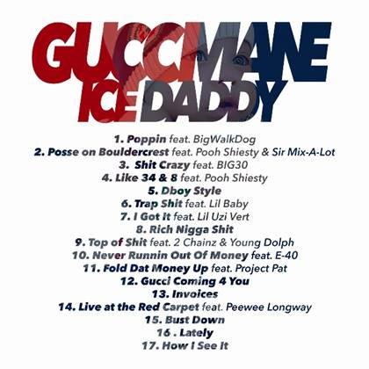

1. “Poppin” feat. BigWalkDog
2. “Posse on Bouldercrest” feat. Pooh Shiesty & Sir Mix-A-Lot
3. “Shit Crazy” feat. BIG30
4. “Like 34 & 8” feat. Pooh Shiesty
5. “Dboy Style”
6. “Trap Shit” feat. Lil Baby
7. “I Got It” feat. Lil Uzi Vert
8. “Rich Nigga Shit”
9. “Top of Shit” feat. 2 Chainz & Young Dolph
10. “Never Runnin Out Of Money” feat. E-40
11. “Fold Dat Money Up” feat. Project Pat
12. “Gucci Coming 4 You”
13. “Invoices”
14. “Live at the Red Carpet” feat. Peewee Longway
15. “Bust Down”
16. “Lately”
17. “How I See It”

CONNECT WITH GUCCI MANE:
OFFICIAL | INSTAGRAM | TWITTER I FACEBOOK I YOUTUBE

GUCCI MANE & 1017 GLOBAL RECORDS PRESS CONTACT:
Ashley Kalmanowitz I Ashley.Kalmanowitz@atlanticrecords.com

