FOR IMMEDIATE RELEASE
AUGUST 18, 2017

GUCCI MANE INTRODUCES “MR. DAVIS”

ICONIC RAPPER ANNOUNCES EAGERLY ANTICIPATED NEW ALBUM

ALBUM PRE-ORDER AVAILABLE EVERYWHERE NOW

NEW TRACK, “GET THE BAG (FT. MIGOS),” PREMIERES TODAY WITH COMPANION VIDEO

UPCOMING LIVE DATES INCLUDE THE WEEKND’S “LEGEND OF THE FALL” TOUR
AND BILLBOARD HOT 100 MUSIC FESTIVAL

“MR. DAVIS” TO BE RELEASED EVERYWHERE FRIDAY, SEPTEMBER 15TH

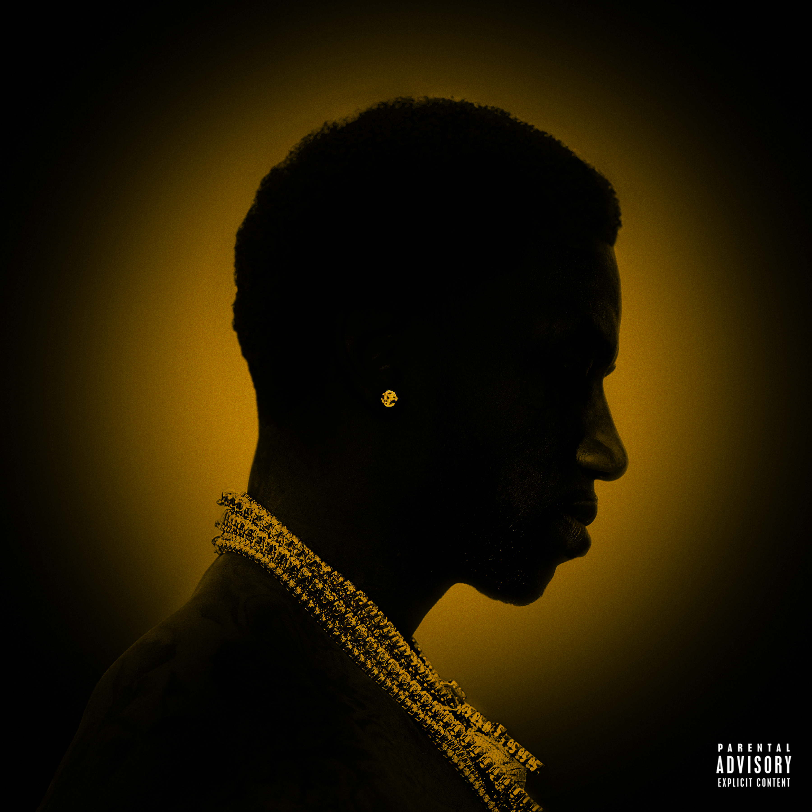

Atlantic recording artist Gucci Mane has announced the release of his eagerly anticipated new album. “MR. DAVIS,” which will be available everywhere on Friday, September 15th.

“MR. DAVIS” is available for pre-order today, with all pre-orders receiving instant grat downloads of the album’s first hits, “Tone It Down (Ft. Chris Brown)” and the just-released “Get The Bag (Ft. Migos).”

“Get The Bag (Ft. Migos)” – which is also available now for streaming and individual purchase – arrives joined by a companion video directed by Eif Rivera. The clip is streaming now at Gucci Mane’s official YouTube channel.

The “Tone It Down (Ft. Chris Brown)” visual landed earlier this month and was instantly named BET Jams “Jam of the Week” amidst copious critical acclamation. Produced by Hitmaka, the single drew instant applause, with The FADER declaring, “The new track has Gucci reminding the people around him that he is not messing around, and that whatever kind of foolishness they're pulling needs to end.”

“MR. DAVIS” follows the release of “DROPTOPWOP,” which was released earlier this year. Produced by Metro Boomin, the mixtape received widespread critical attention, with Pitchfork declaring it to be “their most unhinged music in some time.” “Met Gala (ft. Offset)” has amassed over 54 million streams in just two months after its release.

Gucci Mane has spent much of the past few months on tour, with upcoming dates including this weekend’s Billboard Hot 100 Music Festival, set for Saturday, August 19th at Long Island, NY’s The Grounds at Jones Beach Theater. Additional dates follow, including an eagerly awaited turn as special guest on The Weeknd’s upcoming “Legend of the Fall” arena tour. Those dates begin September 6th at University Park, PA’s Bryce Jordan Center and continue into November. For complete details, please visit GucciManeOnline.com.

Gucci’s first-ever U.S. headline tour, this spring’s “TRAPGOD TOUR” made sold out stops in major markets across the country. Gucci performed at a number of top festivals, including Indio, CA’s Coachella Valley Music & Arts Festival and Texas’ 2017 JMBLYA. What’s more, Gucci recently sold out the inaugural “RapCaviar Live” event in Atlanta, inspired by Spotify’s biggest hip-hop playlist.

A true multi-platform superstar, Gucci Mane will release his much-anticipated memoir September 19th. The Autobiography of Gucci Mane will be published via Simon & Schuster and is available for pre-order now. In addition, his wedding special, Gucci Mane & Keyshia Ka’Oir: The Mane Event, will premiere exclusively via BET Tuesday, October 17th. The 10-episode reality series will follow the power couple as they prepare for what will undoubtedly be the most extravagant celebrity wedding ceremony of the season. For more information re: Gucci Mane & Keyshia Ka’Oir: The Mane Event, please visit BET.com.

As if all that weren’t enough, Gucci Mane recently joined Fifth Harmony for the worldwide hit single, “Down (Feat. Gucci Mane).” Gucci and Fifth Harmony made a series of high profile TV performances supporting the single, including ABC’s Good Morning America and NBC’s The Tonight Show Starring Jimmy Fallon. What’s more, “Down (Feat. Gucci Mane)” is currently an MTV Video Music Award nominee for “Best Pop Video” following its Teen Choice Awards 2017 triumph as “Choice Song: Group.”

Widely ranked among the most gifted rappers of his generation, Gucci has been incredibly productive since his early release from incarceration in May 2016. “EVERYBODY LOOKING” – Gucci’s first studio album in half a decade – arrived soon after and made an incredible chart debut at #1 on Soundscan/Billboard’s Top Current Albums chart; his highest ranking debut to date. Recorded in Atlanta over six days immediately following Gucci’s release from prison, “EVERYBODY LOOKING” includes the hugely popular track releases, “Back,” the Drumma Boy-produced “All My Children,” “No Sleep (Intro),” “Guwop Home (Feat. Young Thug)” and “First Day Out Tha Feds. The latter proved a true pop culture phenomenon, earning close to 1 million SoundCloud plays within the first 12 hours of its May 27th release.

Gucci celebrated the arrival of “EVERYBODY LOOKING” with “Gucci Mane & Friends,” his first full-scale live performance since his release. Held at Atlanta, GA’s world renowned Fox Theatre, the star-studded concert extravaganza saw the Trap God joined by an array of surprise special guests, including Fetty Wap, OJ Da Juiceman, 2 Chainz, Future, and Drake, who personally welcomed Gucci home before busting out versions of “Back On Road” and “Believe It Or Not.” The concert – which was live streamed exclusively online through Revolt TV – received rave reviews across the national media, hailed by Billboard as “yet another win...It’s safe to that Gucci is back (although he never really left) and has reclaimed his Trap God throne.” The Atlanta Journal-Constitution summed it up best: “If anyone doubted it, he’s back.”

Gucci’s third commercial release of 2016, “THE RETURN OF EAST ATLANTA SANTA” dropped just weeks after the arrival of his acclaimed surprise release mixtape, “WOPTOBER.” The latter collection includes such tracks as “Bling Blaww Burr (Feat. Young Dolph),” “Money Machine (Feat. Rick Ross),” and “Aggressive,” each of which are joined by companion video clips streaming now at the OfficialGucciMane YouTube channel.

“THE RETURN OF EAST ATLANTA SANTA” is available now for purchase on the iTunes Stone while streaming exclusively on Apple Music. The album includes blockbuster tracks such as his first platinum hit, “Both (Feat. Drake),” “Last Time (Feat. Travis Scott),” and “Stutter,” all accompanied by official companion videos streaming now on the OfficialGucciMane YouTube channel.

For more news and information, please visit: www.instagram.com/laflare1017, https://twitter.com/gucci1017, www.facebook.com/guccimane, https://www.snapchat.com (@guwopsnaps), www.youtube.com/guccimane, and www.atlanticrecords.com.

# # #

CONTACT:
Ashley Kalmanowitz
212.707.2051
Ashley.Kalmanowitz@atlanticrecords.com

