FOR IMMEDIATE RELEASE

FEBRUARY 26, 2021

**GOODY GRACE RELEASES *DON’T FORGET WHERE YOU CAME FROM***

**CANADIAN SINGER/SONGWRITER/PRODUCER DROPS “ON REPEAT”**

**MUSIC VIDEO FEATURING CIGARETTES AFTER SEX & LEXI JAYDE**

**NEW FULL-LENGTH PROJECT INCLUDES FEATURES FROM G-EAZY, JUICY J, BLINK-182, CIGARETTES AFTER SEX, BURNA BOY & MORE**

[**DOWNLOAD/STREAM *DON’T FORGET WHERE YOU CAME FROM***](https://goodygrace.lnk.to/DFWYCF)

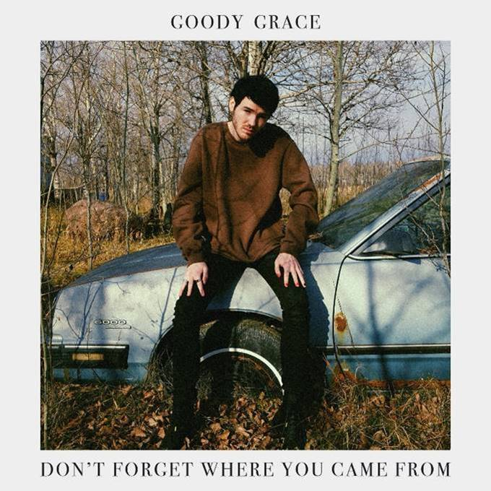

[DOWNLOAD ARTWORK HERE](https://nam04.safelinks.protection.outlook.com/?url=http%3A%2F%2Fpress.atlanticrecords.com%2Fgoody-grace%2F&data=04%7C01%7CBrian.Sommer%40atlanticrecords.com%7Ca99e6854e485470f5b3108d8cd21e912%7C8367939002ec4ba1ad3d69da3fdd637e%7C0%7C0%7C637484892825218129%7CUnknown%7CTWFpbGZsb3d8eyJWIjoiMC4wLjAwMDAiLCJQIjoiV2luMzIiLCJBTiI6Ik1haWwiLCJXVCI6Mn0%3D%7C1000&sdata=PVI2YX9Ml4pVzVpN6nqbwIu1rBNVqJ145p4TMsmWWQU%3D&reserved=0)

*“[Goody has] a signature “cinematic” style, encompassing pop, punk, hip-hop, and folk and nodding to influences as diverse as David Lynch, Danzig, Morrissey, and Watchmen.”*

***-BILLBOARD***

*“[Goody Grace] effortlessly combines stunning indie vocals with upbeat trap rhythms for a unique experience sure to set the stage for a bright musical future … fast approaching the top of alt-pop…”*

*-****ALTERNATIVE PRESS***

*“Symbolic of a modern-day punk rocker, Grace displays originality and unique style on all levels.”*

*-****FLAUNT***

Acclaimed singer-songwriter-producer **Goody Grace** has dropped his first full-length project, ***Don’t Forget Where You Came From***, available now via Atlantic Records – [LISTEN HERE](https://goodygrace.lnk.to/DFWYCF). Inspired by his youth growing up in the remote town of Selkirk, Manitoba, ***Don’t Forget Where You Came From*** is an amalgamation of nostalgia, foresight and the rock, punk, alternative and hip-hop artists that have influenced Goody’s life.

*“The whole record tells the story of the last ten years of my life—from sitting in a classroom in Selkirk, Manitoba, smoking weed, trying to find a way to make something of myself, and freezing my ass off in the cold to going through the trenches without knowing if it would work out, dropping songs, and finally letting people know how I got here on my first full-length.*

*I wouldn’t even be alive if it wasn’t for music. I certainly wouldn’t have left my hometown. If this project inspires one person, who’s lost, to follow a dream, there would be nothing better … because I keep following mine.”*

**-GOODY GRACE**

***Don’t Forget Where You Came From*** also arrives alongside an encapsulating lo-fi visual directed by Kyle Dunleavy & Produced by Zack Stauffer for Goody’s collaboration with **Cigarettes After Sex** and **Lexi Jayde**, **“On Repeat”** – [WATCH HERE](https://www.youtube.com/watch?v=x01QAcYVYsc).

The Canadian musician’s new project contains features from several artists he’s admired and grown close to throughout his career so far, including **G-Eazy**, **Juicy J**, **Cigarettes After Sex**, **blink-182**, **Burna Boy**, **Mr. Hudson**, **Anthony Fantano**, **Bakar** and **Lexi Jayde**.

***Don’t Forget Where You Came From*** was heralded by an impressive string of singles including “[Scumbag](https://atlantic.lnk.to/ScumbagID),” featuring Goody’s childhood heroes **blink-182**, the star-studded [“Nothing Good (Feat. G-Eazy & Juicy J)”](https://goodygrace.lnk.to/NothingGoodID) and the **Burna Boy**-assisted [“Winter,”](https://goodygrace.lnk.to/WinterYA) as well as the solo anthems [“Used To Be,”](https://goodygrace.lnk.to/UsedToBe) [“If I Want To”](https://goodygrace.lnk.to/IfIWantToID) and [“Grape Swisher.”](https://www.youtube.com/watch?v=2Ta-M48Axx)

[*Don’t Forget Where You Came From*](https://goodygrace.lnk.to/DFWYCF)is available now on all major DSPs and streaming services.

[**WATCH “ON REPEAT (FEAT. CIGARETTES AFTER SEX & LEXI JAYDE)” HERE**](https://GoodyGrace.lnk.to/OnRepeatVideo)

*[Directed by: Kyle Dunleavy, Produced by: Zack Stauffer]*

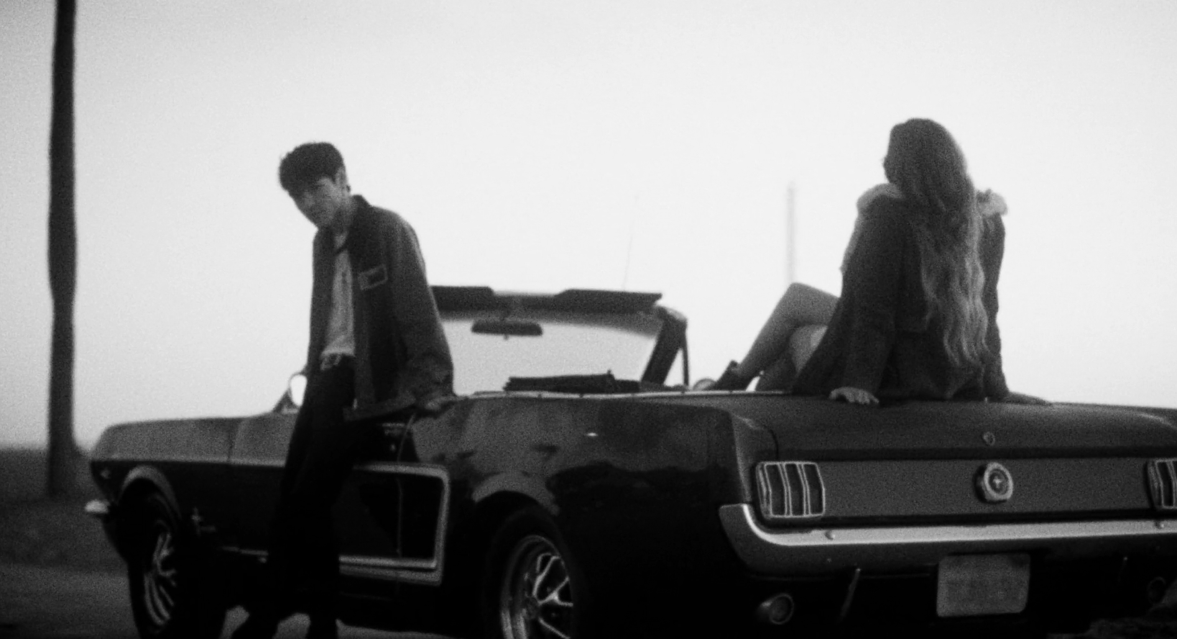

**\*\*\***

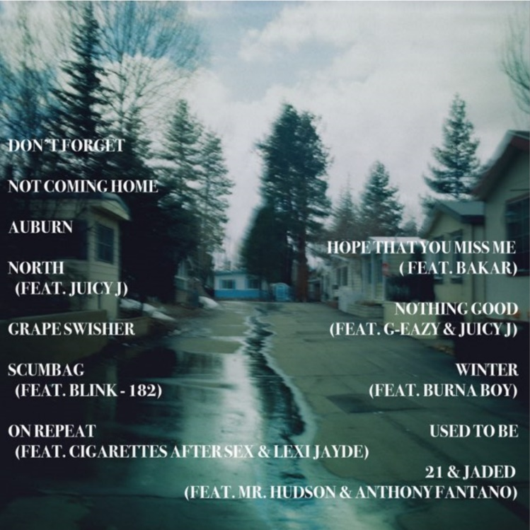

[DOWNLOAD ARTWORK HERE](https://nam04.safelinks.protection.outlook.com/?url=http%3A%2F%2Fpress.atlanticrecords.com%2Fgoody-grace%2F&data=04%7C01%7CBrian.Sommer%40atlanticrecords.com%7Ca99e6854e485470f5b3108d8cd21e912%7C8367939002ec4ba1ad3d69da3fdd637e%7C0%7C0%7C637484892825218129%7CUnknown%7CTWFpbGZsb3d8eyJWIjoiMC4wLjAwMDAiLCJQIjoiV2luMzIiLCJBTiI6Ik1haWwiLCJXVCI6Mn0%3D%7C1000&sdata=PVI2YX9Ml4pVzVpN6nqbwIu1rBNVqJ145p4TMsmWWQU%3D&reserved=0)

***DON’T FORGET WHERE YOU CAME FROM* TRACKLIST:**

1. “Don’t Forget”

2. “Not Coming Home”

3. “Auburn”

4. “North (Feat. Juicy J)”

[5. “Grape Swisher”](https://www.youtube.com/watch?v=2Ta-M48Axx)

[6. “Scumbag (Feat. blink-182)”](https://atlantic.lnk.to/ScumbagID)

[7. “On Repeat (Feat. Cigarettes After Sex & Lexi Jayde)”](https://GoodyGrace.lnk.to/OnRepeatVideo)

8. “Hope That You Miss Me (Feat. Bakar)”

[9. “Nothing Good (Feat. G-Eazy & Juicy J)”](https://goodygrace.lnk.to/NothingGoodID)

[10. “Winter (Feat. Burna Boy)”](https://goodygrace.lnk.to/WinterYA)

[11. “Used To Be”](https://goodygrace.lnk.to/UsedToBe)

12. “21 & Jaded (Feat. Mr. Hudson & Anthony Fantano)”

***

[DOWNLOAD PRESS PHOTO HERE](https://nam04.safelinks.protection.outlook.com/?url=http%3A%2F%2Fpress.atlanticrecords.com%2Fgoody-grace%2F&data=04%7C01%7CBrian.Sommer%40atlanticrecords.com%7Ca99e6854e485470f5b3108d8cd21e912%7C8367939002ec4ba1ad3d69da3fdd637e%7C0%7C0%7C637484892825218129%7CUnknown%7CTWFpbGZsb3d8eyJWIjoiMC4wLjAwMDAiLCJQIjoiV2luMzIiLCJBTiI6Ik1haWwiLCJXVCI6Mn0%3D%7C1000&sdata=PVI2YX9Ml4pVzVpN6nqbwIu1rBNVqJ145p4TMsmWWQU%3D&reserved=0)

[Photo Credit: Marlon LaForte]

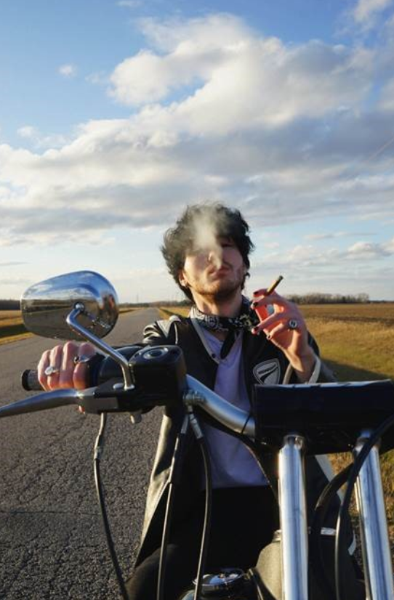

**FOR PRESS INQUIRIES, PLEASE CONTACT**

Jason Davis – [Jason.Davis@atlanticrecords.com](mailto:Jason.Davis@atlanticrecords.com)

Jessica Nall – [Jessica.Nall@atlanticrecords.com](mailto:Jessica.Nall@atlanticrecords.com)

# # #