**GOODY GRACE TAPS G-EAZY & JUICY J FOR “NOTHING GOOD”**

New song follows previous releases “Used To Be,” “If I Want To” and “Scumbag (feat. blink-182)”

[**WATCH “NOTHING GOOD (FEAT. G-EAZY & JUICY J)” MUSIC VIDEO**](https://goodygrace.lnk.to/WatchNothingGood)

Starring: Julia Fox (*Uncut Gems*)

Directed by Adam Faze; produced by Jamie Dolan

Animation by Somnium Animation Studios

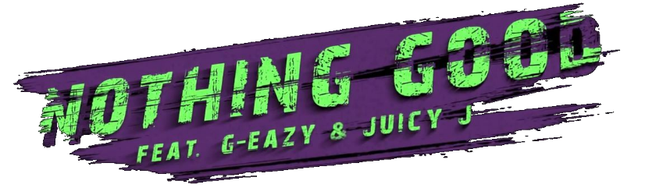

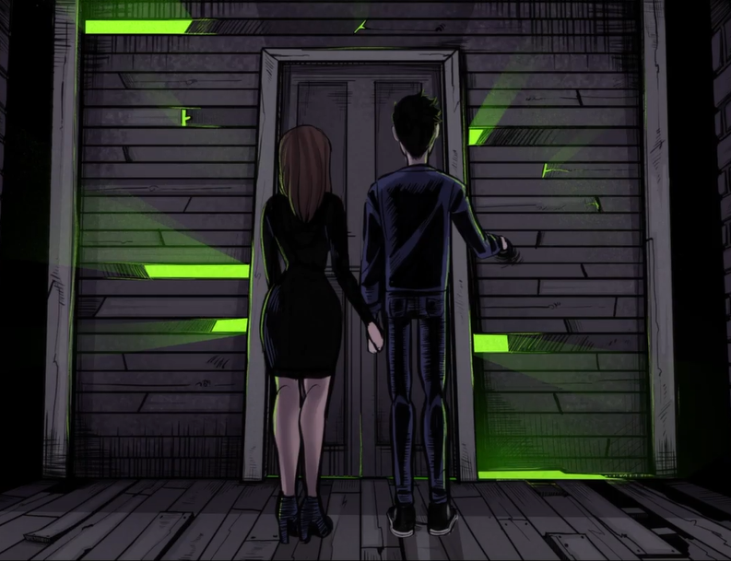

**(Los Angeles, CA – August 21, 2020)** Rising Canadian singer/songwriter/producer **Goody** Grace enlists longtime friend **G-Eazy** and rap legend **Juicy J** for “**Nothing Good**,” out today via Atlantic Records. The new song, produced by The Futuristics, arrives alongside a stunning accompanying video starring *Uncut Gems* actress, **Julia Fox**.

[**STREAM/DOWNLOAD “NOTHING GOOD (FEAT. G-EAZY & JUICY J)**](https://goodygrace.lnk.to/NothingGood)

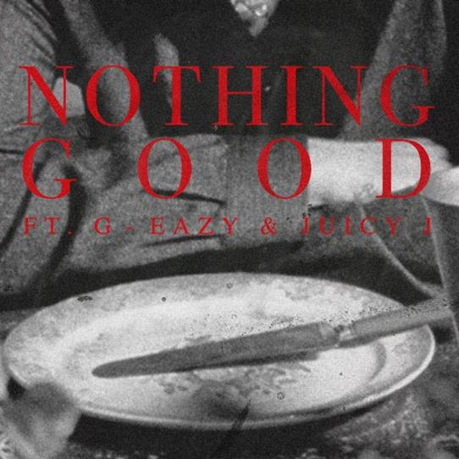

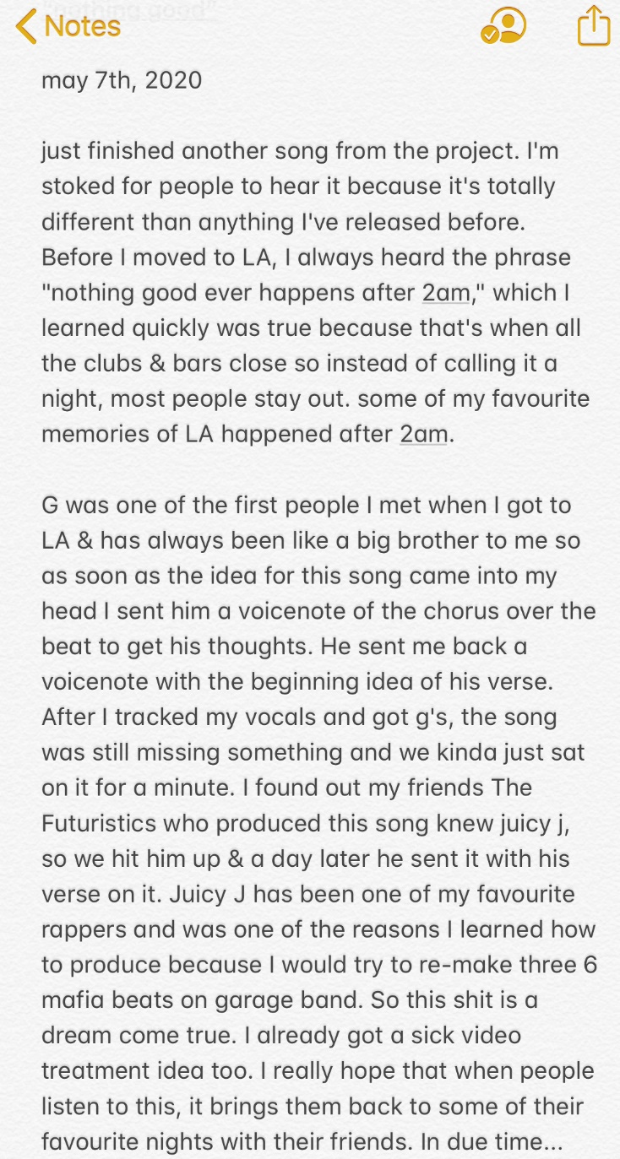

**“Nothing Good”** arrives following a string of previous releases including last month’s, [**“Used To Be,”**](https://nam04.safelinks.protection.outlook.com/?url=https%3A%2F%2Fgoodygrace.lnk.to%2FusedtobePR&data=02%7C01%7CBrian.Sommer%40atlanticrecords.com%7C997c684690964493ad5a08d844acfc92%7C8367939002ec4ba1ad3d69da3fdd637e%7C0%7C0%7C637334857057254845&sdata=ENAzFQha2honPxLWTB5wUQeWZNUTGGFN8YcMLiXqpI0%3D&reserved=0) a vulnerable acoustic ballad, the middle-finger-to-the-sky anthem [**“If I Want To”**](https://nam04.safelinks.protection.outlook.com/?url=https%3A%2F%2Fgoodygrace.lnk.to%2FIfIWantToPR&data=02%7C01%7CBrian.Sommer%40atlanticrecords.com%7C997c684690964493ad5a08d844acfc92%7C8367939002ec4ba1ad3d69da3fdd637e%7C0%7C0%7C637334857057254845&sdata=udfgcN2fv5K%2B%2BslDpVUcpLZ4LN5OQWmX1EJ84fQyCQE%3D&reserved=0) and [**“Scumbag,”**](https://nam04.safelinks.protection.outlook.com/?url=https%3A%2F%2Fatlantic.lnk.to%2FScumbagPR&data=02%7C01%7CBrian.Sommer%40atlanticrecords.com%7C997c684690964493ad5a08d844acfc92%7C8367939002ec4ba1ad3d69da3fdd637e%7C0%7C0%7C637334857057264846&sdata=tCKbGl9mfQky3aaGDjj3tlwj%2BNihT3WT1tWH41k3Bpk%3D&reserved=0) which features pop/punk icons and Goody’s childhood heroes, **blink-182**. Goody also recently teamed up with fellow Canadians, acclaimed DJ/producer **Takis** and chart-topping rapper **Tory Lanez** for the upbeat, summery single “[**Wait For Me**](https://nam04.safelinks.protection.outlook.com/?url=https%3A%2F%2Fyoutu.be%2Fis2tcKvPUOA&data=02%7C01%7CBrian.Sommer%40atlanticrecords.com%7C997c684690964493ad5a08d844acfc92%7C8367939002ec4ba1ad3d69da3fdd637e%7C0%7C0%7C637334857057264846&sdata=kkpxZPWe0m2ZGjPe92eWYWRp%2Bk7Fn7C4mUWFN05PXtk%3D&reserved=0).”

Earlier this year, Goody also made his national television debut on **Jimmy Kimmel Live!** performing **“Scumbag”** alongside **blink-182**. **“Scumbag”** has since gone on to dominate Alternative Radio nationwide as the #1 most added song to the format upon its release. The single has received a number of enticing reworks including remixes from [DJ MAKJ](https://nam04.safelinks.protection.outlook.com/?url=https%3A%2F%2FAtlantic.lnk.to%2FScumbagMAKJ&data=02%7C01%7CBrian.Sommer%40atlanticrecords.com%7C997c684690964493ad5a08d844acfc92%7C8367939002ec4ba1ad3d69da3fdd637e%7C0%7C0%7C637334857057274834&sdata=5M5ClZEZdyHqxqgp%2FNthYLCZZ%2B5%2FlXQsCfqzJ%2FasgaM%3D&reserved=0) and [viral sensation Absofacto](https://nam04.safelinks.protection.outlook.com/?url=https%3A%2F%2FGoodyGrace.lnk.to%2FScumbagABSO&data=02%7C01%7CBrian.Sommer%40atlanticrecords.com%7C997c684690964493ad5a08d844acfc92%7C8367939002ec4ba1ad3d69da3fdd637e%7C0%7C0%7C637334857057274834&sdata=dooDzTWyaMJ%2BlXLBQJHjfqTXJz2t5ZpZLww2Ht7Kwg8%3D&reserved=0), along with Goody’s intimate [acoustic rendition](https://nam04.safelinks.protection.outlook.com/?url=https%3A%2F%2Fgoodygrace.lnk.to%2FScumbagAcoustic&data=02%7C01%7CBrian.Sommer%40atlanticrecords.com%7C997c684690964493ad5a08d844acfc92%7C8367939002ec4ba1ad3d69da3fdd637e%7C0%7C0%7C637334857057284824&sdata=4UQurtA2oKwU4635mCAOarOG4Xda98TAWPuHfU9DwfE%3D&reserved=0) and stripped-down performance of the track, now streaming on [VEVO](https://nam04.safelinks.protection.outlook.com/?url=https%3A%2F%2Fwww.youtube.com%2Fwatch%3Fv%3DGtou8Srv4MQ&data=02%7C01%7CBrian.Sommer%40atlanticrecords.com%7C997c684690964493ad5a08d844acfc92%7C8367939002ec4ba1ad3d69da3fdd637e%7C0%7C0%7C637334857057284824&sdata=vJhnDyYROWH8IKc1VgLKtbYMfG%2BQOnzFtLRooml5GU0%3D&reserved=0).

**ABOUT GOODY GRACE**

Watched over by *Halloween*, The Smiths, and The Beatles posters and with a Misfits button perennially fastened to his jacket, **Goody Grace** first concocted an artful hybrid of pop, punk, hip-hop, and folk back in his Selkirk, Manitoba childhood bedroom—roughly 3,170 miles from Los Angeles. Raised by a single mom and grandmother, he hopped on a plane for the first time in 2015 and left the snowy forests of Canada behind for the Southern California sunshine, with just his guitar. Within a few years’ time, Goody has turned his dreams into a reality and is quickly becoming one of the most promising young artists of the decade.

Goody’s 2018 debut *INFINITE EP* boasted “Two Shots” (feat. gnash), which has amassed over 57 million streams to date. He maintained momentum on a string of singles throughout the following year, including “Too High” (feat. Jesse Rutherford) and “Girls In The Suburbs Singing In Smiths Songs” (feat. G-Eazy). Between touring alongside the likes of blink 182, G-Eazy, The Neighbourhood, Machine Gun Kelly, Charlotte Lawrence, Hoodie Allen, LANY, and Anne-Marie, to name a few, the Canadian tunesmith lit up stages at *Bonnaroo*, *Lollapalooza*, and *Firefly*. Not to mention, he’s garnered praise from Billboard, TIME, Flaunt, Ones To Watch and Alternative Press who claimed, “*In a time dominated by genre-smearing artists looking to make the next wild and weird hit, artists can get lost in the obsession to be the most unique. Goody Grace is an artist who actually sticks out of the crowd, because he isn’t trying to.*”

**Connect with Goody Grace:**

[WEBSITE](https://nam04.safelinks.protection.outlook.com/?url=http%3A%2F%2Fwww.goodygrace.com%2F&data=02%7C01%7CBrian.Sommer%40atlanticrecords.com%7C997c684690964493ad5a08d844acfc92%7C8367939002ec4ba1ad3d69da3fdd637e%7C0%7C0%7C637334857057294818&sdata=wrms7NHnngahqPbMfZ2xW2wiFmypfMihb%2FONJBpLLn4%3D&reserved=0) | [INSTAGRAM](https://nam04.safelinks.protection.outlook.com/?url=http%3A%2F%2Fwww.instagram.com%2Fgoodygrace&data=02%7C01%7CBrian.Sommer%40atlanticrecords.com%7C997c684690964493ad5a08d844acfc92%7C8367939002ec4ba1ad3d69da3fdd637e%7C0%7C0%7C637334857057294818&sdata=fP55H7ZLIdI0mIV2pS18AKRwRJfZ971QW2701nRZjxw%3D&reserved=0) | [TWITTER](https://nam04.safelinks.protection.outlook.com/?url=http%3A%2F%2Fwww.twitter.com%2Fgoodygrace&data=02%7C01%7CBrian.Sommer%40atlanticrecords.com%7C997c684690964493ad5a08d844acfc92%7C8367939002ec4ba1ad3d69da3fdd637e%7C0%7C0%7C637334857057304811&sdata=Zam80EhPziucyq2ezM68N4NxjiEtbae0DVmVH7xyx%2Fc%3D&reserved=0) | [FACEBOOK](https://nam04.safelinks.protection.outlook.com/?url=https%3A%2F%2Fwww.facebook.com%2FGoodyGraceMusic%2F&data=02%7C01%7CBrian.Sommer%40atlanticrecords.com%7C997c684690964493ad5a08d844acfc92%7C8367939002ec4ba1ad3d69da3fdd637e%7C0%7C0%7C637334857057304811&sdata=kRe%2B8RwvYbmMgCB2kHTkSfgFX8ul19Rg9Kg26LbSuh0%3D&reserved=0) | [YOUTUBE](https://nam04.safelinks.protection.outlook.com/?url=https%3A%2F%2Fwww.youtube.com%2Fc%2FGoodyGrace&data=02%7C01%7CBrian.Sommer%40atlanticrecords.com%7C997c684690964493ad5a08d844acfc92%7C8367939002ec4ba1ad3d69da3fdd637e%7C0%7C0%7C637334857057314807&sdata=e3Chnalny0g5sWMZeZLloRKTO340Yxhvq%2BPHX7QnqI4%3D&reserved=0) | [PRESS ASSETS](https://nam04.safelinks.protection.outlook.com/?url=http%3A%2F%2Fpress.atlanticrecords.com%2Fgoody-grace%2F&data=02%7C01%7CBrian.Sommer%40atlanticrecords.com%7C997c684690964493ad5a08d844acfc92%7C8367939002ec4ba1ad3d69da3fdd637e%7C0%7C0%7C637334857057314807&sdata=2rRssfQsT7r9MrljO7X9SbxcRgKLE92Fn9liTZ5psXQ%3D&reserved=0)

# # #

**For press inquiries, please contact:**

Jessica Nall – [Jessica.Nall@atlanticrecords.com](mailto:Jessica.Nall@atlanticrecords.com)

Jason Davis – [Jason.Davis@atlanticrecords.com](mailto:Jason.Davis@atlanticrecords.com)