**GUCCI MANE**

**REVEALS COVER ART FOR HIGHLY ANTICIPATED NEW ALBUM**

***EVIL GENIUS***

***EVIL GENIUS* AVAILABLE DECEMBER 7th**

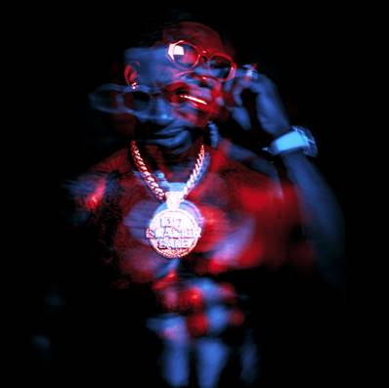

*Photo Credit: Frank Ockenfels*

Gucci Mane has revealed the cover art for his highly anticipated new studio album, *Evil Genius.* Available on December 7th, *Evil Genius* includes the recently released track “[I’m Not Goin’](https://www.youtube.com/watch?v=DEIUzqLFNPM)” featuring Kevin Gates – the video for which already boasts over 4 million views in less than 2 weeks – as well as the smash hit “[Wake Up In The Sky](https://www.youtube.com/watch?v=bS1Nf0syICc)” with Bruno Mars and Kodak Black. The single was recently joined by an official companion video, directed by Mars and streaming now via the official Gucci Mane YouTube channel where it earned over 15 million individual views in just a single week [HERE](https://www.youtube.com/watch?v=U68MJz9DrI4).

*Evil Genius* is also highlighted by track “[Solitaire](https://www.youtube.com/watch?v=f1FX5wvC3DA)” featuring Migos and Lil Yachty, which marked the first single off the album with its release back in March. *Evil Genius* includes some all-star features from Quavo, 21 Savage, Lil Skies, Kevin Gates, and more (see full track list below).

Gucci Mane is currently on the road on his “The Unusual Suspects Tour” with special guest Smokepurpp and support by Hoodrich Pablo Juan. “The Unusual Suspects Tour” kicked off in Brooklyn and travels into late December, wrapping up in Atlanta (see attached itinerary). In addition, Gucci will wrap up another incredible year with a “Gucci & Friends” holiday homecoming event, featuring a stacked lineup of special guests and set for December 27th at Atlanta, GA’s Fox Theater.

*Evil Genius* will mark Gucci Mane’s first full-length release since his prolific 2017 culminated with the acclaimed “[EL GATO: THE HUMAN GLACIER](https://atlantic.lnk.to/ElGatoTheHumanGlacier).” That album followed the RIAA gold certified “[MR. DAVIS](https://atlantic.lnk.to/MrDavis),” highlighted by the 3x platinum hit single, “[I Get The Bag (Feat. Migos),](https://www.youtube.com/watch?v=uo14xGYwWd4&feature=youtu.be)” recently certified platinum by the RIAA and joined by a massively popular companion video, now boasting over *375 million* views at Gucci Mane’s official [YouTube](https://www.youtube.com/user/OfficialGucciMane/featured) channel alone.

Gucci Mane – who recently presented “Best Collaboration” at the 2018 MTV Video Music Awards –recently starred on the cover of [GQ](https://www.gq.com/story/good-word-of-gucci-mane)’s September issue. Other recent cover appearances include [The New York Times Magazine](https://www.nytimes.com/interactive/2018/03/08/magazine/25-songs-future-of-music.html?mtrref=undefined&gwh=29E6022F1FEEEBE742595D08D561E436&gwt=pay)’s March 2018 “25 Songs That Tell us Where Music Is Going” feature.

CONNECT WITH GUCCI MANE:

[INSTAGRAM](http://www.instagram.com/laflare1017)

[TWITTER](https://twitter.com/gucci1017)

[FACEBOOK](http://www.facebook.com/guccimane)

[SNAPCHAT](https://www.snapchat.com/) (@guwopsnaps)

[YOUTUBE](http://www.youtube.com/guccimane)

[ATLANTICRECORDS.COM](http://www.atlanticrecords.com/)

**GUCCI MANE**

**EVIL GENIUS TRACK LIST**

1. Off The Boat
2. By Myself
3. BiPolar ft. Quavo
4. Cold Shoulder ft. YoungBoy Never Broke Again
5. I’m Not Going ft. Kevin Gates
6. On God
7. Outta Proportion
8. Just Like It ft. 21 Savage
9. Wake Up In The Sky with Bruno Mars and Kodak Black
10. Solitaire ft. Migos and Lil Yachty
11. Lord
12. This The Night
13. Mad Russian ft. Lil Skies
14. Money Callin
15. Hard Feelings
16. Dead Broke
17. Lost Y’all Mind ft. Quavo

**GUCCI MANE**

**THE UNUSUAL SUSPECTS TOUR 2018**

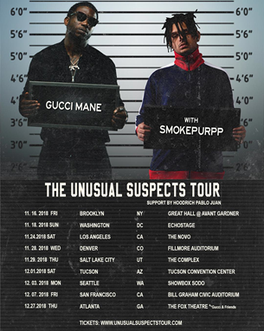

***ALL DATES WITH SMOKEPURPP***

***W/SUPPORT FROM HOODRICH PABLO JUAN EXCEPT \****

**NOVEMBER**

28 – Denver, CO – Fillmore Auditorium

29 – Salt Lake City, UT – The Great Saltair

**DECEMBER**

3 – Seattle, WA – WaMu Theater

5 – Los Angeles, CA – Shrine Expo Hall

7 – San Francisco, CA – Bill Graham Civic Auditorium

27 – Atlanta, GA –  Fox Theatre *\* Gucci & Friends*