FOR IMMEDIATE RELEASE
DECEMBER 7, 2018

GUCCI MANE’S “EVIL GENIUS” ARRIVES TODAY

SUPERSTAR MC RELEASES HIGHLY ANTICIPATED NEW ALBUM

NEW VIDEO FOR “OFF THE BOAT” OUT NOW

LP INCLUDES GOLD CERTIFIED “WAKE UP IN THE SKY” FROM GUCCI MANE X BRUNO MARS X KODAK BLACK, “I’M NOT GOIN’ (FEAT. KEVIN GATES), AND “SOLITAIRE (FEAT. MIGOS & LIL YACHY),

“GUCCI MANE & FRIENDS” HOLIDAY HOMECOMING CONCERT SET FOR
ATLANTA’S FOX THEATRE ON DECEMBER 27TH

“EVIL GENIUS” AVAILABLE ON ALL DSPs NOW

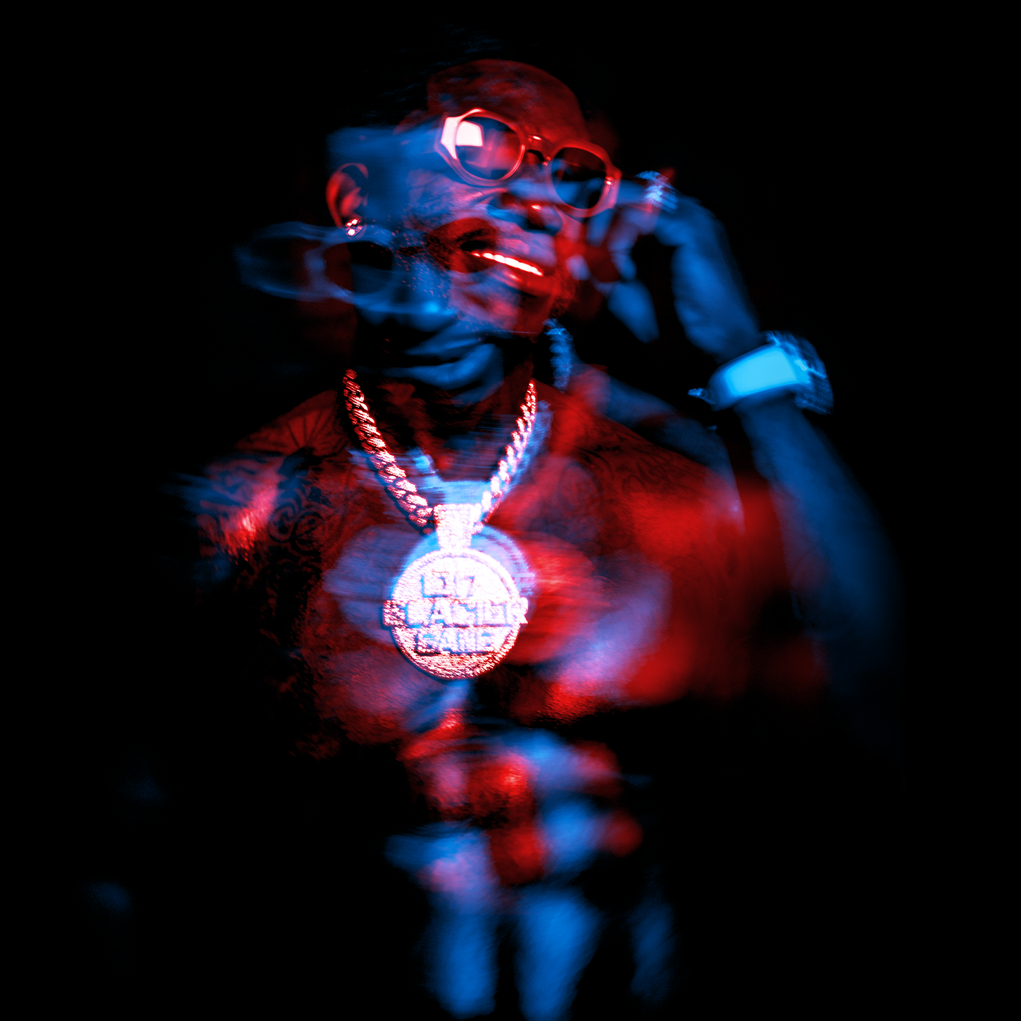

Atlantic recording artist Gucci Mane has officially announced today’s release of his highly anticipated new album. “EVIL GENIUS” is available now at all streaming services HERE. In addition to today’s album release, Gucci Mane has also released the official video for the album’s opener “Off The Boat.”

“EVIL GENIUS” includes an array of hot features – including Quavo, YoungBoy Never Broke Again, 21 Savage, and Lil Skies – alongside such hit singles as Gold certified “Wake Up In The Sky,” with Bruno Mars and Kodak Black, the companion video for which, directed by Mars, has proven a true phenomenon, now with over 48 million individual views. Evil Genius also includes “I’m Not Goin’ (Feat. Kevin Gates)” and “Solitaire (Feat. Migos & Lil Yachty),” both tracks are accompanied by hugely popular companion videos: “Solitaire (Feat. Migos & Lil Yachty)” currently boasts close to 9 million individual YouTube views HERE, while the recently premiered “I’m Not Goin’ (Feat. Kevin Gates)” visual has quickly drawn more than 5 million views HERE.
Earlier this week saw Gucci Mane herald today’s arrival of “EVIL GENIUS” with a high-profile TV appearance on ABC’s Jimmy Kimmel Live! (streaming HERE), featuring a live performance of “I’m Not Goin’” – joined by Kevin Gates.

Gucci Mane has spent the past month celebrating “EVIL GENIUS” on “The Unusual Suspects Tour,” featuring special guest Smokepurpp and support by Asian Doll and Hoodrich Pablo Juan. Gucci Mane will wrap up another incredible year with a “Gucci Mane & Friends” holiday homecoming event, featuring a stacked lineup of special guests and set for December 27th at Atlanta, GA’s Fox Theater – limited tickets remain available HERE.

Additionally, the Evil Genius holiday capsule is now available at Gucci’s official webstore. Items include the exclusive Evil Genius Doppleganger Pullover Hoodie, Dad Hat, and Enamel Pin Set. While supplies last, any physical order from the webstore will receive a free East Atlanta Santa wrapping paper sheet with purchase. Visit the store here: https://1633.lnk.to/EvilGeniusMerchPR

“EVIL GENIUS” marks Gucci Mane’s first full-length release since his prolific 2017 culminated with the acclaimed “EL GATO: THE HUMAN GLACIER.” That album followed the RIAA gold certified “MR. DAVIS,” highlighted by the 3x platinum hit single, “I Get The Bag (Feat. Migos),” recently certified platinum by the RIAA and joined by a massively popular companion video, now boasting over 376 million views at Gucci Mane’s official YouTube channel alone.

“MR. DAVIS” was preceded in May 2017 by “DROPTOPWOP,” featuring the blockbuster single, “Met Gala (Feat. Offset).” Produced by Metro Boomin, the mixtape has been included on a number of year-end lists, among them Noisey’s “The 100 Best Albums of 2017” and Complex’s “The Best Albums of 2017” which hailed the collection as Gucci’s “most darkly compelling collection songs in years – and easily his tightest project.”

Gucci Mane – who recently presented “Best Collaboration” at the 2018 MTV Video Music Awards –recently been featured in GQ’s September issue. Other recent cover appearances include the December issue of 032c Magazine and The New York Times Magazine’s March 2018 “25 Songs That Tell us Where Music Is Going” feature.

CONNECT WITH GUCCI MANE:
INSTAGRAM
TWITTER
FACEBOOK
SNAPCHAT (@guwopsnaps)
YOUTUBE
ATLANTICRECORDS.COM

# # #

GUCCI MANE
“EVIL GENIUS”
(ATLANTIC RECORDS)

TRACKLISTING

- Off The Boat
- By Myself
- BiPolar (Feat. Quavo)
- Cold Shoulder (Feat. YoungBoy Never Broke Again)
- I’m Not Going (Feat. Kevin Gates)
- On God
- Outta Proportion
- Just Like It (Feat. 21 Savage)
- Wake Up In The Sky with Bruno Mars and Kodak Black
- Solitaire (Feat. Migos & Lil Yachty)
- Lord
- This The Night
- Mad Russian (Feat. Lil Skies)
- Money Callin
- Hard Feelings
- Dead Broke
- Lost Y’all Mind (Feat. Quavo)

# # #

Press Contact:
Ashley Kalmanowitz
Ashley.Kalmanowitz@atlanticrecords.com
212.707.2051

