FOR IMMEDIATE RELEASE

MARCH 29, 2018



**HONNE RETURN WITH TWO NEW SOULFUL SINGLES,**

**“DAY 1 ◑ / SOMETIMES ◐”**

**BOTH TRACKS ARE FEATURED ON THE DUO’S FORTHCOMING SOPHOMORE ALBUM, ARRIVING LATER THIS YEAR VIA ATLANTIC RECORDS**

**HONNE HAVE AMASSED OVER HALF A BILLION STREAMS WORLDWIDE**

*“This steamy upstart electro-soul duo purr sweet nothings over lusty beats”* ***– New York Times***

*"A record of sleek, understated electronic pop”* ***–******The FADER***

*“Captivating music that flirts with funk and shines in its quieter moments…captivating and downright refreshing”*  ***– NYLON***

**LISTEN:**

**“**[**DAY 1 ◑/SOMETIMES ◐**](https://lnk.to/DAY1-SOMETIMES?ref=https%3A//www.youtube.com/)**”**   
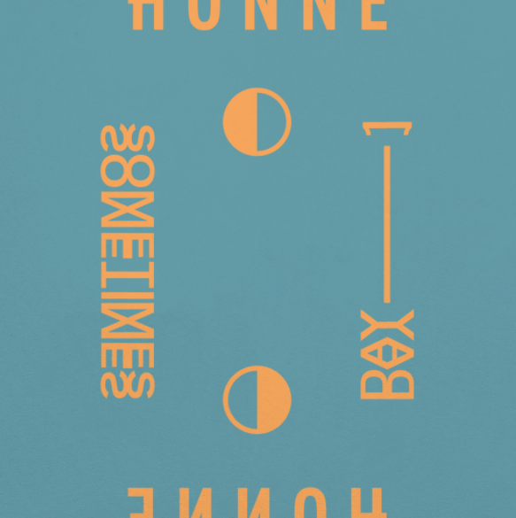

[**[DOWNLOAD ARTWORK]**](https://warnermusicgroup.box.com/s/dk63d202adftr1v49flpdfff3q04ecze)

Critically-acclaimed electro-soul duo, **HONNE** (pronounced “HAHN”), have made their highly-anticipated return with two brand new tracks, “**Day 1 ◑**/**Sometimes ◐”**, - available now via Atlantic Records. Both songs will be featured on the duo’s forthcoming sophomore album due later this year and are now available at all DSPs and streaming services [HERE](https://lnk.to/DAY1-SOMETIMES?ref=https%3A//www.youtube.com/).

**“Day 1 ◑”** and “**Sometimes ◐**” are an intriguing, irresistibly infectious return from **HONNE**. With its assured blend of soul, R&B and courteous romance, “**Day 1 ◑”** is “*fundamentally about loyalty and being with someone right from the beginning,*” says the band, “*it’s the sound of a duo pushing their idiosyncratic sound forward into more confident, beat-driven territory whilst retaining a back-to-basics precision.*

“**Sometimes ◐**,” however, reveals a darker, more self-critical side to **HONNE,** reflecting on all the things you often take for granted in a relationship. Both tracks take you full circle and – much like the tight-knit relationship of Andy & James themselves – are designed to work best when together.

This past year has seen **HONNE** hard at work on their forthcoming sophomore album and follow-up to their acclaimed debut, ‘[**Warm On A Cold Night**’](https://open.spotify.com/album/6hmakfMxhTWYmSUed1HPFA?si=HOSjUAvWR6aOXbwIbmaD0g). The duo’s positive and relatable portraits of twenty-first century romance and modern city living have won them a global audience, amassing over half a billion streams worldwide. Along the way, they have sold out sizable venues across Europe, Asia (the album went triple-platinum in Korea), and the US.

Following an intimate performance at London’s Village Underground, **HONNE’s** blissful live show can be seen at an array of summer festivals. For more information, please visit: <http://hellohonne.com/live/>

**\*\*\***

**HONNE** are singer Andy and multi-instrumentalist James, who first bonded over their shared upbringing in South-West England; followed by the more evocative, US West Coast grooves of their record collections, and a mutual fascination with Japan. During a midnight re-watching of ‘Lost in Translation,’ it became apparent that this sense of a partner at a loose end - of wandering through a strange environment, and struggling to convey what you mean - was just as relevant to their lives off-screen. When James found the word ‘Honne’ later on (a Japanese phrase meaning ‘true feelings’), the boys knew it was theirs. The first song **HONNE** ever finished, 'Warm On A Cold Night', also served as the title for their stunning debut album. And, between the millions of stream and sell-out shows since then, the soulful duo have carved out an instantly-identifiable sound all of their own.

**Connect with HONNE:**

[SOUNDCLOUD](http://www.soundcloud.com/helloHONNE) | [FACEBOOK](http://www.facebook.com/helloHONNE) | [TWITTER](http://www.twitter.com/helloHONNE) | [INSTAGRAM](https://www.instagram.com/hellohonne/?hl=en) | [PRESS ASSETS](http://press.atlanticrecords.com/honne/)

**For press inquiries, please contact:**

Jessica Nall

[Jessica.nall@atlanticrecords.com](mailto:Jessica.nall@atlanticrecords.com)

###