***HAMILTON (ORIGINAL BROADWAY CAST RECORDING)***

**RISES TO #2 ON BILLBOARD’S ‘TOP ALBUMS’ & ‘TOP 200’ CHARTS AFTER MONUMENTAL 250 CONSECUTIVE WEEKS ON CHARTS**

**UNPRECEDENTED MUSICAL COMPANION TO HISTORIC BROADWAY SHOW CELEBRATES NEW MILESTONE WITH UPCOMING 5 YEAR ANNIVERSARY**

***“…one of the most important music moments of the decade.” – Rolling Stone***

[**LISTEN TO *HAMILTON (ORIGINAL BROADWAY CAST RECORDING)* HERE**](https://nam04.safelinks.protection.outlook.com/?url=http%3A%2F%2Fsmarturl.it%2FHamiltonMusic&data=02%7C01%7CBrian.Sommer%40atlanticrecords.com%7C28388782499d459e54f508d824ee8670%7C8367939002ec4ba1ad3d69da3fdd637e%7C0%7C0%7C637299954169738421&sdata=d%2BjyINjWQu2CjjP0JXweE8QIOEaxZ8b8RsqHN%2FUd6VA%3D&reserved=0)

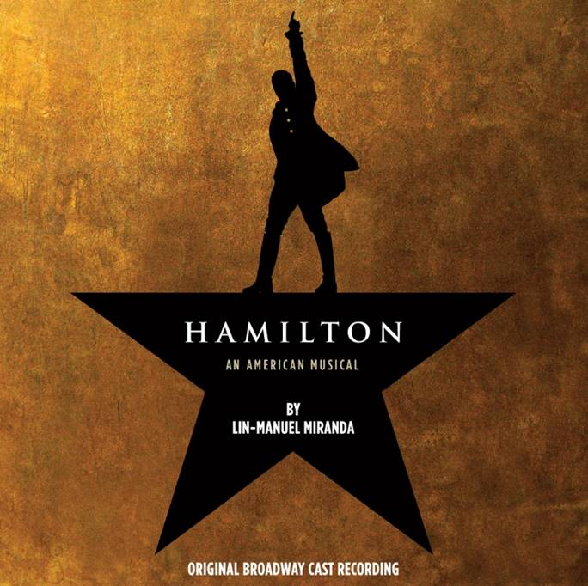

**(New York, NY – July 13, 2020)** Following the highly-anticipated film release of ***HAMILTON*** on **Disney+**, the ***HAMILTON (ORIGINAL BROADWAY CAST RECORDING)*** is once again celebrating a new milestone after the album surged to the #**2** position on the **Billboard 200 Albums Chart** on its **250th consecutive week**, surpassing its previous peak position of #3, shortly after its initial release nearly five years ago. The new peak makes ***HAMILTON (ORIGINAL BROADWAY CAST RECORDING)*** the **highest-charting cast album** since 1969. Propelled by the new movie, the groundbreaking album also soared to **#2** on the **Billboard Top Albums Chart,** with its largest consumption week to date.

Since its release in September 2015, the unprecedented collection has since gone on to become as ground-breaking as it’s theatrical companion, with an astounding **5 Billion streams** to date, **6X-Platinum** certification by the RIAA and the Grammy Award for “Best Musical Theatre Album,” to name a few. The ***HAMILTON (ORIGINAL BROADWAY CAST RECORDING)*** still holds the title for the biggest first week sales for a digital cast recording and the second biggest first week sales ever for any cast recording. What’s more, 22 of the dual-disc album’s 46 songs have earned individual RIAA-certifications; 17 gold & 5 platinum. (see complete list below.)

**Disc 1**

"Alexander Hamilton" – 1X PLATINUM

"Aaron Burr, Sir" – 1X PLATINUM

"My Shot" – 1X PLATINUM

"The Story Of Tonight" – GOLD

"The Schuyler Sisters" – 1X PLATINUM

"Farmer Refuted" – GOLD

"You'll Be Back" – GOLD

"Right Hand Man" – GOLD

"A Winter's Ball" – GOLD

"Helpless" – GOLD

"Satisfied" - 1X PLATINUM

"The Story of Tonight (Reprise)" – GOLD

"Wait For It" – GOLD

"Ten Duel Commandments" - GOLD

"That Would Be Enough"– GOLD

"Guns and Ships" – GOLD

"History Has Its Eyes On You" – GOLD

"Yorktown (The World Turned Upside Down)" – GOLD

"Dear Theodosia" – GOLD

"Non-Stop" – GOLD

**Disc 2**

"The Room Where It Happens"- GOLD

"Burn" – GOLD

***HAMILTON (ORIGINAL BROADWAY CAST RECORDING)*** has been heralded as groundbreaking since its inception, with ***Rolling Stone*** proclaiming the collection as one of the, ***“most important music moments of the decade.”***

To continue Lin-Manuel Miranda’s genre-defying vision for the Hamilton franchise, the ***HAMILTON (ORIGINAL BROADWAY CAST RECORDING)*** was soon followed by the now RIAA Gold-Certified collection, ***THE HAMILTON MIXTAPE***, a revolutionary, first-of-its-kind, re-imagined collection of songs from the Broadway show, performed by some of music’s beloved artists including **Alicia Keys**, **Kelly Clarkson**, **Usher**, **Sia**, **Jimmy Fallon**, **The Roots**, **Chance The Rapper**, **Nas**, **Wiz Khalifa**, **Miguel**, **Queen Latifah**, **Ja Rule**, **Ashanti** and more. The now RIAA Gold-Certified, ground-breaking album includes incredible reimagined versions of fan-favorites including “It’s Quiet Uptown,” “Immigrants (We Get The Job Done)” and the anthemic “My Shot,” to name a few.

*Lin-Manuel Miranda didn’t stop there!* He followed ***THE HAMILTON MIXTAPE*** with ***HAMILDROPS***, a series of special songs and content that were released once a month, for 13 months consecutively, which included a posthumous release and tribute to the late rapper **Prodigy of Mobb Deep**, a stunning visual for **Andra Day’s** reimagined version of “Burn” and concluded with a remake of “One Last Time” featuring original cast member and TONY winner, **Christopher Jackson** and former **President Barack Obama**, who contributed an iconic recitation of a passage from George Washington’s farewell address.

Produced by Alex Lacamoire, Bill Sherman, Lin-Manuel Miranda, and Ahmir “Questlove” Thompson & Tarik “Black Thought” Trotter, founding members of the GRAMMY®-winning hip-hop band, The Roots, *“****HAMILTON (ORIGINAL BROADWAY CAST RECORDING)****”* marks the first album to be mixed and mastered at the legendary Atlantic Records Studio in New York City.

* * *

**ABOUT “HAMILTON”:**

With book, music and lyrics by Lin-Manuel Miranda, direction by Thomas Kail, choreography by Andy Blankenbuehler, music direction/orchestrations by Alex Lacamoire, HAMILTON is based on Ron Chernow’s biography of Founding Father Alexander Hamilton.  The musical won eleven 2016 Tony Awards including Best Musical, Score, Book of a Musical, Direction of a Musical, Choreography and Orchestrations.  Mr. Miranda received the Pulitzer Prize for Drama for HAMILTON. HAMILTON is the story of America’s Founding Father Alexander Hamilton, an immigrant from the West Indies who became George Washington’s right-hand man during the Revolutionary War, and was the new nation’s first Treasury Secretary.  Featuring a score that blends hip-hop, jazz, blues, rap, R&B and Broadway, HAMILTON is the story of America then, told by America now.

HAMILTON is among the most honored works of our time, including a record-setting 16 nominations at the 70th Annual Tony Awards, winning 11, among them “Best Musical.” This year also saw the original cast making indelible performances at both the [70th Annual Tony Awards](https://nam04.safelinks.protection.outlook.com/?url=http%3A%2F%2Fwww.rollingstone.com%2Fculture%2Fnews%2Fwatch-hamilton-casts-thrilling-tony-awards-performance-20160612&data=02%7C01%7CBrian.Sommer%40atlanticrecords.com%7C28388782499d459e54f508d824ee8670%7C8367939002ec4ba1ad3d69da3fdd637e%7C0%7C0%7C637299954169748416&sdata=Hf%2Fl1%2BeYDGB8qzoKyKHOga1DDZL%2FQeZ2CUpekQ%2BDkWc%3D&reserved=0) and the [58th Annual GRAMMY® Awards](https://nam04.safelinks.protection.outlook.com/?url=http%3A%2F%2Fwww.slate.com%2Fblogs%2Fbrowbeat%2F2016%2F02%2F15%2Fwatch_the_cast_of_hamilton_perform_the_musical_s_electrifying_opening_number.html&data=02%7C01%7CBrian.Sommer%40atlanticrecords.com%7C28388782499d459e54f508d824ee8670%7C8367939002ec4ba1ad3d69da3fdd637e%7C0%7C0%7C637299954169748416&sdata=935jKhadUsiiMxW44ci%2FKZhdMSWlLJUPqfe9TCTK08s%3D&reserved=0), where it was named “Best Musical Theatre Album.” In addition, [HAMILTON’S AMERICA](https://nam04.safelinks.protection.outlook.com/?url=http%3A%2F%2Fwww.pbs.org%2Fwnet%2Fgperf%2Fhamiltonfullfilm%2F5801%2F&data=02%7C01%7CBrian.Sommer%40atlanticrecords.com%7C28388782499d459e54f508d824ee8670%7C8367939002ec4ba1ad3d69da3fdd637e%7C0%7C0%7C637299954169758407&sdata=d982YgvjaE6GfK%2BMMFcgVI8hDOdiw7AoRdMQ5sADkQI%3D&reserved=0), a documentary film exploring both the Broadway musical and the man who inspired it, premiered on PBS’ [Great Performances](https://nam04.safelinks.protection.outlook.com/?url=http%3A%2F%2Fwww.pbs.org%2Fwnet%2Fgperf%2Fepisodes%2Fhamiltons-america%2F&data=02%7C01%7CBrian.Sommer%40atlanticrecords.com%7C28388782499d459e54f508d824ee8670%7C8367939002ec4ba1ad3d69da3fdd637e%7C0%7C0%7C637299954169758407&sdata=odPPwVR%2Bd%2BxIjulSSxFVilr3lJJOHRVB00LaGWYA5j0%3D&reserved=0) as part of the 2016 PBS Arts Fall Festival, earning a remarkable viewership of 3.6 million. Other awards include the 2016 Pulitzer Prize for Drama, 10 Lucille Lortel Awards, eight Drama Desk Awards, three Outer Critics Circle Awards, the 2015 New York Drama Critics Circle Award for “Best Musical,” and the prestigious 2015 Obie Award for “Best New American Theatre Work.”

# # #

**Press Contacts:**

Sheila Richman (Atlantic Records) – [Sheila.Richman@atlanticrecords.com](mailto:Sheila.Richman@atlanticrecords.com)

Jason Davis (Atlantic Records) – [Jason.Davis@atlanticrecords.com](mailto:Jason.Davis@atlanticrecords.com)