FOR IMMEDIATE RELEASE

FEBRUARY 27, 2020

**James Blunt takes to the dance floor in “Halfway” ft. Ward Thomas**

**NEW ALBUM *ONCE UPON A MIND* out now**

[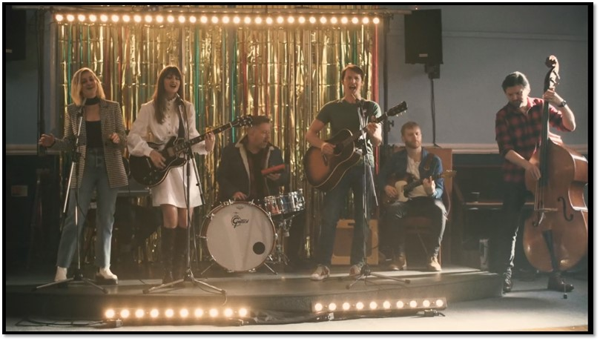](https://nam04.safelinks.protection.outlook.com/?url=https%3A%2F%2Fvimeo.com%2F392967474%2F3de9766747&data=02%7C01%7CTed.Sullivan%40atlanticrecords.com%7C916204767fe7443f03c808d7bb6fb59d%7C8367939002ec4ba1ad3d69da3fdd637e%7C0%7C0%7C637183961546755593&sdata=eHqe%2BaSFpfOVTi8eYS3VJyt942mCRHpkAh53WM5Kydc%3D&reserved=0)

**WATCH “HALFWAY” MUSIC VIDEO:** <https://youtu.be/DexelCs2I5Y>

**STREAM *ONCE UPON A MIND*:** <http://atlanti.cr/OnceUponAMind>

Multi-GRAMMY nominated and multi-platinum British singer/songwriter **James Blunt** has shared the feel good video for “**Halfway**” featuring country pop duo **Ward Thomas**. The original solo version of the track appears on his acclaimed sixth studio album ***Once Upon A Mind***.

Directed by **Dan Massie** (**Ed** **Sheeran**, **Paul** **Weller**, **Rudimental**), the video for “**Halfway”** features fantastic line dance choreography from **Peter Flockhart** and **The Cactus Club** to Blunt and **Ward Thomas**’ effortless harmonies. Peter, who has been teaching line dancing since 1993, set up **The Cactus Club**, an LGBT line dancing social club in Clapham (London), alongside fellow line dance enthusiasts Anne and Michael. The reluctant freestyle dancer is **Nick Hall Lazzerini** who is co-principal at **The Dan Tien Performing Arts Studios** in Watford, UK.

***

After flirting with electronica on his last album (2017’s ***The Afterlove****)*, **James Blunt** returns to what he does best on ***Once Upon A Mind***, writing classic songs that touch both the heart and the head.  The album sees Blunt collaborating with a variety of producers such as **Steve Robson**, **Jimmy Hogarth** and **TMS** – resulting in a freshness that resonates throughout the eleven-song collection, with highlights including first single “**Cold**” (with a music video mirroring the iconic “**You’re Beautiful**” video fourteen years later), the poignant ballad “**Monsters**,” pop-infused “**5 Miles**” and the country tinged “**Halfway**.”

*“I think this is the most honest album I have ever made”* said Blunt. *“’****Back To Bedlam****’ was similar in that I had been writing those songs for a while about my life experiences at that time, and they came together on my debut.  And every song on this album represents something that I’m currently going through or have recently experienced. It’s a very personal record, and I’m proud I can share it.”*

Blunt first captured the world’s attention in 2005 with his 3x RIAA platinum-certified debut, ***Back To Bedlam***, and its history-making 2x platinum-certified #1 single “**You’re Beautiful**.” The British tunesmith has since become one of the most popular singer/songwriters of the modern era, with total album sales now in excess of 23 million worldwide. He has also been the recipient of a remarkable range of top honors, including five GRAMMY nominations, two BRIT Awards, two Ivor Novello Awards (honoring British music and songwriters), and a host of MTV awards. Blunt has also earned viral acclaim for his hugely popular and extremely witty Twitter account, boasting over 1.8 million followers and growing [(@jamesblunt](https://twitter.com/JamesBlunt)). 2020 will also see Blunt embarking on a major UK and European headline tour, his first since performing on the North American leg of **Ed Sheeran**’s ***÷ Tour*** and international headline run in 2017.

**CONNECT:**

[WEBSITE](http://www.jamesblunt.com/) | [FACEBOOK](https://www.facebook.com/jamesblunt) | [TWITTER](https://twitter.com/JamesBlunt) | [INSTAGRAM](http://instagram.com/jamesblunt) | [YOUTUBE](http://www.youtube.com/user/jamesbluntmusic) | [ASSETS](http://press.atlanticrecords.com/james-blunt/)

**CONTACT:**

Sheila Richman | [Sheila.Richman@atlanticrecords.com](mailto:Sheila.Richman@atlanticrecords.com)

Ted Sullivan | [Ted.Sullivan@atlanticrecords.com](mailto:Ted.Sullivan@atlanticrecords.com)