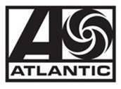

JACK HARLOW RETURNS WITH NEW SINGLE “NAIL TECH”
OUT EVERYWHERE NOW

DOWNLOAD/STREAM | WATCH MUSIC VIDEO

MULTIPLE GRAMMY-NOMINATED RAP SUPERSTAR DEBUTS ENERGETIC COMPANION VISUAL CO-DIRECTED BY JACK HARLOW, FRANK BORIN & ACE PRO

LOUISVILLE NATIVE NAMED AS NEW BALANCE’S LATEST BRAND AMBASSADOR

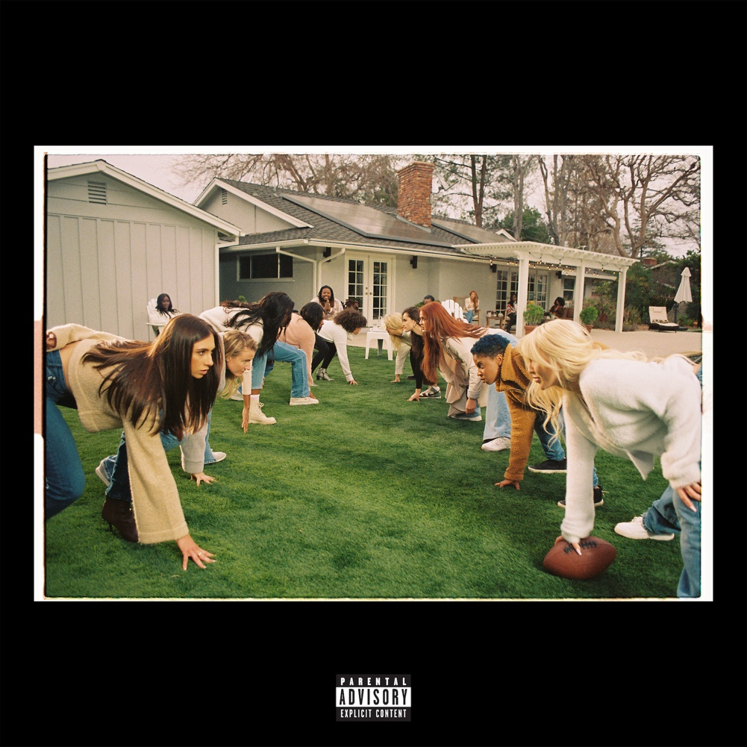
(Photo Credit: Urban Wyatt - download assets)

Produced by Boi 1da for 1da Boi Productions, Coleman, Jahaan Sweet, Fierce, Angel "BabeTruth" Lopez, Rogét Chahayed. Additional production by John Mayer

Music video co-directed by: Jack Harlow, Frank Borin & Ace Pro

(New York, NY – February 18, 2022) Multiple GRAMMY-nominated, chart-topping rap superstar Jack Harlow is back with his new single, “Nail Tech,” out everywhere today via Generation Now/Atlantic Records. The bombastic song arrives alongside a colorful companion visual co-directed by Frank Borin (Lil Nas X, Cardi B), Ace Pro and Jack himself. The song features background vocals from Louisville, KY personality C-Tez, who appears in the music video, as well. “Nail Tech” made its broadcast premiere on MTV Live, MTVU, BET Jams and BET Hip Hop, as well as on the Paramount Global Times Square billboards.

DOWNLOAD/STREAM | WATCH MUSIC VIDEO

“Nail Tech” marks the first solo song from the Louisville-bred rapper since the release of his critically acclaimed, Platinum-certified debut album THATS WHAT THEY ALL SAY in December 2020.

The new single arrives a day after Harlow was announced as the latest brand ambassador for New Balance. “I have been rocking New Balance since I was a kid, so to officially join the brand in this way is really exciting,” says Jack. “I’ve always loved the 990 and recently the Joe Fresh Goods 993 and collabs with the 550’s have been fire. I’m excited to peek behind the curtain and work with the brand more.”

In addition to New Balance, Jack recently joined forces with fellow Kentucky brand KFC for a one-of-a-kind yearlong partnership. He also starred in Tommy Hilfiger’s “Pass The Mic” Fall 2021 campaign.

Harlow’s return comes after a blockbuster 2021, which saw the acclaimed rapper become a household name. In addition to gracing the cover of Variety, Forbes, Complex, SPIN and Footwear News, he made his Saturday Night Live debut, performed with Lil Nas X at the 2021 MTV Video Music Awards, attended the MET Gala, and celebrated his first ever #1 on the Billboard Hot 100 with his GRAMMY-nominated Lil Nas X collaboration, “Industry Baby.”

Harlow also cemented himself as one of music’s most dynamic live performers with standout performances at major festivals including Lollapalooza, Austin City Limits, Rolling Loud and more, all before embarking on his sold-out, North American “Crème de la Crème Tour.” He wrapped up the year by returning to Louisville for his “No Place Like Home” shows, which saw Harlow performing 5 unforgettable shows at 5 iconic venues in his hometown.

The 23-year-old gave back to his hometown with donations to five different organizations that benefit causes close to his heart: AMPED, The Center for Women and Families, Grace James Academy, Louisville Urban League & Metro United Way. Inspired by his initial individual efforts, Instagram and KFC joined Harlow in making additional donations to these organizations.

For all Jack Harlow press inquiries, please contact:
Jason Davis jason.davis@atlanticrecords.com

(Photo Credit: Urban Wyatt – download assets)

* * *

ABOUT JACK HARLOW:
Hailed by The FADER as a “maverick rapper destined for legendary status,” 23-year-old, Louisville, KY native Jack Harlow has quickly become one of music’s biggest stars with nearly 4.5 billion career streams to date. The Generation Now/Atlantic Records rapper has released a project a year, for the last 5 years, the most recent being his RIAA Platinum-Certified, critically acclaimed debut album THATS WHAT THEY ALL SAY. The album features the 6x-Platinum single “WHATS POPPIN,” which earned Harlow his first Grammy nomination, among countless other accolades including nominations at the 2021 Billboard Music Awards, 2021 BET Awards, 2020 MTV Video Music Awards, 2020 E! People’s Choice Awards & 2020 BET Hip Hop Awards.

Harlow has been widely featured in high profile publications ranging from Rolling Stone, Billboard and Complex to GQ, TIME, Interview and Forbes, graced the covers of XXL’s coveted Freshman Class issue, Variety, Complex, SPIN and Footwear News and brought his captivating live show to the masses with national television performances on Saturday Night Live, The Tonight Show Starring Jimmy Fallon, Jimmy Kimmel Live! and more.

For more information on Jack Harlow, please visit: www.jackharlow.us.

# # #

