Janelle Monáe UNVEILS NEW VIDEO FOR “I LIKE THAT” FROM UPCOMING ALBUM

“DIRTY COMPUTER” AVAILABLE EVERYWHERE FRIDAY, APRIL 27TH

Monáe also ANNOUNCES LONG AWAITED RETURN TO THE ROAD WITH

‘Dirty Computer TOUR’ featuring SPECIAL GUEST St. Beauty

Tickets On Sale To General Public Starting Wednesday, May 2 at LiveNation.com

WATCH “I LIKE THAT”
https://janellemonae.lnk.to/ILikeThatVideo
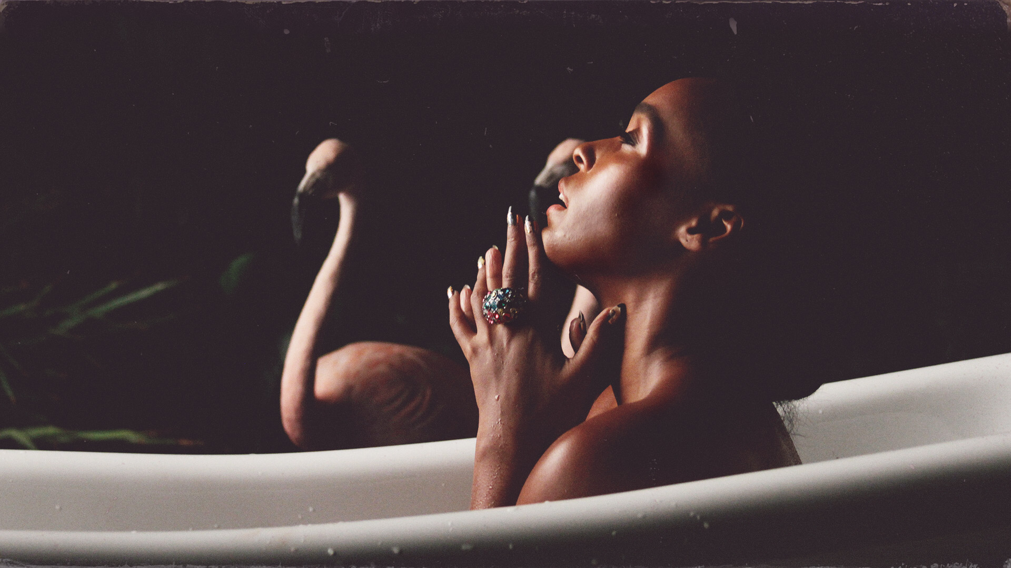

LOS ANGELES (Apr 23, 2018) – GRAMMY®-nominated singer-songwriter, producer, actress, and activist Janelle Monáe has released a brand new music video today for her previously released single “I Like That.

Additionally, Monáe announced her return to touring with her upcoming North American Dirty Computer Tour. Fellow Wondaland artists Alexe Belle and Isis Valentino, known together as the soulful duo St. Beauty, will join the tour as a special guest. Monáe made a big splash with the recent announcement of her upcoming Dirty Computer album, releasing buzzworthy visuals for hot singles “Make Me Feel,” “Django Jane” and “PYNK,” giving fans an exciting peek in to the creative vision for her new music. The 27-city tour produced by Live Nation will kick off June 11 in Seattle, WA and make stops across famous amphitheaters and theaters in Los Angeles, Detroit, Nashville, New York, Atlanta, Miami and more before wrapping August 4 in Atlanta, GA. Tickets will go on sale to the general public beginning Wednesday, May 2 at LiveNation.com.

As an extension of their two year partnership, Monáe and Belvedere Vodka will co-create signature experiences along the tour, including music-inspired cocktails and VIP activations at major tour stops.

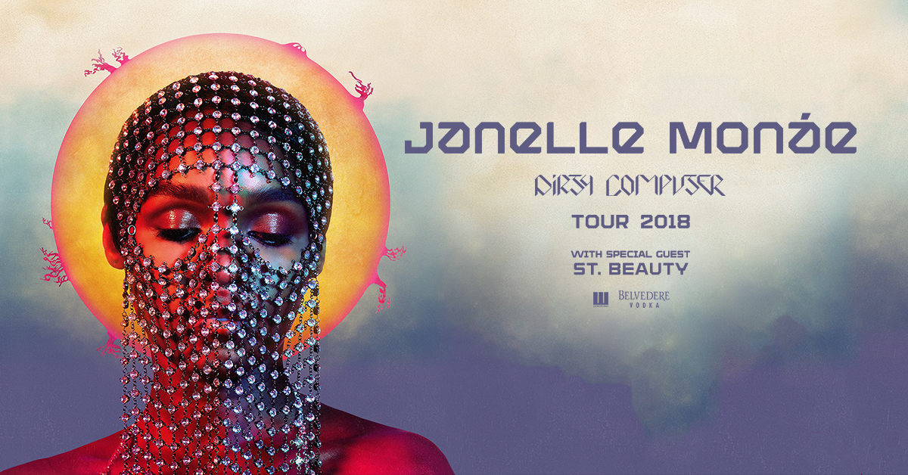

Her highly-anticipated third album Dirty Computer will be released this Friday, April 27th and is available for pre-order now. Every online U.S. ticket purchased for Janelle Monáe's 2018 tour includes a standard digital copy of her new album, Dirty Computer. Instructions on how to redeem a copy will be sent to ticket purchasers via email on release day, April 27th 2018. Notable outlets such as NPR, Billboard, and W Magazine, among others, have praised Monae’s cinematic range and vision on this album. The trailer is streaming now via YouTube and Monáe’s official website.

2016 saw Monáe embark on her film acting career with stellar performances in two milestone films, Hidden Figures and Moonlight; both films received Academy Award nominations for Best Picture, with the latter winning the award at the 89th Academy Awards.

JANELLE MONÁE WITH SPECIAL GUEST ST. BEAUTY ‘DIRTY COMPUTER TOUR’ DATES:
DATE | CITY | VENUE
Mon Jun 11 | Seattle, WA | King County’s Marymoor Park
Tue Jun 12 | Vancouver, BC | Queen Elizabeth Theatre
Wed Jun 13 | Portland, OR | McMenamins Edgefield Amphitheater
Sat Jun 16 | San Francisco, CA | The Masonic
Wed Jun 20 | San Diego, CA | Cal Coast Credit Union Open Air Theatre at SDSU
Thu Jun 28 | Los Angeles, CA | The Greek Theatre
Sat Jun 30 | Salt Lake City, UT | The Complex
Sun Jul 01 | Denver, CO | The Paramount Theatre
Tue Jul 03 | Minneapolis, MN | State Theatre
Thu Jul 05 | Chicago, IL | The Chicago Theatre
Fri July 06 | Milwaukee, WI* | Summerfest*
Sat Jul 07 | Grand Rapids, MI | 20 Monroe Live
Mon Jul 09 | Detroit, MI | Fox Theatre Detroit
Tue Jul 10 | Cincinnati, OH | Taft Theatre
Wed Jul 11 | St. Louis, MO | The Pageant
Fri Jul 13 | Nashville, TN+ | Ryman Auditorium+
Sat Jul 14 | Indianapolis, IN | Murat Theatre at Old National Centre
Mon Jul 16 | Toronto, ON | Rebel
Wed Jul 18 | New York, NY | Hulu Theater at Madison Square Garden
Fri Jul 20 | Washington, DC* | The Anthem*
Sat Jul 21 | Boston, MA | Blue Hills Bank Pavilion
Mon Jul 23 | Raleigh, NC | The Ritz
Tue Jul 24 | Charlotte, NC | The Fillmore Charlotte
Thu Jul 26 | Tampa, FL | Jannus Live
Fri Jul 27 | Miami, FL | The Fillmore Miami at Jackie Gleason Theater
Sat Jul 28 | Orlando, FL | House of Blues Orlando
Sat Aug 04 | Atlanta, GA | Tabernacle

*non-Live Nation date
+on sale beginning May 4

About Janelle Monáe
Janelle Monáe is a Grammy-nominated singer-songwriter, performer, producer, activist and actress. She recently unveiled new details of her highly-anticipated third solo album, DIRTY COMPUTER and the accompanying DIRTY COMPUTER: AN EMOTION PICTURE BY JANELLE MONÁE. The album arrives everywhere Friday, April 27th. Immersed in the performing arts at a young age, Monáe founded her record label the Wondaland Arts Society releasing the EP "Metropolis: Suite I (The Chase)." Monáe previously released critically acclaimed albums “ArchAndroid” and “The Electric Lady.” Additionally, Janelle took her talent to the silver screen, where she starred in the Academy-Award nominated, Hidden Figures and “Best Picture” winner, Moonlight.

About Live Nation Entertainment
Live Nation Entertainment (NYSE: LYV) is the world’s leading live entertainment company comprised of global market leaders: Ticketmaster, Live Nation Concerts, and Live Nation Media & Sponsorship. For additional information, visit www.livenationentertainment.com.

For Janelle Monáe, contact:
NATIONAL - Cara Donatto
cara.donatto@atlanticrecords.com

TOUR/ONLINE - Jessica Nall
Jessica.nall@atlanticrecords.com

For Live Nation, contact:
Emily Bender
EmilyBender@LiveNation.com

Monique Sowinski
MoniqueSowinski@LiveNation.com

