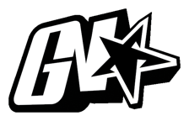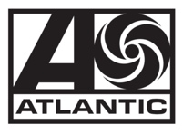

JACK HARLOW ANNOUNCES “NO PLACE LIKE HOME” SHOWS

GRAMMY-NOMINATED RAPPER RETURNS HOME TO LOUISVILLE, KY FOR 5 UNFORGETTABLE NIGHTS AT 5 ICONIC VENUES

HARLOW CELEBRATES FIRST #1 ON BILLBOARD HOT 100
WITH LIL NAS X COLLAB “INDUSTRY BABY”

ARTIST PRE-SALE BEGINS TOMORROW, OCTOBER 20 AT 10AM EST
GENERAL ON-SALE BEGINS THIS FRIDAY, OCTOBER 22 AT 10AM EST

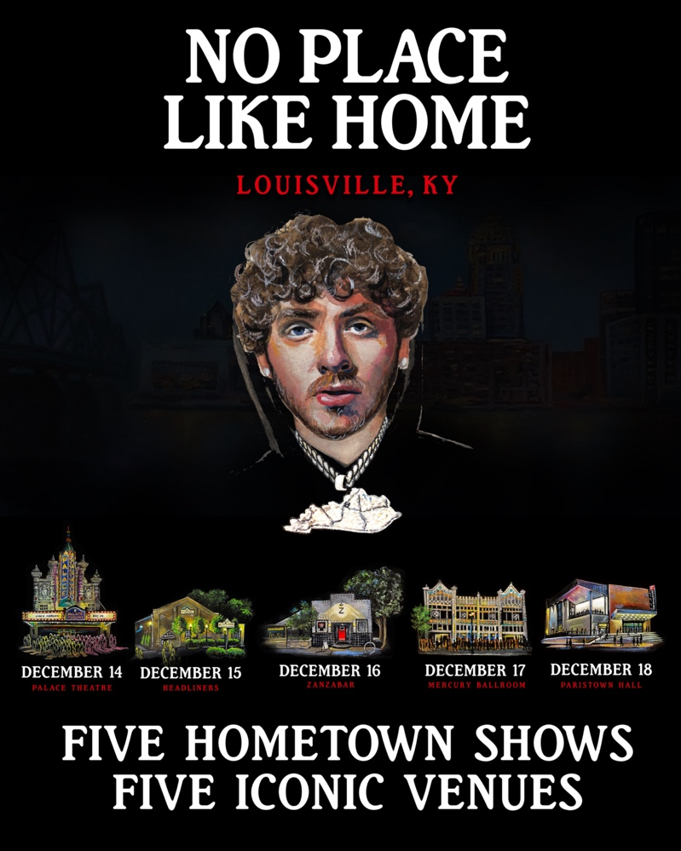

(October 19, 2021 – New York, NY) GRAMMY-nominated rapper Jack Harlow has announced plans to return home to Louisville, KY this December, for his “No Place Like Home” shows. The “No Place Like Home” dates will see the 23-year-old performing 5 unforgettable shows at 5 iconic venues, kicking off December 14th at The Palace Theatre and concluding on December 18 at Old Forester’s Paristown Hall.

DECEMBER 14 – PALACE THEATRE
DECEMBER 15 – HEADLINERS
DECEMBER 16 – ZANZABAR
DECEMBER 17 – MERCURY BALLROOM
DECEMBER 18 – OLD FORESTER’S PARISTOWN HALL

Live Nation will join Harlow’s recent philanthropic efforts in Louisville, by donating $1 from each ticket sold to Harlow’s shows this year, to one of the five Louisville organizations he recently donated to. Earlier this month, Harlow gave back to Louisville with donations to five different organizations that benefit causes close to his heart: AMPED, The Center for Women and Families, Grace James Academy, Louisville Urban League & Metro United Way. Inspired by his initial individual efforts, Instagram and KFC joined Harlow in making additional donations to these organizations.

Fans can get early access to tickets to the “No Place Like Home” shows beginning tomorrow, Wednesday, October 20 at 10am EST until Thursday, October 21 at 10pm EST at https://jackharlow.tix.to/NoPlaceLikeHomeTour. Tickets go on sale to the general public this Friday, October 22 at 10am EST at https://jackharlow.tix.to/NoPlaceLikeHomeTour.

The “No Place Like Home” shows will wrap what has been an incredible year for the Generation Now/Atlantic Records rising superstar, who is currently celebrating his first ever #1 on the Billboard Hot 100 with “Industry Baby,” his explosive collaboration with Lil Nas X, which the duo performed at the 2021 MTV Video Music Awards. Other live show highlights include headlining his first sold-out tour in nearly 2 years and performing acclaimed sets to seas of screaming fans at some of the biggest festivals including Lollapalooza, Austin City Limits, Bottle Rock, Atlanta’s Music Midtown, to name a few.

On top of this, the multi-platinum rapper made his Saturday Night Live debut, performed songs from his debut album THATS WHAT THEY ALL SAY for NPR’s Tiny Desk, graced the covers of Complex, SPIN and Footwear News, attended the coveted MET Gala and appeared in Tommy Hilfiger’s “Pass The Mic” Fall 2021 campaign.

For all press inquiries, please contact:
Jason Davis – jason.davis@atlanticrecords.com

* * *

ABOUT JACK HARLOW:
Hailed by The FADER as a “maverick rapper destined for legendary status,” 23-year-old, Louisville, KY native Jack Harlow has quickly become one of music’s biggest stars with over 3 billion career streams to date. The Generation Now/Atlantic Records rapper has released a project a year, for the last 5 years, the most recent being his RIAA Gold-Certified, critically acclaimed debut album THATS WHAT THEY ALL SAY. The album features the 6x-Platinum single “WHATS POPPIN,” which earned Harlow his first Grammy nomination, among countless other accolades including nominations at the 2021 Billboard Music Awards, 2021 BET Awards, 2020 MTV Video Music Awards, 2020 E! People’s Choice Awards & 2020 BET Hip Hop Awards.

Harlow has been widely featured in high profile publications ranging from Rolling Stone, Billboard and Complex to GQ, TIME, Interview and Forbes, graced the covers of XXL’s coveted Freshman Class issue, Complex, SPIN and Footwear News and brought his captivating live show to the masses with national television performances on Saturday Night Live, The Tonight Show Starring Jimmy Fallon, Jimmy Kimmel Live! and more.

For more information on Jack Harlow, please visit: www.jackharlow.us.

# # #

