JACK HARLOW CELEBRATES NEW RIAA CERTIFICATIONS ON THE HEELS OF WRAPPING SOLD-OUT HEADLINING TOUR

GRAMMY-NOMINATED RAPPER TO BE HONORED AS THE “HITMAKER OF TOMORROW” AT VARIETY’S ANNUAL HITMAKERS EVENT ON DECEMBER 4

NEXT UP, HARLOW HEADS HOME TO LOUISVILLE, KY FOR
5-NIGHT “NO PLACE LIKE HOME” SHOWS AT 5 ICONIC VENUES

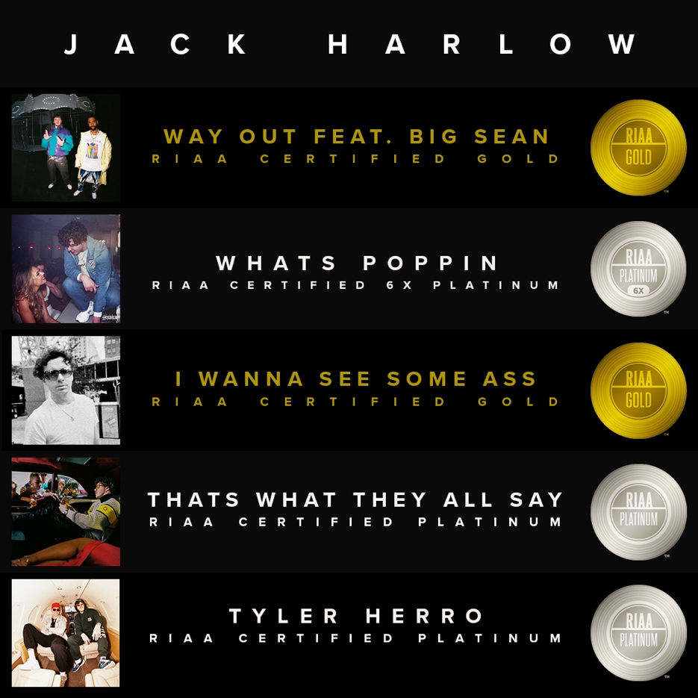

(November 22, 2021 – New York, NY) GRAMMY-nominated rapper Jack Harlow continues his incredible year with a set of new RIAA certifications, including the platinum certification of his debut album, THATS WHAT THEY ALL SAY, released in December 2020. In addition to this, stand out songs “Way Out (feat. Big Sean)” and “Tyler Herro,” earn Gold and Platinum certification, respectively, while fan favorite “I WANNA SEE SOME ASS,” from his March 2020, Sweet Action EP becomes certified gold, while his GRAMMY-nominated break out hit single, “WHATS POPPIN” becomes 6x-platinum certified.

WHATS POPPIN – 6x Platinum
‘THATS WHAT THEY ALL SAY’ – Platinum
TYLER HERRO – Platinum
WAY OUT (feat. Big Sean) – Gold
I WANNA SEE SOME ASS – Gold

Up next, on December 4, Harlow will be honored as the “Hitmaker of Tomorrow” at Variety’s 5th Annual Hitmakers Event, celebrating the magazine’s Hitmakers Issue, which recognizes the writers, producers, publishers, managers and executives who helped make and break the 25 most consumed songs of the year.

These new accolades come as Harlow wrapped his sold-out, headlining “The Crème de la Crème Tour,” and just before he heads home to Louisville, KY for his “No Place Like Home” shows this December. The “No Place Like Home” shows will see the 23-year-old rapper performing 5 unforgettable shows at 5 iconic venues, kicking off December 14th at The Palace Theatre and concluding on December 18 at Old Forester’s Paristown Hall. Harlow will end 2021 with shows at Atlanta’s Coca-Cola Roxy on December 28 and New York City’s Terminal 5 on December 30, both of which are already sold-out.

The “No Place Like Home” shows will wrap what has been an incredible year for the Generation Now/Atlantic Records rising superstar, who celebrated his first ever #1 on the Billboard Hot 100 with “Industry Baby,” his explosive collaboration with Lil Nas X, which the duo performed at the 2021 MTV Video Music Awards. Other live show highlights include acclaimed performances at some of the biggest festivals including Lollapalooza, Austin City Limits, Bottle Rock, Atlanta’s Music Midtown, to name a few.

On top of this, the multi-platinum rapper made his Saturday Night Live debut, performed songs from his debut album THATS WHAT THEY ALL SAY for NPR’s Tiny Desk, graced the covers of Complex, SPIN and Footwear News, attended the coveted MET Gala and appeared in Tommy Hilfiger’s “Pass The Mic” Fall 2021 campaign.

For all press inquiries, please contact:
Jason Davis – jason.davis@atlanticrecords.com

* * *

ABOUT JACK HARLOW:
Hailed by The FADER as a “maverick rapper destined for legendary status,” 23-year-old, Louisville, KY native Jack Harlow has quickly become one of music’s biggest stars with nearly 4 billion career streams to date. The Generation Now/Atlantic Records rapper has released a project a year, for the last 5 years, the most recent being his RIAA Platinum-Certified, critically acclaimed debut album THATS WHAT THEY ALL SAY. The album features the 6x-Platinum single “WHATS POPPIN,” which earned Harlow his first Grammy nomination, among countless other accolades including nominations at the 2021 Billboard Music Awards, 2021 BET Awards, 2020 MTV Video Music Awards, 2020 E! People’s Choice Awards & 2020 BET Hip Hop Awards.

Harlow has been widely featured in high profile publications ranging from Rolling Stone, Billboard and Complex to GQ, TIME, Interview and Forbes, graced the covers of XXL’s coveted Freshman Class issue, Complex, SPIN and Footwear News and brought his captivating live show to the masses with national television performances on Saturday Night Live, The Tonight Show Starring Jimmy Fallon, Jimmy Kimmel Live! and more.

For more information on Jack Harlow, please visit: www.jackharlow.us.

# # #

