FOR IMMEDIATE RELEASE
JULY 16, 2021

James Blunt Announces A Stellar Career-Spanning Greatest Hits Album & February 2022 UK Arena Tour
'The Stars Beneath My Feet (2004-2021)’ Out November 19th
Includes four new studio songs & four exclusive live tracks
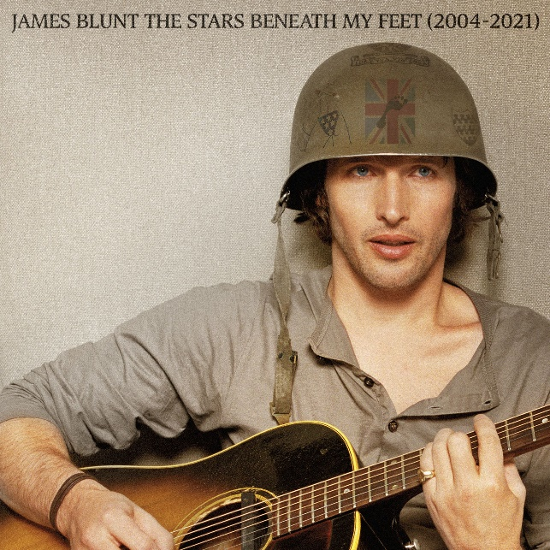

James Blunt today announces a special greatest hits album, The Stars Beneath My Feet (2004-2021) – out November 19th on Atlantic Records – alongside a huge UK arena tour for 2022 which will see James celebrate songs spanning a stellar 17-year career that has spawned over 23 million album sales, a global smash hit with “You’re Beautiful,” two Brit Awards and two Ivor Novello Awards, as well as receiving five GRAMMY Award nominations.
Amongst the string of hit singles, The Stars Beneath My Feet (2004-2021) will also include four new songs (“Love Under Pressure,” “Unstoppable,” “Adrenaline” & “I Came For Love”), as well as four exclusive live performances from around the world, including the Glastonbury Festival. It also features stunning tracks from his latest Gold-selling album Once Upon A Mind, including “Cold,” and the heartbreaking ballad for his father, “Monster.”
James reflects; “Amazingly, I’m releasing my Greatest Hits. I wanted to call it ‘Greatest Hit (& Songs I Wish You’d Heard),’ but the good people at Atlantic Records suggested I call it something more sensible, so it’s called ‘The Stars Beneath My Feet.’ If you’d ever wished that James Blunt had only ever released one album – this is that album. It’s 30 awesome songs, including live performances from Glastonbury and elsewhere, and four new songs. To celebrate its release, I’ll be heading out to tour the world all next year. I can’t wait to see you then.”

James’ classic 2004 debut album Back To Bedlam, was recently named as one of the top ten best selling albums of that decade, and with Once Upon A Mind, James Blunt reinforced his reputation for writing honest, emotional songs that people can easily relate to. The album marked a return to what James Blunt does best – writing classic songs that touch both the heart and the head. Another side of James - his wit and charm - have in recent times been showcased via his always engaging Twitter account.

As well as his huge 2022 greatest hits UK arena tour, James Blunt and his band will be one of the highlights of this summer during his string of highly anticipated rescheduled UK dates. The tour includes a must-see date at the Royal Albert Hall on July 23rd, the first full-capacity concert at the venue as part of its 150th anniversary celebrations.

James Blunt 2022 UK arena dates:
Feb 3rd – BRIGHTON, Brighton Centre
Feb 4th – MANCHESTER, AO Arena
Feb 5th – LONDON, SSE Wembley Arena
Feb 7th – CARDIFF, Motorpoint Arena
Feb 8th – HULL, Bonus Arena
Feb 10th – BIRMINGHAM, Resort World
Feb 11th – LEEDS, First Direct Arena
Feb 12th – NOTTINGHAM, Motorpoint Arena
Feb 13th – GLASGOW, SEC Armadillo

The Stars Beneath My Feet (2004-2021)
1. Love Under Pressure
2. 1973
3. Wisemen
4. Same Mistake
5. You’re Beautiful
6. Monsters
7. Tears And Rain
8. Bonfire Heart
9. I Really Want You (live in New York)
10. The Truth
11. Heart To Heart
12. Champions
13. Postcards
14. No Bravery (live in London)
15. Adrenaline
16. Smoke Signals
17. Unstoppable
18. Goodbye My Lover
19. Coz I Love You (live at Glastonbury)
20. So Long, Jimmy
21. Carry You Home
22. The Greatest
23. High
24. Don’t Give Me Those Eyes
25. OK
26. Stay The Night
27. Bartender
28. Cold
29. Where Is My Mind? (live in Paris)
30. I Came For Love
CONNECT:
WEBSITE | FACEBOOK | TWITTER | INSTAGRAM | YOUTUBE | ASSETS

CONTACT:
Sheila Richman | Sheila.Richman@atlanticrecords.com
Ted Sullivan | Ted.Sullivan@atlanticrecords.com

