FOR IMMEDIATE RELEASE

OCTOBER 18, 2019

**James Blunt reveals new track “MOnsters”**

**Multi-GRAMMY nominated & multi-platinum singer/songwriter’s**

**New album *Once Upon A Mind* arrives October 25th**

**MUSIC video for new single “COLD” paying homage to**

**iconic “You’re Beautiful” visual out now**

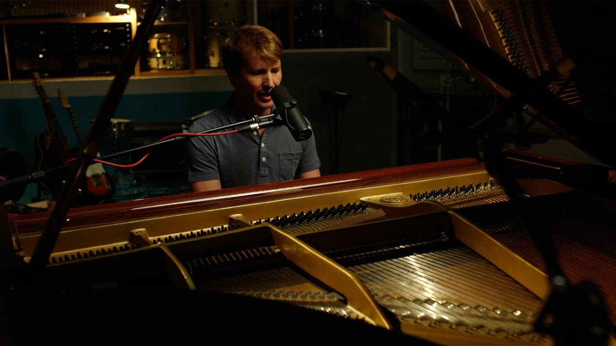

**STREAM “MONSTERS”:** [LINK](https://lnk.to/JB-MonstersPR)

**WATCH “MONSTERS” ACOUSTIC:** [LINK](https://atlanti.cr/Monsters-Video)

**PRE-ORDER *ONCE UPON A MIND*:** [LINK](https://nam04.safelinks.protection.outlook.com/?url=https%3A%2F%2Fatlanti.cr%2FOnceUponAMind&data=02%7C01%7CSophie.Kaplan%40atlanticrecords.com%7C7d170d60a386412a572108d748da4c6f%7C8367939002ec4ba1ad3d69da3fdd637e%7C0%7C0%7C637057974742645477&sdata=bXOOp4TUM5P2CIcUUEKWKu71jL5FwEWWSrckko%2BVuYI%3D&reserved=0)

Multi-GRAMMY nominated and multi-platinum British singer/songwriter **James Blunt** has revealed a fourth new track, “**Monsters**,” off his upcoming sixth studio album ***Once Upon A Mind*** (arriving October 25th via **Custard**/**Atlantic Records**). “**Monsters**” is simple, minimal and stark. A heart-breaking ode from a son to his father, the track showcases Blunt’s emotional vocal line at its strongest and is sure to reduce even the most resilient to tears.

On the track Blunt reflects, *“’****Monsters****’ is a song for my father who I idolized as a child, has been my best friend through adult life, and now urgently needs an O positive kidney donor."*

Blunt’s current single “**Cold**” has already amassed over 7.7 million streams since release last month. The **Calum** **Macdiarmid**-directed visual mirrors the iconic visual for Blunt’s debut global hit single “**You’re Beautiful**,” finding the tunesmith washed ashore fourteen years after his iconic dive into the water in the same clothes and scaling cliffs for moments of jaw-dropping tension with no stunt doubles involved. Fans will be able to connect the dots as he pays further homage, picking up original items from the 2005 video during his ascent before his eventual airlift to safety.

***

After flirting with electronica on his last album (2017’s ***The Afterlove****)*, **James Blunt** returns to what he does best on ***Once Upon A Mind***, writing classic songs that touch both the heart and the head.  The album sees Blunt collaborating with a variety of producers such as **Steve Robson**, **Jimmy Hogarth** and **TMS** – resulting in a freshness that resonates throughout the eleven-song collection, with highlights including the poignant ballad “**Monsters**,” pop-infused “**5 Miles**” and the country tinged “**Halfway**.”

*“I think this is the most honest album I have ever made”* said Blunt. *“’****Back To Bedlam****’ was similar in that I had been writing those songs for a while about my life experiences at that time, and they came together on my debut.  And every song on this album represents something that I’m currently going through or have recently experienced. It’s a very personal record, and I’m proud I can share it.”*

Blunt first captured the world’s attention in 2005 with his 3x RIAA platinum-certified debut, ***Back To Bedlam***, and its history-making 2x platinum-certified #1 single “**You’re Beautiful**.” The British tunesmith has since become one of the most popular singer/songwriters of the modern era, with total album sales now in excess of 23 million worldwide. He has also been the recipient of a remarkable range of top honors, including five GRAMMY nominations, two BRIT Awards, two Ivor Novello Awards (honoring British music and songwriters), and a host of MTV awards. Blunt has also earned viral acclaim for his hugely popular and extremely witty Twitter account, boasting over 1.8 million followers and growing ([@jamesblunt](https://nam04.safelinks.protection.outlook.com/?url=https%3A%2F%2Ftwitter.com%2FJamesBlunt&data=02%7C01%7CSophie.Kaplan%40atlanticrecords.com%7C7d170d60a386412a572108d748da4c6f%7C8367939002ec4ba1ad3d69da3fdd637e%7C0%7C0%7C637057974742645477&sdata=ILzO7uejQpTKbyA3TlQ86HsMH7Fv6pwCbSnp3rrdgI8%3D&reserved=0)). 2020 will also see Blunt embarking on a major UK and European headline tour, his first since performing on the North American leg of **Ed Sheeran**’s ***÷ Tour*** and international headline run in 2017.

***Once Upon A Mind***

(Custard/Atlantic Records)

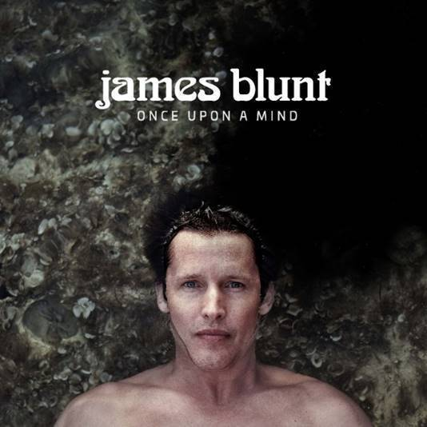

1. The Truth

2. Cold

3. Champions

4. Monsters

5. Youngster

6. 5 Miles

7. How It Feels To Be Alive

8. I Told You

9. Halfway

10. Stop The Clock

11. The Greatest

**CONNECT:**

[WEBSITE](https://nam04.safelinks.protection.outlook.com/?url=http%3A%2F%2Fwww.jamesblunt.com%2F&data=02%7C01%7CSophie.Kaplan%40atlanticrecords.com%7C7d170d60a386412a572108d748da4c6f%7C8367939002ec4ba1ad3d69da3fdd637e%7C0%7C0%7C637057974742655468&sdata=JOSNWbMhvE6ZP5rXhmPTtzvzVjGRXT7nWZlPmIPk%2Bq0%3D&reserved=0) | [FACEBOOK](https://nam04.safelinks.protection.outlook.com/?url=https%3A%2F%2Fwww.facebook.com%2Fjamesblunt&data=02%7C01%7CSophie.Kaplan%40atlanticrecords.com%7C7d170d60a386412a572108d748da4c6f%7C8367939002ec4ba1ad3d69da3fdd637e%7C0%7C0%7C637057974742655468&sdata=V0dM6Cs6rZKnwsxeunGkko75DFBvaRsIW8ankBTe3TE%3D&reserved=0) | [TWITTER](https://nam04.safelinks.protection.outlook.com/?url=https%3A%2F%2Ftwitter.com%2FJamesBlunt&data=02%7C01%7CSophie.Kaplan%40atlanticrecords.com%7C7d170d60a386412a572108d748da4c6f%7C8367939002ec4ba1ad3d69da3fdd637e%7C0%7C0%7C637057974742655468&sdata=turAHCUR3yJNU%2Fu53uZ7rAyhSDd8grdUtd7Xl7pGzCE%3D&reserved=0) | [INSTAGRAM](https://nam04.safelinks.protection.outlook.com/?url=http%3A%2F%2Finstagram.com%2Fjamesblunt&data=02%7C01%7CSophie.Kaplan%40atlanticrecords.com%7C7d170d60a386412a572108d748da4c6f%7C8367939002ec4ba1ad3d69da3fdd637e%7C0%7C0%7C637057974742665467&sdata=G8P9Vz9ECpxpqkX6%2BZUvcRnmkQXRsC%2FOJGCMx5pP%2BeM%3D&reserved=0) | [YOUTUBE](https://nam04.safelinks.protection.outlook.com/?url=http%3A%2F%2Fwww.youtube.com%2Fuser%2Fjamesbluntmusic&data=02%7C01%7CSophie.Kaplan%40atlanticrecords.com%7C7d170d60a386412a572108d748da4c6f%7C8367939002ec4ba1ad3d69da3fdd637e%7C0%7C0%7C637057974742665467&sdata=mr58Qy%2FHmtvHG3vaN1iBsjq2qhbtq4I2nOLSP4WatDQ%3D&reserved=0) | [ASSETS](https://nam04.safelinks.protection.outlook.com/?url=http%3A%2F%2Fpress.atlanticrecords.com%2Fjames-blunt%2F&data=02%7C01%7CSophie.Kaplan%40atlanticrecords.com%7C7d170d60a386412a572108d748da4c6f%7C8367939002ec4ba1ad3d69da3fdd637e%7C0%7C0%7C637057974742675463&sdata=EGmKET7qsS1Fne5lkAXbZ5gqSbjrm0UDuRLY4WQ6GbM%3D&reserved=0)

**CONTACT:**

Sheila Richman | [Sheila.Richman@atlanticrecords.com](mailto:Sheila.Richman@atlanticrecords.com)

Ted Sullivan | [Ted.Sullivan@atlanticrecords.com](mailto:Ted.Sullivan@atlanticrecords.com)