FOR IMMEDIATE RELEASE

JANUARY 15, 2020

**James Blunt Unveils Emotional ‘Monsters’ Video**

**NEW ALBUM *ONCE UPON A MIND* out now**

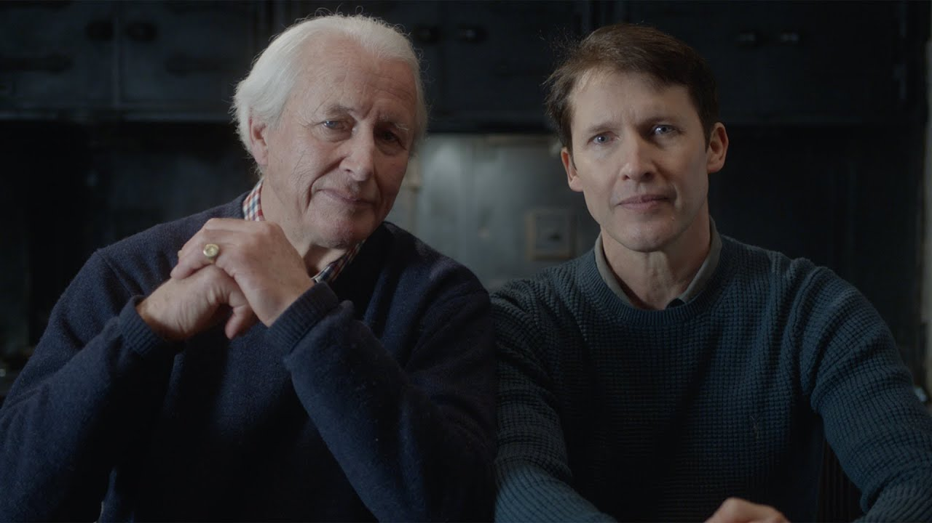

**WATCH “MONSTERS” MUSIC VIDEO:** <https://youtu.be/DTFbGcnl0po>

**STREAM *ONCE UPON A MIND*:** <http://atlanti.cr/OnceUponAMind>

Multi-GRAMMY nominated and multi-platinum British singer/songwriter **James Blunt** has made one of the most compelling videos of his career for his new song “**Monsters**,” one of the highlights from his acclaimed sixth studio album ***Once Upon A Mind***.

Filmed in Oxfordshire and directed by **Vaughan Arnell** (**George Michael**, **One Direction**), the stark and emotive video was conceived by Blunt personally. *“****’Monsters’*** *is for my father who has Stage 4 Chronic Kidney disease, so I asked if he’d like to be in the video with me”* he explained.

The simple, minimal and stirring track is one of the most personal songs Blunt has ever written. A heartbreaking ode from a son to his father, the track showcases his emotional vocal line at its strongest and is certain to reduce even the most resilient to tears. The centuries old, Gothic house where the video was filmed was also home to James Bond in the film ***Quantum of Solace***. Without question, it will certainly be one of the most talked about videos of the year, with Blunt generously donating all royalties to **Help for Heroes** and the **British Legion**.

*“I’m not your son. You’re not my father,*

*We’re just two grown men saying goodbye.*

*No need to forgive. No need to forget.*

*I know your mistakes and you know mine.*

*And while you’re sleeping, I’ll try to make you proud.*

*So daddy, won’t you close your eyes.*

*Don’t be afraid. It’s my turn to chase the monsters away.”*

***

After flirting with electronica on his last album (2017’s ***The Afterlove****)*, **James Blunt** returns to what he does best on ***Once Upon A Mind***, writing classic songs that touch both the heart and the head.  The album sees Blunt collaborating with a variety of producers such as **Steve Robson**, **Jimmy Hogarth** and **TMS** – resulting in a freshness that resonates throughout the eleven-song collection, with highlights including first single “[**Cold**](https://youtu.be/xU4wN8WbTfE)” (with a music video mirroring the iconic “**You’re Beautiful**” video fourteen years later), the poignant ballad “**Monsters**,” pop-infused “**5 Miles**” and the country tinged “**Halfway**.”

*“I think this is the most honest album I have ever made”* said Blunt. *“’****Back To Bedlam****’ was similar in that I had been writing those songs for a while about my life experiences at that time, and they came together on my debut.  And every song on this album represents something that I’m currently going through or have recently experienced. It’s a very personal record, and I’m proud I can share it.”*

Blunt first captured the world’s attention in 2005 with his 3x RIAA platinum-certified debut, ***Back To Bedlam***, and its history-making 2x platinum-certified #1 single “**You’re Beautiful**.” The British tunesmith has since become one of the most popular singer/songwriters of the modern era, with total album sales now in excess of 23 million worldwide. He has also been the recipient of a remarkable range of top honors, including five GRAMMY nominations, two BRIT Awards, two Ivor Novello Awards (honoring British music and songwriters), and a host of MTV awards. Blunt has also earned viral acclaim for his hugely popular and extremely witty Twitter account, boasting over 1.9 million followers and growing [(@jamesblunt](https://twitter.com/JamesBlunt)). 2020 will also see Blunt embarking on a major UK and European headline tour, his first since performing on the North American leg of **Ed Sheeran**’s ***÷ Tour*** and international headline run in 2017.

***Once Upon A Mind***

(Custard/Atlantic Records)

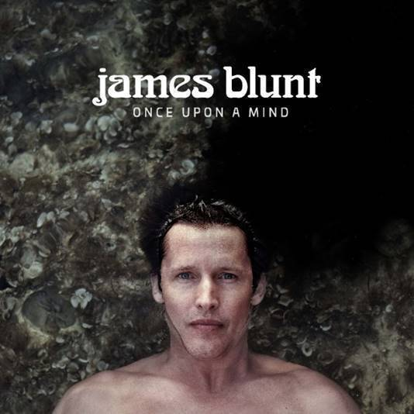

1. The Truth

2. Cold

3. Champions

4. Monsters

5. Youngster

6. 5 Miles

7. How It Feels To Be Alive

8. I Told You

9. Halfway

10. Stop The Clock

11. The Greatest

**CONNECT:**

[WEBSITE](http://www.jamesblunt.com/) | [FACEBOOK](https://www.facebook.com/jamesblunt) | [TWITTER](https://twitter.com/JamesBlunt) | [INSTAGRAM](http://instagram.com/jamesblunt) | [YOUTUBE](http://www.youtube.com/user/jamesbluntmusic) | [ASSETS](http://press.atlanticrecords.com/james-blunt/)

**CONTACT:**

Sheila Richman | [Sheila.Richman@atlanticrecords.com](mailto:Sheila.Richman@atlanticrecords.com)

Ted Sullivan | [Ted.Sullivan@atlanticrecords.com](mailto:Ted.Sullivan@atlanticrecords.com)