FOR IMMEDIATE RELEASE

SEPTEMBER 10, 2019

**ATLANTIC RAISES THE CURTAIN ON “& JULIET (ORIGINAL LONDON CAST RECORDING)”**

**SENSATIONAL NEW WEST END MUSICAL FEATURES**

**THE MUSIC AND LYRICS** **OF GROUNDBREAKING SONGWRITER MAX MARTIN**

**DIGITAL PRE-ORDERS AVAILABLE NOW** [**HERE**](http://atlantic.lnk.to/AndJulietPR)

**ALL PRE-ORDERS JOINED BY “ROAR” PERFORMED BY MIRIAM-LEAK LEE**

**“& JULIET (ORIGINAL LONDON CAST RECORDING)”**

**AVAILABLE NOVEMBER 20TH AT ALL DIGITAL SERVICE PROVIDERS**

***& JULIET* OPENS AT THE SHAFTESBURY THEATRE, LONDON ON NOVEMBER 20TH**

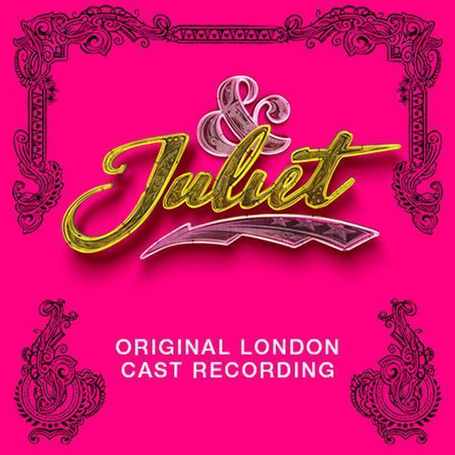

Atlantic Records is proud to announce the release of “& JULIET (ORIGINAL LONDON CAST RECORDING),” the official companion to the hugely anticipated new West End musical featuring the music of legendary pop songwriter Max Martin. The eagerly awaited album is available now for pre-order [HERE](http://atlantic.lnk.to/AndJulietPR); all pre-orders will be joined by an instantly available pre-release download of “Roar,” performed by Miriam-Teak Lee and streaming now [HERE](https://Atlantic.lnk.to/RoarPR). “& JULIET (ORIGINAL LONDON CAST RECORDING)” arrives November 20th at all DSPs and streaming services.

*& JULIET* offers a joyous new version of the most famous love story ever told, remixed. What if Juliet’s famous ending was really just her beginning? What if she decided to choose her own fate? The hilariously irreverent new musical follows Juliet’s sensational journey of self-discovery and second chances, told through some of the most glittering pop anthems of the last three decades. *& JULIET* soars with the music and lyrics of Max Martin, including such worldwide favorites as “…Baby One More Time,” “Since U Been Gone,” “Roar,” “Everybody (Backstreet's Back),” “Love Me Like You Do,” “Can’t Feel My Face,” and the brand new pop anthem, “One More Try,” all newly arranged for the stage by Tony® and GRAMMY® Award-winning musical supervisor/orchestrator/producer Bill Sherman (*Hamilton*, *In The Heights*) and with musical direction by GRAMMY® Award winning producer/composer/multi-instrumentalist Dominic Fallacaro.

Max Martin and Tim Headington present *& JULIET*, produced by Max Martin, Tim Headington, Theresa Steele Page, Jenny Petersson and Martin Dodd, will play a limited season at Manchester Opera House, from September 10th to October 12th, before beginning performances at London’s Shaftesbury Theatre on Wednesday, November 20th. Tickets are available now [HERE](https://andjulietthemusical.co.uk/).

A timely and timeless tale of one independent young woman, *& JULIET* is a riotous comic blast of fun and glorious pop music that proves when it comes to love, there’s always life after Romeo. Brought to life by an award-winning creative team in an explosive fusion of styles, *& JULIET* stars Miriam-Teak Lee (*Hamilton*, *On The Town*) as Juliet alongside a host of performers who have headlined some of the most celebrated shows of recent years, including two-time Olivier Award winner David Bedella (*Jerry Springer: The Musical*, *In The Heights*), Cassidy Janson (*Chess*, *Beautiful: The Carole King Musical*); Oliver Tompsett (*Kinky Boots*, *Wicked*); Arun Blair-Mangat (*Angels in America*); Melanie La Barrie (*Wicked*, *Matilda*); Jordan Luke Gage (*Bat Out of Hell*), and Tim Mahendran (*Spring Awakening*). *& JULIET* is directed by Luke Sheppard (*In The Heights*) with a book by David West Read (*Schitt’s Creek*), electrifying choreography from Jennifer Weber (*The Hip Hop Nutcracker*), stunning set design from Soutra Gilmour, and costume design by Paloma Young.

Second only to John Lennon and Paul McCartney for the most-ever #1 singles on the Billboard Hot 100, Max Martin is the groundbreaking songwriter and producer of some of the biggest pop anthems of the last three decades – recorded by artists including Backstreet Boys, Justin Timberlake, Britney Spears, Katy Perry and Ariana Grande. *& JULIET* marks the first musical production from Max, who serves not just as musical collaborator with his extensive catalogue, but as producer overseeing all aspects of the development. He is the winner of five GRAMMY® Awards (including 2015’s “Producer of the Year, Non-Classical”), an 11x ASCAP Pop Music Awards “Songwriter of the Year,” an Academy Award and Golden Globe Award nominee, and 2017 Songwriters Hall of Fame inductee.

“& JULIET (ORIGINAL LONDON CAST RECORDING)” continues Atlantic Records’ recent string of landmark Original Cast Recordings, including 2015’s GRAMMY® Award-winning, chart-topping milestone, “HAMILTON (ORIGINAL BROADWAY CAST RECORDING)” – currently the best-selling cast album of all time with 5x platinum certification – and 2017’s “DEAR EVAN HANSEN (ORIGINAL BROADWAY CAST RECORDING),” along with “HAMILTON,” one of only seven cast albums to reach the top 20 of the Billboard 200 in the last 50 years.

**FOR MORE INFORMATION:**

[OFFICIAL](https://andjulietthemusical.co.uk/) | [FACEBOOK](https://www.facebook.com/JulietMusical/) | [INSTAGRAM](https://www.instagram.com/julietmusical/?hl=en) | [YOUTUBE](https://www.youtube.com/channel/UC7POTPCfmgr20Y4hnl4Vzbw)

**“& JULIET (ORIGINAL LONDON CAST RECORDING)”**

**TRACKLISTING**

**1. Larger Than Life**

Oliver Tompsett, Original London Cast of & Juliet

**2. I Want It That Way**

Cassidy Janson, Oliver Tompsett, Original London Cast of & Juliet

**3. …Baby One More Time**

Miriam-Teak Lee

**4. Show Me The Meaning of Being Lonely**

Kirstie Skivington, Grace Mouat, Danielle Fiamanya, Cassidy Janson, Oliver Tompsett, Jocasta Almgill, Ivan De Freitas, Miriam-Teak Lee, Original London Cast of & Juliet

**5.** **Domino**

Cassidy Janson, Miriam-Teak Lee, Arun Blair-Mangat, Melanie La Barrie

**6. Show Me Love**

Miriam-Teak Lee, Cassidy Janson, Arun Blair-Mangat, Melanie La Barrie, Original London Cast of & Juliet

**7. Blow**

Miriam-Teak Lee, Cassidy Janson, Melanie La Barrie, Arun Blair-Mangat, Ivan De Freitas, Original London Cast of & Juliet

**8. I'm Not A Girl, Not Yet A Woman**

Arun Blair-Mangat, Miriam-Teak Lee

**9. Overprotected**

Tim Mahendran, Miriam-Teak Lee

**10. Confident**

Miriam-Teak Lee, Tim Mahendran, Melanie La Barrie, Original London Cast of & Juliet

**11. Teenage Dream / Break Free**

David Bedella, Melanie La Barrie

**12. Oops!...I Did It Again**

Miriam-Teak Lee, Melanie La Barrie

**13. I Kissed A Girl**

Tim Mahendran, Arun Blair-Mangat, Original London Cast of & Juliet

**14. It's My Life**

Jordan Luke Gage, Oliver Tompsett, Miriam-Teak Lee, Cassidy Janson, Original London Cast of & Juliet

**15. Love Me Like You Do**

Jordan Luke Gage

**16. Since U Been Gone**

Miriam-Teak Lee, Original London Cast of & Juliet

**17. Whataya Want From Me**

Tim Mahendran, Arun Blair-Mangat

**18. One More Try**

Miriam-Teak Lee, Jordan Luke Gage, Original London Cast of & Juliet

**19. Problem / Can’t Feel My Face**

Miriam-Teak Lee, Jordan Luke Gage, Original London Cast of & Juliet

**20. That's The Way It Is**

Cassidy Janson, Miriam-Teak Lee

**21. Everybody**

Tim Mahendran, Oliver Tompsett, David Bedella, Arun Blair-Mangat, Jordan Luke Gage, Original London Cast of & Juliet

**22. As Long As You Love Me**

Tim Mahendran

**23. It's Gonna Be Me**

Tim Mahendran, Arun Blair-Mangat

**24. Shape Of My Heart**

David Bedella, Tim Mahendran, Arun Blair-Mangat

**25. Stronger**

Miriam-Teak Lee

**26. F**kin’ Perfect (Explicit)**

Melanie La Barrie, Original London Cast of & Juliet

**27. Roar**

Miriam-Teak Lee, Original London Cast of & Juliet

**28. I Want It That Way (Reprise)**

Oliver Tompsett, Cassidy Janson, Miriam-Teak Lee, Jordan Luke Gage, Original London Cast of & Juliet

**29. Can't Stop The Feeling!**

Oliver Tompsett, Original London Cast of & Juliet

**30. One More Try (Original Version)**

Original London Cast of & Juliet