FOR IMMEDIATE RELEASE

NOVEMBER 15, 2019

**“I’M NOT A GIRL, NOT YET A WOMAN” MARKS ANOTHER**

**EMPOWERING ANTHEM FROM *& JULIET***

**NEW WEST END MUSICAL *& JULIET* FEATURES**

**THE MUSIC AND LYRICS** **OF GROUNDBREAKING SONGWRITER MAX MARTIN**

**“I’M NOT A GIRL, NOT YET A WOMAN” PERFORMED BY**

**Arun Blair-Mangat & Miriam-Teak Lee available now**

**“& JULIET (ORIGINAL LONDON CAST RECORDING)”**

**AVAILABLE NOVEMBER 22ND AT ALL DIGITAL SERVICE PROVIDERS**

[***& JULIET***](https://andjulietthemusical.co.uk/) **OPENS AT THE SHAFTESBURY THEATRE NEXT WEDNESDAY, NOVEMBER 20TH**

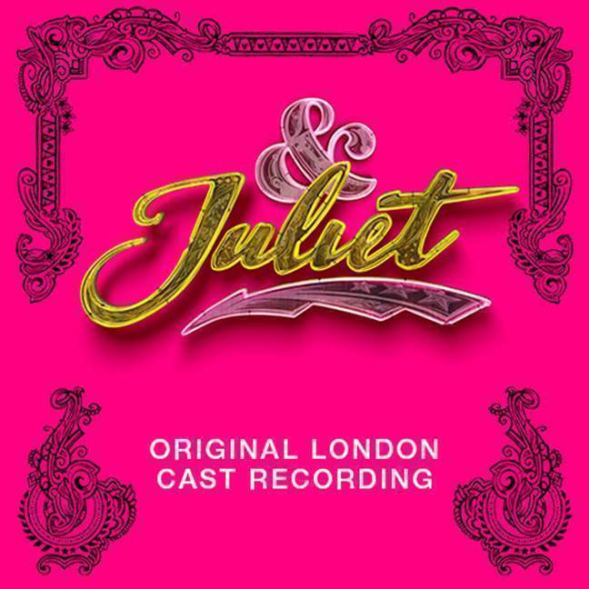

**STREAM “I’M NOT A GIRL, NOT YET A WOMAN”:** <https://atlantic.lnk.to/NotAGirlPR>

**PRE-ORDER** **“& JULIET (ORIGINAL LONDON CAST RECORDING)”:** <https://Atlantic.lnk.to/AndJulietPR>

**Atlantic Records** is proud to release a fifth track from **“& Juliet (Original London Cast Recording)**,” the official companion to the new West End musical featuring the music of legendary pop songwriter **Max Martin**. Arriving today is a moving rendition of “**I’m Not A Girl, Not Yet A Woman**,” performed by **Arun Blair-Mangat** & **Miriam-Teak Lee** – streaming now [HERE](https://Atlantic.lnk.to/NotAGirlPR). The stunning ballad follows additional pre-release tracks “**Since U Been Gone**,” “**Domino**,” “**…Baby One More Time**” & “**Roar**.” **“& Juliet (Original London Cast Recording)**” arrives November 22nd, and is available now for pre-order [HERE](http://atlantic.lnk.to/AndJulietPR).

***& Juliet*** offers a joyous new version of the most famous love story ever told. What if Juliet’s famous ending was really just her beginning? What if she decided to choose her own fate? The hilarious new musical follows Juliet’s sensational journey of self-discovery and second chances, told through some of the most glittering pop anthems of the last three decades. ***& Juliet*** soars with the music and lyrics of **Max Martin**, including such worldwide favorites as “**…Baby One More Time**,” “**Since U Been Gone**,” “**Roar**,” “**Everybody** **(Backstreet's Back)**,” “**Love** **Me** **Like** **You** **Do**,” “**Can’t Feel My Face**,” and the brand new pop anthem, “**One More Try**,” all newly arranged for the stage by Tony® and GRAMMY® Award-winning musical supervisor/orchestrator/producer **Bill Sherman** (***Hamilton***, ***In The Heights***) and with musical direction by GRAMMY® Award winning producer/composer/multi-instrumentalist **Dominic Fallacaro**.

***& Juliet***, produced by **Max** **Martin**, **Tim** **Headington**, **Theresa** **Steele** **Page**, **Jenny** **Petersson** and **Martin** **Dodd**, wrapped a limited season at **Manchester Opera House** last month to overwhelmingly positive audience reactions, and began performances last week at **London’s Shaftesbury Theatre**, with opening night on November 20th. Tickets are available now [HERE](https://andjulietthemusical.co.uk/).

A timely and timeless tale of one independent young woman, ***& Juliet*** is a riotous comic blast of fun and glorious pop music that proves when it comes to love, there’s always life after Romeo. Brought to life by an award-winning creative team in an explosive fusion of styles, ***& Juliet*** stars **Miriam-Teak Lee** (***Hamilton***, ***On The Town***) as Juliet alongside a host of performers who have headlined some of the most celebrated shows of recent years, including two-time Olivier Award winner **David Bedella** (***Jerry Springer: The Musical***, ***In The Heights***), **Cassidy** **Janson** (***Chess***, ***Beautiful****:* ***The Carole King Musical***); **Oliver** **Tompsett** (***Kinky******Boots***, ***Wicked***); **Arun Blair-Mangat** (***Angels******in******America***); **Melanie La Barrie** (***Wicked***, ***Matilda***); **Jordan** **Luke** **Gage** (***Bat******Out******of Hell***), and **Tim** **Mahendran** (***Spring******Awakening***). ***& Juliet*** is directed by **Luke** **Sheppard** (***In The Heights***) with a book by **David** **West** **Read** (***Schitt’s Creek***), electrifying choreography from **Jennifer** **Weber** (***The******Hip******Hop******Nutcracker***), stunning set design from **Soutra** **Gilmour**, costume design by **Paloma** **Young**, video/projection design by **Andrzej Goulding**, sound design by **Gareth Owen**, and lighting design by **Howard Hudson**.

Second only to **John** **Lennon** and **Paul** **McCartney** for the most-ever #1 singles on the Billboard Hot 100, **Max** **Martin** is the groundbreaking songwriter and producer of some of the biggest pop anthems of the last three decades – recorded by artists including **Backstreet** **Boys**, **Justin** **Timberlake**, **Britney** **Spears**, **Katy** **Perry** and **Ariana** **Grande**. ***& Juliet*** marks the first musical production from Max, who serves not just as musical collaborator with his extensive catalogue, but as producer overseeing all aspects of the development. He is the winner of five GRAMMY® Awards (including 2015’s “Producer of the Year, Non-Classical”), an 11x ASCAP Pop Music Awards “Songwriter of the Year,” an Academy Award and Golden Globe Award nominee, and 2017 Songwriters Hall of Fame inductee.

“**& Juliet (Original London Cast Recording)**”continues **Atlantic Records’** recent string of landmark Original Cast Recordings, including 2015’s GRAMMY® Award-winning, chart-topping milestone, “**Hamilton (Original Broadway Cast Recording)**” – currently the best-selling cast album of all time with 5x platinum certification – and 2017’s “**Dear Evan Hansen (Original Broadway Cast Recording)**,” along with “**Hamilton**,” one of only seven cast albums to reach the top 20 of the Billboard 200 in the last 50 years.

**FOR MORE INFORMATION:**

[OFFICIAL](https://andjulietthemusical.co.uk/) | [FACEBOOK](https://www.facebook.com/JulietMusical/) | [INSTAGRAM](https://www.instagram.com/julietmusical/?hl=en) | [YOUTUBE](https://www.youtube.com/channel/UC7POTPCfmgr20Y4hnl4Vzbw)| [PRESS ASSETS](http://press.atlanticrecords.com/juliet/)

**“& JULIET (ORIGINAL LONDON CAST RECORDING)”**

**TRACKLISTING**

**1. Larger Than Life**

Oliver Tompsett, Original London Cast of & Juliet

**2. I Want It That Way**

Cassidy Janson, Oliver Tompsett, Original London Cast of & Juliet

**3. …Baby One More Time**

Miriam-Teak Lee

**4. Show Me The Meaning of Being Lonely**

Kirstie Skivington, Grace Mouat, Danielle Fiamanya, Cassidy Janson, Oliver Tompsett, Jocasta Almgill, Ivan De Freitas, Miriam-Teak Lee, Original London Cast of & Juliet

**5.** **Domino**

Cassidy Janson, Miriam-Teak Lee, Arun Blair-Mangat, Melanie La Barrie

**6. Show Me Love**

Miriam-Teak Lee, Cassidy Janson, Arun Blair-Mangat, Melanie La Barrie, Original London Cast of & Juliet

**7. Blow**

Miriam-Teak Lee, Cassidy Janson, Melanie La Barrie, Arun Blair-Mangat, Ivan De Freitas, Original London Cast of & Juliet

**8. I'm Not A Girl, Not Yet A Woman**

Arun Blair-Mangat, Miriam-Teak Lee

**9. Overprotected**

Tim Mahendran, Miriam-Teak Lee

**10. Confident**

Miriam-Teak Lee, Tim Mahendran, Melanie La Barrie, Original London Cast of & Juliet

**11. Teenage Dream / Break Free**

David Bedella, Melanie La Barrie

**12. Oops!...I Did It Again**

Miriam-Teak Lee, Melanie La Barrie

**13. I Kissed A Girl**

Tim Mahendran, Arun Blair-Mangat, Original London Cast of & Juliet

**14. It's My Life**

Jordan Luke Gage, Oliver Tompsett, Miriam-Teak Lee, Cassidy Janson, Original London Cast of & Juliet

**15. Love Me Like You Do**

Jordan Luke Gage

**16. Since U Been Gone**

Miriam-Teak Lee, Original London Cast of & Juliet

**17. Whataya Want From Me**

Tim Mahendran, Arun Blair-Mangat

**18. One More Try**

Miriam-Teak Lee, Jordan Luke Gage, Original London Cast of & Juliet

**19. Problem / Can’t Feel My Face**

Miriam-Teak Lee, Jordan Luke Gage, Original London Cast of & Juliet

**20. That's The Way It Is**

Cassidy Janson, Miriam-Teak Lee

**21. Everybody**

Tim Mahendran, Oliver Tompsett, David Bedella, Arun Blair-Mangat, Jordan Luke Gage, Original London Cast of & Juliet

**22. As Long As You Love Me**

Tim Mahendran

**23. It's Gonna Be Me**

Tim Mahendran, Arun Blair-Mangat

**24. Shape Of My Heart**

David Bedella, Tim Mahendran, Arun Blair-Mangat

**25. Stronger**

Miriam-Teak Lee

**26. F**kin’ Perfect (Explicit)**

Melanie La Barrie, Original London Cast of & Juliet

**27. Roar**

Miriam-Teak Lee, Original London Cast of & Juliet

**28. I Want It That Way (Reprise)**

Oliver Tompsett, Cassidy Janson, Miriam-Teak Lee, Jordan Luke Gage, Original London Cast of & Juliet

**29. Can't Stop The Feeling!**

Oliver Tompsett, Original London Cast of & Juliet

**30. One More Try (Original Version)**

Original London Cast of & Juliet