KENTUCKY FRIED CHICKEN® AND LOUISVILLE’S OWN JACK HARLOW
TEAM UP TO USHER IN A NEW ERA FOR THE ICONIC FRIED CHICKEN BRAND

Multiple GRAMMY-nominated rapper and Louisville native Jack Harlow kicks off
year-long partnership with KFC in Louisville during “No Place Like Home” concert series

WATCH ANNOUNCEMENT TRAILER
DOWNLOAD ALL ASSETS

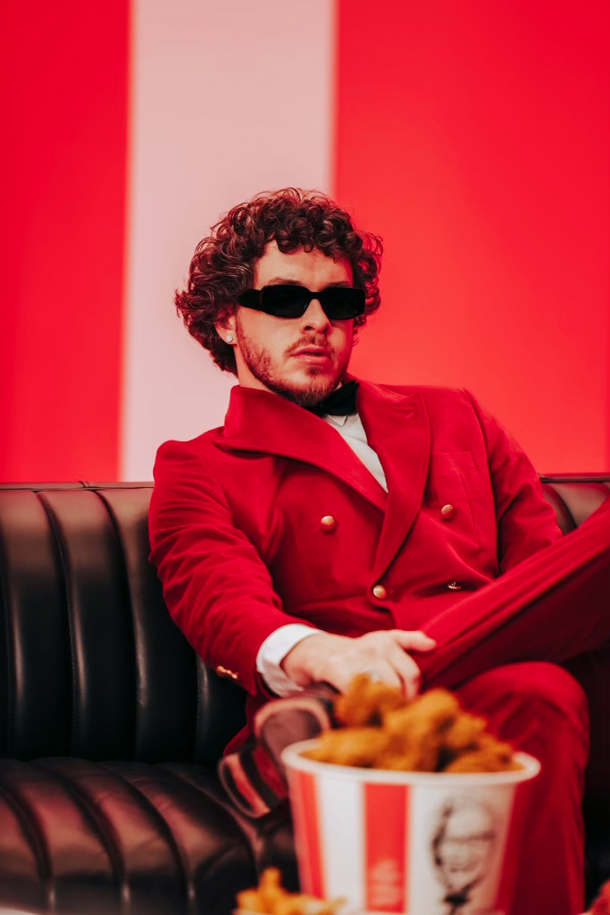
Photo Credit: Christopher Alvarenga

December 13, 2021 – LOUISVILLE, KY. – Kentucky Fried Chicken® is teaming up with multiple GRAMMY-nominated rapper and Louisville native Jack Harlow to usher in a new era for the iconic fried chicken brand, which will be full of surprises for fans over the course of the next year.

Harlow has long been vocal about his passion for his home state, which is why Harlow and Kentucky Fried Chicken are a match made in heaven the Ville. Starting this week, he’ll bring his signature swag to the home of the 11 Herbs and Spices.

A shared passion for Harlow’s and KFC’s home state of Kentucky is at the heart of this partnership, and today they are coming together to support communities across Western Kentucky that were ravaged on December 11 by one of the deadliest tornado events in the state’s history. Harlow, Kentucky Fried Chicken, and KFC parent company, Yum! Brands, will be donating $250,000 to the American Red Cross in support of relief efforts. Fans and customers are encouraged to donate to the affected communities via www.kfc.us/tornadorelief.

And over the next year, from brand campaigns and social media activations to menu item launches and exclusive experiences for fried chicken lovers – maybe even at a KFC restaurant near you – fans will have endless opportunities to celebrate their finger lickin’ fried chicken favorites with Jack Harlow.

“Growing up I always dreamed of being that guy who would put Kentucky on the map in the music scene. But to team up with an iconic national staple like KFC, the biggest brand to come out of Kentucky, is truly an honor. I’m looking forward to all the amazing things we’re about to do together,” Harlow said.

Harlow and KFC will work together to bring forward a new generation of fried chicken lovers, kicking it off where it all began, back home in Louisville where he is performing in five “No Place Like Home” shows.

On December 14, just before Jack’s show at the Louisville Palace Theatre, the first of the 5 night-run, select fans will have the opportunity to get their hands on KFC’s best sandwich ever, the KFC Chicken Sandwich, in custom Jack Harlow packaging from a KFC food truck. Attendees at two of the “No Place Like Home” shows will also experience a giant KFC Bucket Boombox pumping out Harlow’s chart-toppers outside of the venue.

Although Jack will have a regular presence in support of KFC’s world-famous fried chicken, he will not portray KFC founder Colonel Harland Sanders. After all, Jack is a Kentucky legend in his own right.

There’s lots more to come, but we can’t share it all now because, well what’s the fun in that? For exclusive updates on What’s Poppin from KFC x Jack Harlow, download the KFC App and opt-in to receive KFC Colonel’s Club emails, or follow KFC on Tik Tok, Instagram, Facebook, and Twitter.

Media Contacts:
Jason Davis (Jack Harlow)
Jason.Davis@atlanticrecords.com

Lori Eberenz (KFC)
502-874-8614
Lori.Eberenz@yum.com

* * *

About KFC:
KFC Corporation, based in Louisville, Ky., is the world's most popular chicken restaurant chain. KFC specializes in Original Recipe®, Extra Crispy™, Kentucky Grilled Chicken® and Extra Crispy™ Tenders, Hot Wings®, KFC Famous Bowls®, Pot Pies, freshly hand prepared chicken sandwiches, biscuits and homestyle side items. There are more than 26,000 KFC restaurants in over 145 countries and territories around the world. KFC Corporation is a subsidiary of Yum! Brands, Inc., Louisville, Ky. (NYSE: YUM). For more information, visit www.kfc.com. Follow KFC on Facebook (www.facebook.com/kfc), Twitter (www.twitter.com/kfc) and Instagram (www.instagram.com/KFC).

About Jack Harlow:
Hailed by The FADER as a “maverick rapper destined for legendary status,” 23-year-old, Louisville, KY native Jack Harlow has quickly become one of music’s biggest stars with nearly 4 billion career streams to date. The Generation Now/Atlantic Records rapper has released a project a year, for the last 5 years, the most recent being his RIAA Platinum-Certified, critically acclaimed debut album THATS WHAT THEY ALL SAY. The album features the 6x-Platinum single “WHATS POPPIN,” which earned Harlow his first Grammy nomination, among countless other accolades including nominations at the 2021 Billboard Music Awards, 2021 BET Awards, 2020 MTV Video Music Awards, 2020 E! People’s Choice Awards & 2020 BET Hip Hop Awards.

Harlow has been widely featured in high profile publications ranging from Rolling Stone, Billboard and Complex to GQ, TIME, Interview and Forbes, graced the covers of XXL’s coveted Freshman Class issue, Variety, Forbes, Complex, SPIN and Footwear News and brought his captivating live show to the masses with national television performances on Saturday Night Live, The Tonight Show Starring Jimmy Fallon, Jimmy Kimmel Live! and more.

For more information on Jack Harlow, please visit: www.jackharlow.us.

# # #

