FOR IMMEDIATE RELEASE
SEPTEMBER 15, 2021

Kelly Clarkson announces NEW HOLIDAY single
“Christmas Isn’t Canceled (Just You)” arriving September 23rd

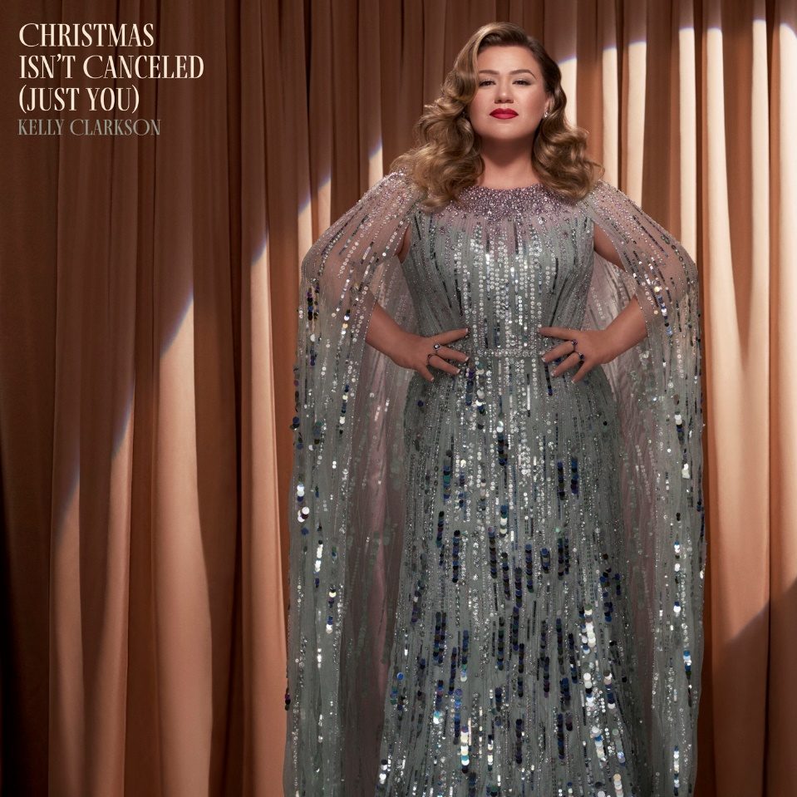
DOWNLOAD HIGH-RES ART + PRESS IMAGE

Pre-save “Christmas Isn’t Canceled (Just You)”: LINK

GRAMMY-winning global superstar Kelly Clarkson has unveiled her new holiday single “Christmas Isn’t Canceled (Just You)” – arriving September 23rd via Atlantic Records. Watch her announcement video here: LINK

“Christmas Isn’t Canceled (Just You)” marks the first offering from Clarkson’s forthcoming ninth studio album, her latest since 2017’s Meaning of Life and her second holiday release following 2013’s Wrapped In Red. Meanwhile, this past week has seen Clarkson kick off the third season of the six-time Daytime Emmy Award-winning The Kelly Clarkson Show ahead of her return next Monday as three-time champion coach on the 21st season of The Voice.

ABOUT KELLY CLARKSON:
Kelly Clarkson is among the most popular artists of this era with total worldwide sales of more than 25 million albums and 40 million singles. The Texas-born singer-songwriter first came to fame in 2002 as the winner of the inaugural season of American Idol. Clarkson’s debut single, “A Moment Like This,” followed and quickly went to #1 on Billboard’s Hot 100, ultimately ranking as the year’s best-selling single in the U.S. Further, Clarkson is one of pop’s top singles artists, with 19 singles boasting multi-platinum, platinum and gold certifications around the world, including such global favorites as “Miss Independent” and “Because of You.” Clarkson has released eight studio albums (Thankful, Breakaway, My December, All I Ever Wanted, Stronger, Wrapped In Red, Piece By Piece, Meaning of Life), one greatest hits album, and two children’s books (New York Times Top 10 best seller River Rose and the Magical Lullaby and the follow up River Rose and the Magical Christmas). She is the recipient of an array of awards including three GRAMMY Awards, four American Music Awards, three MTV Video Music Awards, two Academy of Country Music Awards, two American Country Awards, one Country Music Association Award, and two Daytime Emmy Awards. She is also the first artist to top each of Billboard’s pop, adult contemporary, country and dance charts.

For more information, please visit:
KellyClarkson.com | Facebook | Twitter | Instagram | YouTube | Press Assets

For press inquiries:
Sheila Richman | Sheila.Richman@atlanticrecords.com
Ted Sullivan | Ted.Sullivan@atlanticrecords.com

