FOR IMMEDIATE RELEASE
JULY 10, 2020

Kelly Clarkson’s “i Dare You” gets
reimagined by virtual a capPella choir

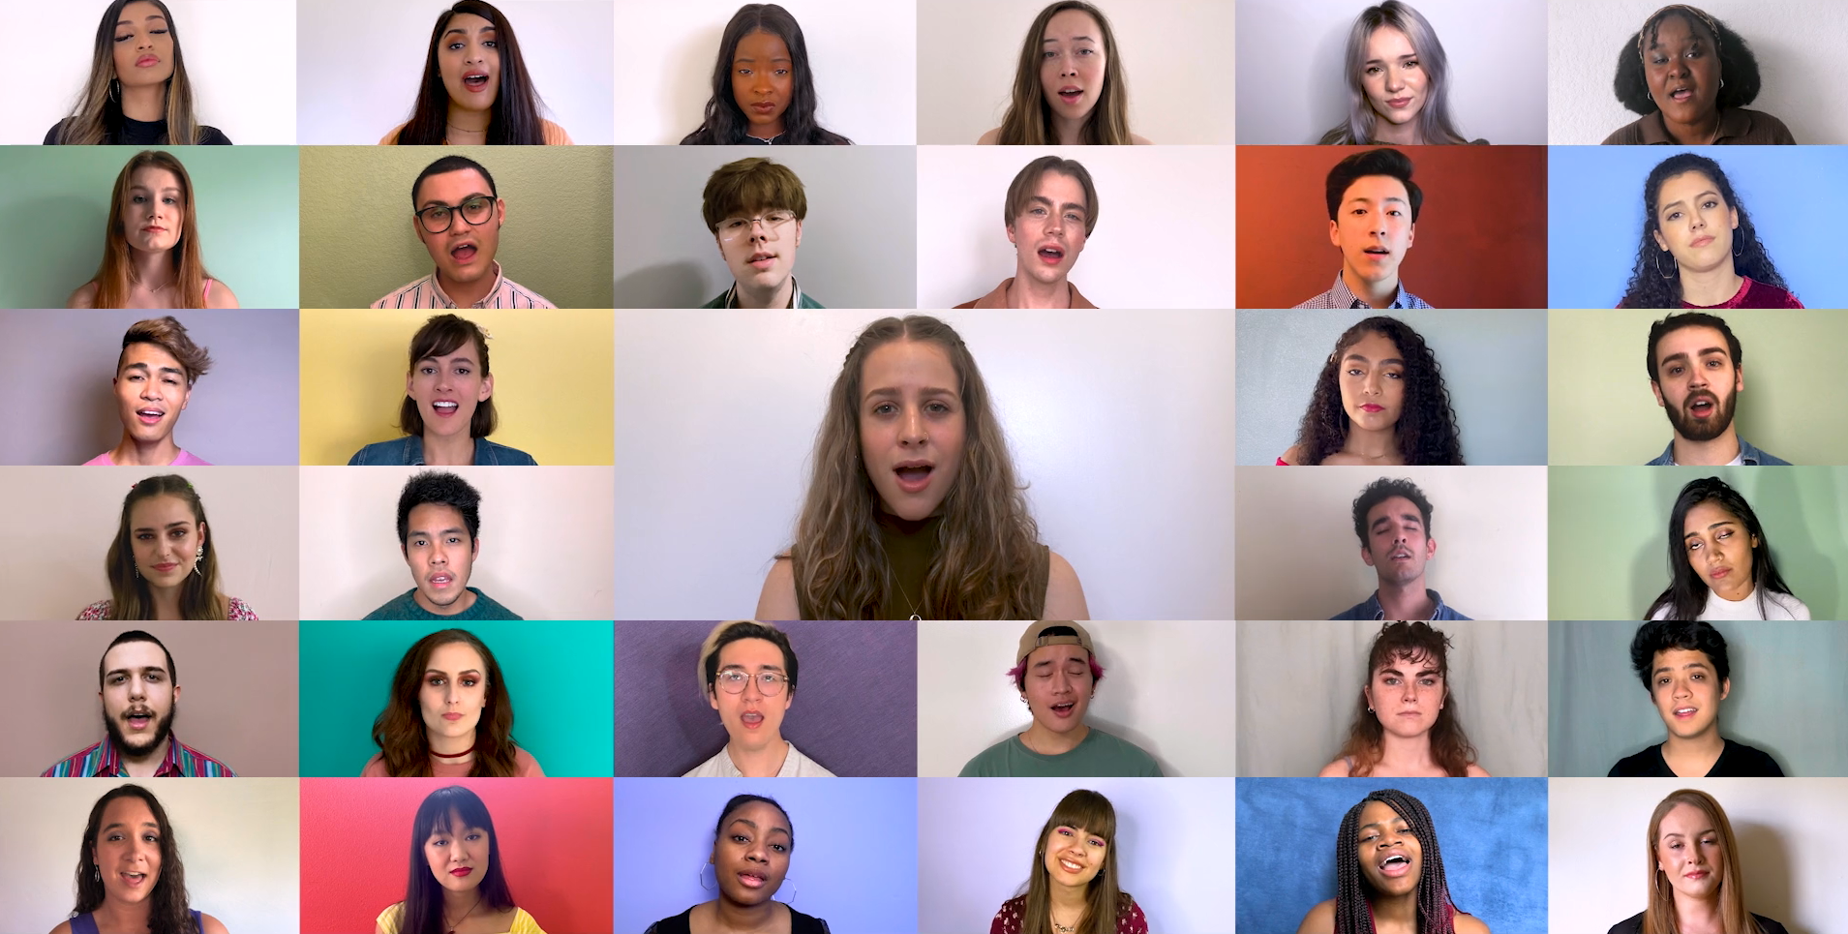

WATCH VIRTUAL A CAPPELLA CHOIR PERFORMANCE: https://Atlantic.lnk.to/IDYAcapellaPR
STREAM “I DARE YOU” (MULTI-LANGUAGE DUETS): https://Atlantic.lnk.to/IDareYouPR

47 young vocalists across the globe have joined together, using their voices as instruments to champion love through music with a stunning a cappella performance of GRAMMY-winning global superstar Kelly Clarkson’s latest single “I Dare You” – entirely sung and filmed virtually by the performers with arrangement by Shams Ahmed.

Penned by Natalie Hemby (The Highwomen, Kacey Musgraves), Laura Veltz (Dan + Shay, Maren Morris) and Ben West (P!nk, Lady Antebellum) with production by longtime collaborator Jesse Shatkin (Sia, Jennifer Lopez), “I Dare You” is a sensational anthem of resilience by way of love and positivity – having amassed over 26 million total streams to date. The single arrived alongside a five-track collection of multi-language duet versions, sung with a canon of internationally acclaimed vocalists in their native tongue – including Zaz (“Appelle Ton Amour” – French Version), Faouzia ("كنتحداك” – Arabic Version), Blas Cantó (“Te Reto A Amar” – Spanish Version), Glasperlenspiel (“Trau Dich” – German Version) and Maya Buskila (“בוא נראה” – Hebrew Version). The past month has also seen dancefloor-ready remixes of the track, from the likes of Eden Prince, Arkadi, Gozzi & Lash.

ABOUT KELLY CLARKSON:
Kelly Clarkson is among the most popular artists of this era with total worldwide sales of more than 25 million albums and 40 million singles. The Texas-born singer-songwriter first came to fame in 2002 as the winner of the inaugural season of American Idol. Clarkson’s debut single, “A Moment Like This,” followed and quickly went to #1 on Billboard’s Hot 100, ultimately ranking as the year’s best-selling single in the U.S. Further, Clarkson is one of pop’s top singles artists, with 18 singles boasting multi-platinum, platinum and gold certifications around the world, including such global favorites as “Miss Independent” and “Because of You.” Clarkson has released eight studio albums (Thankful, Breakaway, My December, All I Ever Wanted, Stronger, Wrapped In Red, Piece By Piece, Meaning of Life), one greatest hits album, and two children’s books (New York Times Top 10 best seller River Rose and the Magical Lullaby and the follow up River Rose and the Magical Christmas). She is the recipient of an array of awards including three GRAMMY Awards, four American Music Awards, three MTV Video Music Awards, two Academy of Country Music Awards, two American Country Awards, and one Country Music Association Award. She is also the first artist to top each of Billboard’s pop, adult contemporary, country and dance charts.

For more information, please visit:
KellyClarkson.com | Facebook | Twitter | Instagram | YouTube | Press Assets

For press inquiries:
Sheila Richman | Sheila.Richman@atlanticrecords.com
Ted Sullivan | Ted.Sullivan@atlanticrecords.com

