FOR IMMEDIATE RELEASE
APRIL 16, 2020 (10a EST)

Kelly Clarkson Dares You To Love

Brand new single “I Dare You” available now, alongside Multi-language duet collection including French, Arabic, Spanish, German & Hebrew versions

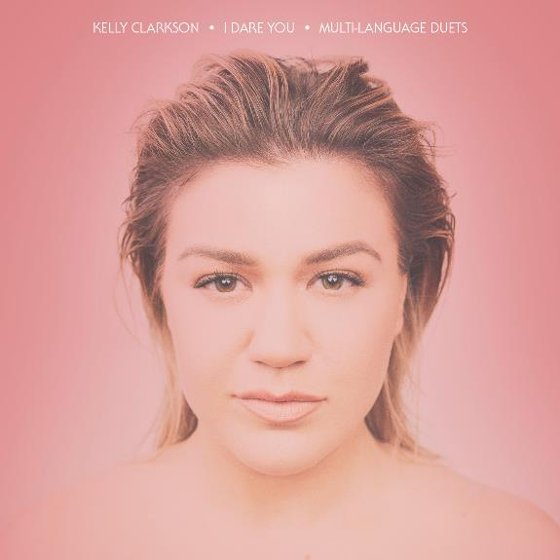

STREAM “I DARE YOU”: https://Atlantic.lnk.to/IDareYouPR
WATCH “I DARE YOU” PERFORMANCE VIDEO: https://Atlantic.lnk.to/IDYMegaMixPR

GRAMMY-winning global superstar Kelly Clarkson has unveiled her brand new single “I Dare You” – available now via Atlantic Records. Penned by Natalie Hemby (The Highwomen, Kacey Musgraves), Laura Veltz (Dan + Shay, Maren Morris) and Ben West (P!nk, Lady Antebellum) with production by longtime collaborator Jesse Shatkin (Sia, Jennifer Lopez), the track is a sensational anthem of resilience by way of love and positivity.

“I Dare You” arrives alongside a five-track collection of multi-language duet versions, sung with a canon of internationally acclaimed vocalists in their native tongue. The bundle sees Clarkson joined by Zaz (“Appelle Ton Amour” – French Version), Faouzia ("كنتحداك” – Arabic Version), Blas Cantó (“Te Reto A Amar” – Spanish Version), Glasperlenspiel (“Trau Dich” – German Version) and Maya Buskila (“בוא נראה” – Hebrew Version) – truly encapsulating the song’s message of all-inclusivity. Clarkson will also share a world premiere performance music video for “I Dare You” on today’s episode of The Kelly Clarkson Show, singing virtually with her global duet partners.

“This is my favorite/hardest project that I’ve ever worked on” explained Clarkson. “It has always been a dream of mine, as I grew up singing in different languages, to find that perfect song, with the perfect message, to connect us all globally and then record that song with several other artists around the world in their native languages. We have put a lot of work into this as a team and decided to continue with our release date of this project because we feel like we all couldn’t be more connected right now across the world, and maybe this message will bring a little hope in this sometimes dark, and isolating time. Thank you so much to all the artists that worked on this with me. We hope everyone out there connects with this message and chooses love instead of fear. I dare you.”

Last year proved to be monumental for Clarkson, kicking off with a 28-show US arena tour in support of her critically acclaimed and GRAMMY-nominated eighth studio album, Meaning of Life. Clarkson has captivated viewers on small and large screens alike – earning her third win as coach on NBC’s The Voice (to which she returned a fifth time for the show’s current 18th season) and voicing characters in STXFilms’ UglyDolls & Universal Pictures’ Trolls World Tour. She also made the highest rated daytime debut in seven years with her very own talk show, The Kelly Clarkson Show (syndicated by NBCUniversal Television Distribution), which received a nomination for Best Talk Show at the 10th Critics' Choice Television Awards.

Clarkson is due to host the Billboard Music Awards for a third consecutive year in 2020, in addition to kicking off her recently-announced Las Vegas residency, Kelly Clarkson: Invincible, on July 29th at Zappos Theater at Planet Hollywood Resort & Casino. For ticket and show information, please visit KellyClarkson.com/Vegas.

ABOUT KELLY CLARKSON:
Kelly Clarkson is among the most popular artists of this era with total worldwide sales of more than 25 million albums and 40 million singles. The Texas-born singer-songwriter first came to fame in 2002 as the winner of the inaugural season of American Idol. Clarkson’s debut single, “A Moment Like This,” followed and quickly went to #1 on Billboard’s Hot 100, ultimately ranking as the year’s best-selling single in the U.S. Further, Clarkson is one of pop’s top singles artists, with 18 singles boasting multi-platinum, platinum and gold certifications around the world, including such global favorites as “Miss Independent” and “Because of You.” Clarkson has released eight studio albums (Thankful, Breakaway, My December, All I Ever Wanted, Stronger, Wrapped In Red, Piece By Piece, Meaning of Life), one greatest hits album, and two children’s books (New York Times Top 10 best seller River Rose and the Magical Lullaby and the follow up River Rose and the Magical Christmas). She is the recipient of an array of awards including three GRAMMY Awards, four American Music Awards, three MTV Video Music Awards, two Academy of Country Music Awards, two American Country Awards, and one Country Music Association Award. She is also the first artist to top each of Billboard’s pop, adult contemporary, country and dance charts.

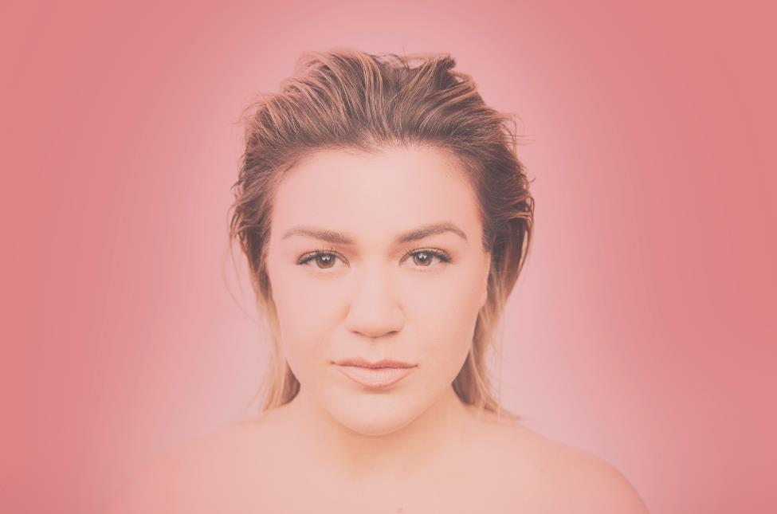
DOWNLOAD HIGH-RES IMAGE (CREDIT: WEISS EUBANKS)

For more information, please visit:
KellyClarkson.com | Facebook | Twitter | Instagram | YouTube | Press Assets

For press inquiries:
Sheila Richman | Sheila.Richman@atlanticrecords.com
Ted Sullivan | Ted.Sullivan@atlanticrecords.com

