FOR IMMEDIATE RELEASE
MAY 15, 2020 (10a PST / 1p EST)

Kelly Clarkson shares “i Dare You” remixes

“I Dare You” (Eden Prince Remix) available now,
alongside stunning Multi-language duet collection

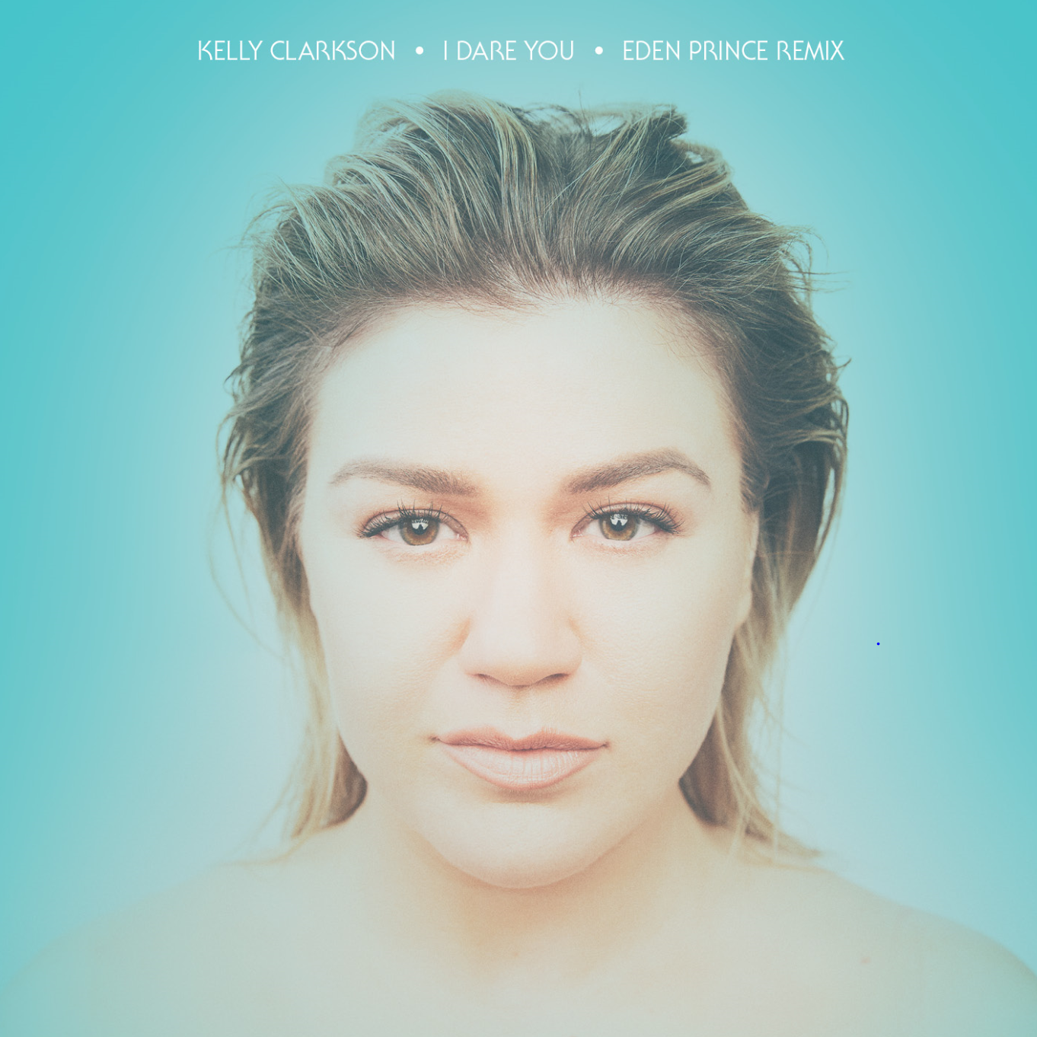

STREAM “I DARE YOU” (EDEN PRINCE REMIX): https://Atlantic.lnk.to/IDYEDRmxPR
STREAM “I DARE YOU” (MULTI-LANGUAGE DUETS): https://Atlantic.lnk.to/IDareYouPR

GRAMMY-winning global superstar Kelly Clarkson has shared the dancefloor-ready Eden Prince Remix of her brand new single “I Dare You”– available now via Atlantic Records. The high energy remix marks the first of four set to arrive over the next month, including reworks by Arkadi, Gozzi and Lash.

Penned by Natalie Hemby (The Highwomen, Kacey Musgraves), Laura Veltz (Dan + Shay, Maren Morris) and Ben West (P!nk, Lady Antebellum) with production by longtime collaborator Jesse Shatkin (Sia, Jennifer Lopez), “I Dare You” is a sensational anthem of resilience by way of love and positivity – having amassed over 8 million total streams to date. The single arrived last month alongside a five-track collection of multi-language duet versions, sung with a canon of internationally acclaimed vocalists in their native tongue – including Zaz (“Appelle Ton Amour” – French Version), Faouzia ("كنتحداك” – Arabic Version), Blas Cantó (“Te Reto A Amar” – Spanish Version), Glasperlenspiel (“Trau Dich” – German Version) and Maya Buskila (“בוא נראה” – Hebrew Version). Clarkson debuted “I Dare You” with a virtual duet performance on The Kelly Clarkson Show, followed by appearances on the TODAY Show, The Tonight Show starring Jimmy Fallon, Late Night with Seth Meyers & more. Next week will see another performance of the song for the season finale of The Voice, airing May 19th on NBC.

Last year proved to be monumental for Clarkson, kicking off with a 28-show US arena tour in support of her critically acclaimed and GRAMMY-nominated eighth studio album, Meaning of Life. Clarkson has captivated viewers on small and large screens alike – earning her third win as coach on NBC’s The Voice (to which she returned a fifth time for the show’s current 18th season) and voicing characters in STXFilms’ UglyDolls & Universal Pictures’ Trolls World Tour. She also made the highest rated daytime debut in seven years with her very own talk show, The Kelly Clarkson Show (syndicated by NBCUniversal Television Distribution), which received a nomination for Best Talk Show at the 10th Critics' Choice Television Awards. Clarkson is due to host the Billboard Music Awards for a third consecutive year in 2020, in addition to kicking off her debut Las Vegas residency, Kelly Clarkson: Invincible, in 2021 at Zappos Theater at Planet Hollywood Resort & Casino.

ABOUT KELLY CLARKSON:
Kelly Clarkson is among the most popular artists of this era with total worldwide sales of more than 25 million albums and 40 million singles. The Texas-born singer-songwriter first came to fame in 2002 as the winner of the inaugural season of American Idol. Clarkson’s debut single, “A Moment Like This,” followed and quickly went to #1 on Billboard’s Hot 100, ultimately ranking as the year’s best-selling single in the U.S. Further, Clarkson is one of pop’s top singles artists, with 18 singles boasting multi-platinum, platinum and gold certifications around the world, including such global favorites as “Miss Independent” and “Because of You.” Clarkson has released eight studio albums (Thankful, Breakaway, My December, All I Ever Wanted, Stronger, Wrapped In Red, Piece By Piece, Meaning of Life), one greatest hits album, and two children’s books (New York Times Top 10 best seller River Rose and the Magical Lullaby and the follow up River Rose and the Magical Christmas). She is the recipient of an array of awards including three GRAMMY Awards, four American Music Awards, three MTV Video Music Awards, two Academy of Country Music Awards, two American Country Awards, and one Country Music Association Award. She is also the first artist to top each of Billboard’s pop, adult contemporary, country and dance charts.

For more information, please visit:
KellyClarkson.com | Facebook | Twitter | Instagram | YouTube | Press Assets

For press inquiries:
Sheila Richman | Sheila.Richman@atlanticrecords.com
Ted Sullivan | Ted.Sullivan@atlanticrecords.com

