FOR IMMEDIATE RELEASE

DECEMBER 10, 2020

**Kelly Clarkson & Brett Eldredge bring “Under The Mistletoe” to life**

**Animated video for new original Christmas duet available now**

**Live performances slated for *The Tonight Show Starring Jimmy Fallon***

**& *The Kelly Clarkson Show***

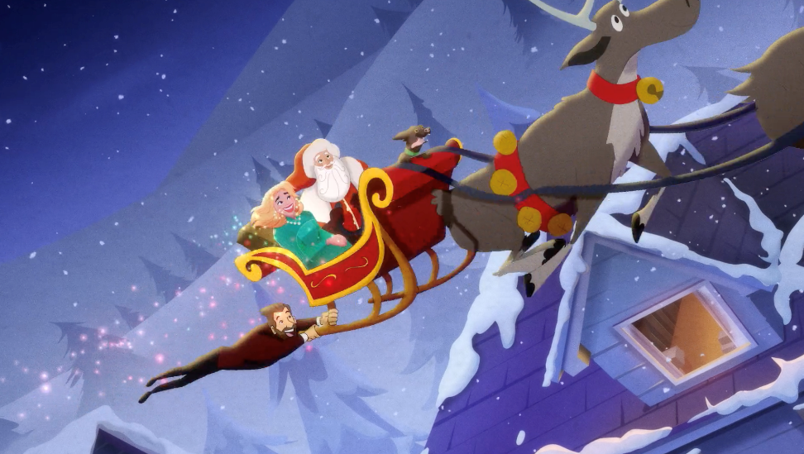

**WATCH “Under The Mistletoe” with Brett Eldredge:** [LINK](https://Atlantic.lnk.to/UTMVideoPR)

**Stream the *Atlantic Holiday* playlist:** [LINK](https://atlantic.lnk.to/Holiday)

GRAMMY-winning global superstar **Kelly** **Clarkson** and acclaimed country singer-songwriter **Brett Eldredge** have brought their holiday duet “**Under** **The** **Mistletoe**” to life with a festive hand-drawn animated music video directed by **Jay** **Martin** with animation by **Ingenuity** **Studios** – available now via **Atlantic Records**. The future Christmas classic, co-written by Clarkson and produced by longtime collaborator **Jesse Shatkin** (**Sia**, **Jennifer** **Lopez**), depicts a budding holiday romance with a throwback melody sure to bring people together this holiday season. Since release, the track has generated over 22 million global streams (becoming the top streaming on-demand audio Christmas track released in 2020 as of last week) and climbed into the Top 10 on both the Hot AC and Holiday radio charts.

Last week saw Clarkson and Eldredge made their debut live performance of “**Under** **The** **Mistletoe**” on NBC’s ***Christmas In Rockefeller Center*** special, followed by a performance this past Tuesday on the season finale of ***The Voice***. The duo is also set to perform the song this Friday, December 11th on ***The Tonight Show Starring Jimmy Fallon*** and next Wednesday, Dec 16th on ***The Kelly Clarkson Show***. In addition to “**Under** **The** **Mistletoe**,” Clarkson also released a stunning cover of the **Vince Vance & the Valiants**’ classic “**All I Want For Christmas Is You**” this holiday season – [STREAM HERE](https://atlantic.lnk.to/AIWFCIYID).

*“I love writing new Christmas songs that have a classic, throwback vibe*. *Brett is such an amazing singer and I was so impressed by his classic sound on his Christmas record so it was a perfect match for picking a duet partner for ‘****Under******The******Mistletoe****.’” –* **KELLY CLARKSON**

*“When Kelly sent me this song I was blown away by the soul and joy that it brought into my life the moment I heard it. I couldn’t wait to go in and sing it, and once I heard our voices together I knew we landed something very special. I think we are going to be singing this song for a very long time and I’m glad I get to do that with one of the best vocalists on this earth.”* – **BRETT** **ELDREDGE**

Earlier this year, Clarkson hosted the **Billboard Music Awards** for a third consecutive time and resumed her role as three-time champion coach on ***The Voice*** (to which she returned a sixth time for the show’s current 19th season). She also kicked off the second season of ***The Kelly Clarkson Show*** following a blockbuster 2019 inaugural season that marked the highest rated daytime debut in seven years, in addition to earning three **Daytime Emmy Awards** (including “Outstanding Entertainment Talk Show Host”), a **People’s Choice Award** nomination for “Daytime Talk Show of 2020,” and a **Critics’ Choice Television Award** nomination for “Best Talk Show.”

**ABOUT KELLY CLARKSON:**

Kelly Clarkson is among the most popular artists of this era with total worldwide sales of more than 25 million albums and 40 million singles. The Texas-born singer-songwriter first came to fame in 2002 as the winner of the inaugural season of *American Idol*. Clarkson’s debut single, “A Moment Like This,” followed and quickly went to #1 on Billboard’s Hot 100, ultimately ranking as the year’s best-selling single in the U.S. Further, Clarkson is one of pop’s top singles artists, with 18 singles boasting multi-platinum, platinum and gold certifications around the world, including such global favorites as “Miss Independent” and “Because of You.” Clarkson has released eight studio albums (*Thankful*, *Breakaway*, *My December*, *All I Ever Wanted*, *Stronger*, *Wrapped In Red*, *Piece By Piece, Meaning of Life*), one greatest hits album, and two children’s books (New York Times Top 10 best seller *River Rose and the Magical Lullaby* and the follow up *River Rose and the Magical Christmas*). She is the recipient of an array of awards including three GRAMMY Awards, four American Music Awards, three MTV Video Music Awards, two Academy of Country Music Awards, two American Country Awards, one Country Music Association Award, and one Daytime Emmy Award. She is also the first artist to top each of Billboard’s pop, adult contemporary, country and dance charts.

**ABOUT BRETT ELDREDGE:**

Nearly three years after the chart-topping success of his self-titled, fourth studio album, country superstar Brett Eldredge proves you can go home again with his latest album *Sunday Drive*. Joined by GRAMMY-winning producers Daniel Tashian and Ian Fitchuk, he holed up in Chicago’s intimate Shirk Studios, where the album came to life. The wistful, piano-driven lead single “Gabrielle,” which was co-written by Eldredge, Tashian and Fitchuk, made its TV debut on *The Late Show with Stephen Colbert* and has been called “a breath of fresh air” by Rolling Stone*.* Having added a seventh country radio No. 1 to his name with “Love Someone,” the critically acclaimed entertainer filled arenas on his first ever sold-out headlining The Long Way tour, which included performances of his Gold and Platinum-certified singles spanning four albums. His highly celebrated Christmas album *Glow* debuted at No. 2 on the country charts and featured the BillboardAdult Contemporary and Holiday Music Chart-topping duet “Baby, It’s Cold Outside” with Meghan Trainor. In 2016, the album inspired a single live holiday show in Nashville, which has now grown into the annual Glow LIVE holiday tour, hitting major cities across the country.

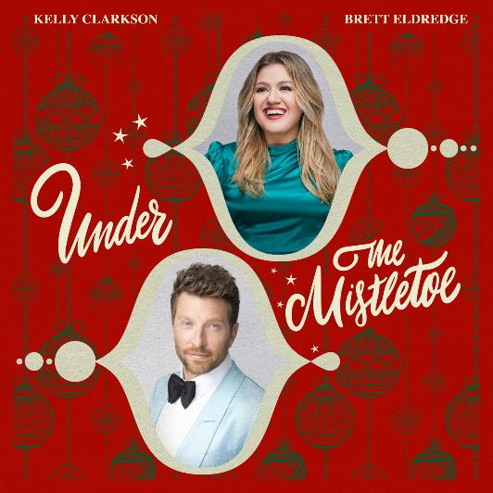

[DOWNLOAD HIGH-RES ARTWORK](http://press.atlanticrecords.com/kelly-clarkson/)

For more information, please visit:

[KellyClarkson.com](https://www.kellyclarkson.com/) | [Facebook](https://www.facebook.com/kellyclarkson) | [Twitter](https://twitter.com/kelly_clarkson) | [Instagram](https://www.instagram.com/kellyclarkson/) | [YouTube](https://www.youtube.com/user/kellyclarkson) | [Press Assets](http://press.atlanticrecords.com/kelly-clarkson/)

For press inquiries:

Sheila Richman | [Sheila.Richman@atlanticrecords.com](mailto:Sheila.Richman@atlanticrecords.com)

Ted Sullivan | [Ted.Sullivan@atlanticrecords.com](mailto:Ted.Sullivan@atlanticrecords.com)