**BREAKOUT MEMPHIS RAPPERS KEVO MUNEY & JUCEE FROOT TEAM UP FOR**

**“4 A.M. REMIX” AND OFFICIAL VIDEO, OUT TODAY**

**WATCH HERE:** <https://youtu.be/xxtOceA4lRw>



[PRESS PHOTO HERE](https://nam04.safelinks.protection.outlook.com/?url=https%3A%2F%2Fpress.atlanticrecords.com%2Fwp-content%2Fuploads%2F2019%2F11%2FKevo-Muney-3-credit-Jimmy-Fontaine.jpg&data=02%7C01%7CGabrielle.Reese%40atlanticrecords.com%7C7d5ad055593447d785df08d7d1a8cae0%7C8367939002ec4ba1ad3d69da3fdd637e%7C0%7C0%7C637208395195138605&sdata=vVVsJxWl5Z3G4QtqLSt7PU4EAL5lM8DvgRwlHVE5FsY%3D&reserved=0)

**KEVO MUNEY’S ‘BABY G.O.A.T.’ & JUCEE FROOT’S ‘BLACK SHEEP’ MIXTAPES OUT NOW**

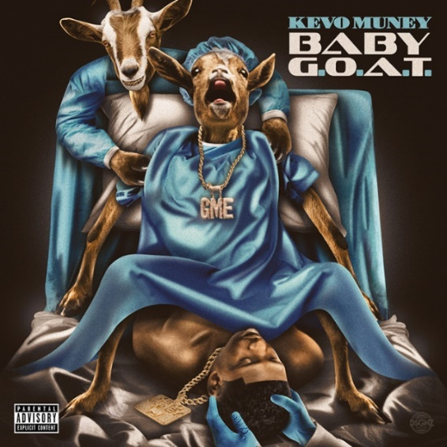 

Two of Memphis’ most promising young talents, rappers **Kevo Muney** and **Jucee Froot**, have teamed up for their new track, **“4 A.M. Remix,”** out today via Atlantic Records. Watch the official video [HERE](https://kevomuney.lnk.to/4AMRemix). “4 A.M. Remix” follows the duo’s recent collaboration on [“Understandable,”](https://nam04.safelinks.protection.outlook.com/?url=https%3A%2F%2Fwww.youtube.com%2Fwatch%3Fv%3DA5ezGpJ3DzY&data=02%7C01%7CGabrielle.Reese%40atlanticrecords.com%7C7d5ad055593447d785df08d7d1a8cae0%7C8367939002ec4ba1ad3d69da3fdd637e%7C0%7C0%7C637208395195148599&sdata=HobgqHVWO9Ixt5CcMjeleZ1jaQHf1iLm2UsiTjlAVME%3D&reserved=0) found on Jucee Froot’s debut mixtape ‘Black Sheep,’ released earlier this month.

19-year-old Atlantic Records rapper Kevo Muney fulfilled his vow to “bring soul back to rap” in December with the release of his mixtape, [BABY G.O.A.T](https://nam04.safelinks.protection.outlook.com/?url=https%3A%2F%2Fkevomuney.lnk.to%2FBabyGOAT&data=02%7C01%7CGabrielle.Reese%40atlanticrecords.com%7C7d5ad055593447d785df08d7d1a8cae0%7C8367939002ec4ba1ad3d69da3fdd637e%7C0%7C0%7C637208395195148599&sdata=sSYu0790Kjq6kBb68AAchxP8%2BVEk8tZjX2Do2WjNkOo%3D&reserved=0). The tape also sparked a viral moment online for its radical cover art (pictured above), which had both DJ Akademiks and WorldStarHipHop suggesting it was “the best mixtape cover art of the year.” Now mixtape track “4 A.M.” gets a refresh from fellow Atlantic Records rapper Jucee Froot, who adds her fearless bars. “4 A.M. Remix” follows Kevo’s recent collaboration BlocBoy JB on Baby G.O.A.T. track, [“On God.”](https://nam04.safelinks.protection.outlook.com/?url=https%3A%2F%2Fwww.youtube.com%2Fwatch%3Fv%3DlH7H26-QhPs&data=02%7C01%7CGabrielle.Reese%40atlanticrecords.com%7C7d5ad055593447d785df08d7d1a8cae0%7C8367939002ec4ba1ad3d69da3fdd637e%7C0%7C0%7C637208395195158592&sdata=A6%2BB6CBJZAzW%2FX69eqW86zeWMsaW7tIdcI86aaaIt5Y%3D&reserved=0) Kevo Muney has earned acclaim and radio play in his native Memphis as well as early co-signs from heavyweights like **Chief Keef,** **Kevin Gates**, **Gunna**, **Tay Keith, BlocBoy JB**, and others, with Memphis hip-hop legend **Don Trip** declaring him “*a breath of fresh air.*” Before Baby G.O.A.T., Kevo released [Who Am I: Reloaded](https://nam04.safelinks.protection.outlook.com/?url=https%3A%2F%2Fkevomuney.lnk.to%2FWhoAmIID&data=02%7C01%7CGabrielle.Reese%40atlanticrecords.com%7C7d5ad055593447d785df08d7d1a8cae0%7C8367939002ec4ba1ad3d69da3fdd637e%7C0%7C0%7C637208395195158592&sdata=w6V%2FS035wSSga7BJ0xdZdI0USjnYj%2B%2FlJmE02AcvnGw%3D&reserved=0), whose tracks have accumulated 20 million views on YouTube.

Jucee Froot has quickly become a vital presence in hip-hop, an honest voice equally hailed for her fearless approach as well as her bulletproof bars, confessional choruses, and clever adlibs. The Memphis-based rapper earned every bit of that acclaim through tear-filled viral freestyles, countless shows nationwide, and a prolific string of independent releases, all of which led to more than 20 million worldwide streams, praise from such icons as Birdman and Kevin Gates, and now, a major label deal with Loyal 100 Entertainment/Art@War/Atlantic Records. Irresistible tracks like “Life’s A Bitch” and “F*cked Up” – both streaming now on all DSP’s - affirm Jucee Froot as a one-of-a-kind new artist with a remarkable true story to share with the world.

**CONNECT WITH KEVO MUNEY**

[INSTAGRAM](https://nam04.safelinks.protection.outlook.com/?url=https%3A%2F%2Fwww.instagram.com%2Fkevomuney3%2F%3Fhl%3Den&data=02%7C01%7CGabrielle.Reese%40atlanticrecords.com%7C7d5ad055593447d785df08d7d1a8cae0%7C8367939002ec4ba1ad3d69da3fdd637e%7C0%7C0%7C637208395195168591&sdata=FbkSVE0ywtiiH5qFPLx9GchNnHFiC6NiMvwdMmAbrsM%3D&reserved=0) | [YOUTUBE](https://nam04.safelinks.protection.outlook.com/?url=https%3A%2F%2Fwww.youtube.com%2Fchannel%2FUCuxaxCwM-JEstB4iesqpX_Q&data=02%7C01%7CGabrielle.Reese%40atlanticrecords.com%7C7d5ad055593447d785df08d7d1a8cae0%7C8367939002ec4ba1ad3d69da3fdd637e%7C0%7C0%7C637208395195168591&sdata=HSGDgeVRjAve5b%2B%2FIJGnR6aUzkNCgH1sEWpQ0qRQQnc%3D&reserved=0) | [TWITTER](https://nam04.safelinks.protection.outlook.com/?url=https%3A%2F%2Ftwitter.com%2FKevo_Muney%3Flang%3Den&data=02%7C01%7CGabrielle.Reese%40atlanticrecords.com%7C7d5ad055593447d785df08d7d1a8cae0%7C8367939002ec4ba1ad3d69da3fdd637e%7C0%7C0%7C637208395195178609&sdata=Pk94i1wKwk5uFdldV8ZXbifSGHkR6zJ4%2FL8KBsooms8%3D&reserved=0) | [FACEBOOK](https://nam04.safelinks.protection.outlook.com/?url=https%3A%2F%2Fwww.facebook.com%2FKevoMoney&data=02%7C01%7CGabrielle.Reese%40atlanticrecords.com%7C7d5ad055593447d785df08d7d1a8cae0%7C8367939002ec4ba1ad3d69da3fdd637e%7C0%7C0%7C637208395195178609&sdata=%2BJj2ql%2BVUm0L6JTzOolmQDIUi0OYxFj7RXhea5wnIiU%3D&reserved=0) | [PRESS SITE](https://nam04.safelinks.protection.outlook.com/?url=http%3A%2F%2Fpress.atlanticrecords.com%2Fkevo-muney%2F&data=02%7C01%7CGabrielle.Reese%40atlanticrecords.com%7C7d5ad055593447d785df08d7d1a8cae0%7C8367939002ec4ba1ad3d69da3fdd637e%7C0%7C0%7C637208395195188580&sdata=jYQn10k9gIJNosMzM92KpyiPlYaAj1eXsnIgMuB0pdA%3D&reserved=0)

**CONNECT WITH JUCEE FROOT**

[INSTAGRAM](https://www.instagram.com/iamjuceefroot/) | [YOUTUBE](https://www.youtube.com/channel/UCOkAcorVft9iS9NArXrKggQ) | [TWITTER](https://twitter.com/iamjuceefroot) | [FACEBOOK](https://www.facebook.com/iamjuceefroot/) | [PRESS SITE](https://press.atlanticrecords.com/jucee-froot/)

Kevo Muney Press contact: [Corey.brewer@atlanticrecords.com](mailto:Corey.brewer@atlanticrecords.com)

Jucee Froot Press Contact: [Ashley.Kalmanowitz@atlanticrecords.com](mailto:Ashley.Kalmanowitz@atlanticrecords.com)