**ATLANTIC RECORDS RAPPER KEVO MUNEY RELEASES**

**EMOTIONAL TRACK + VIDEO FOR “**[**LEAVE SOME DAY**](https://KevoMuney.lnk.to/LeaveSomeDayVideo)**”**

***COMPLEX – “Kevo Muney heads into 2020 with strong momentum”***

***BILLBOARD – “co-signs from industry heavyweights like Gunna and Kevin Gates”***

***ELEVATOR – “an ode to the grind and hardships that forged Kevo into artist he has become”***

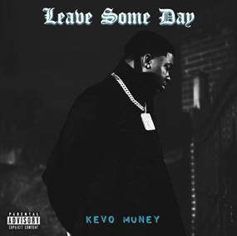

[PRESS PHOTO HERE](https://nam04.safelinks.protection.outlook.com/?url=https%3A%2F%2Fpress.atlanticrecords.com%2Fwp-content%2Fuploads%2F2019%2F11%2FKevo-Muney-3-credit-Jimmy-Fontaine.jpg&data=02%7C01%7CGabrielle.Reese%40atlanticrecords.com%7C8995ae0b42d1494c419308d7b65093b0%7C8367939002ec4ba1ad3d69da3fdd637e%7C0%7C0%7C637178329494286512&sdata=Q%2F6wdEuiA7VdC80LzWfOjTdkRvM1DeucRF3OAilwOlw%3D&reserved=0)

**FOLLOWING HIS MIXTAPE, BABY G.O.A.T., RELEASED IN DECEMBER**

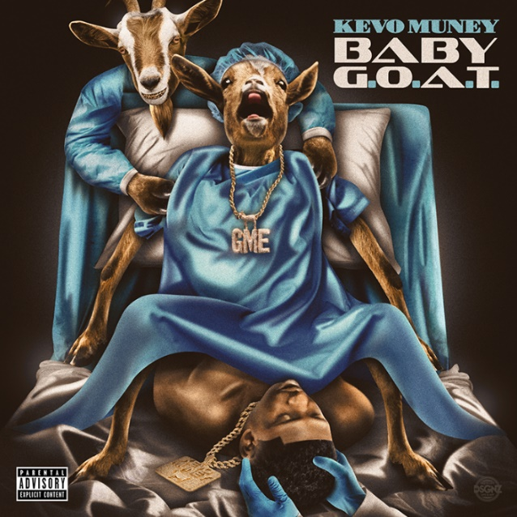

19-year-old Atlantic Records rapper **Kevo Muney** fulfilled his vow to “bring soul back to rap” in December with the release of his mixtape, [BABY G.O.A.T](https://nam04.safelinks.protection.outlook.com/?url=https%3A%2F%2Fkevomuney.lnk.to%2FBabyGOAT&data=02%7C01%7CGabrielle.Reese%40atlanticrecords.com%7C8995ae0b42d1494c419308d7b65093b0%7C8367939002ec4ba1ad3d69da3fdd637e%7C0%7C0%7C637178329494286512&sdata=52WRFDZ%2F43kqPbronZYodwXram0FFYEAftGwxmSyCnI%3D&reserved=0). The tape also sparked a viral moment online for its radical cover art (pictured above), which had both DJ Akademiks and WorldStarHipHop suggesting it was “the best mixtape cover art of the year.” Following his explosive performance in New York last night opening for Chief Keef, Kevo celebrates his NYC debut with today’s release of his powerful new single, “[Leave Some Day](https://KevoMuney.lnk.to/LeaveSomeDayVideo),” after a snippet of the track went viral on his socials. As a die-hard NBA fan who also plays ball (watch Kevo sink a shot on legendary actor Adam Sandler [here](https://nam04.safelinks.protection.outlook.com/?url=https%3A%2F%2Fwww.instagram.com%2Fp%2FB6RpNPdpOXP%2F%3Futm_source%3Dig_web_copy_link&data=02%7C01%7CGabrielle.Reese%40atlanticrecords.com%7C8995ae0b42d1494c419308d7b65093b0%7C8367939002ec4ba1ad3d69da3fdd637e%7C0%7C0%7C637178329494296502&sdata=%2FPP6To3h%2B3J6VL2IrBw5PyU7m8n65ihnVvBN27ud99M%3D&reserved=0)), the song is also accompanied by an official video that honors Kobe and Gianna Bryant. [Watch here.](https://KevoMuney.lnk.to/LeaveSomeDayVideo)

“’Leave Some Day” (produced by **Real Red**) *means coming to reality and accepting and understanding that we unfortunately all have to leave here at some point*,” says Kevo. “*It’s not just another pain record, it’s a story about people out there who may think that life is always great and that they’ll be here forever. But that’s far from the truth- we all must prepare ourselves to ‘Leave Some Day.’”*

“On God (Feat. BlocBoy JB)” from BABY G.O.A.T. premiered via [Complex](https://nam04.safelinks.protection.outlook.com/?url=https%3A%2F%2Fwww.complex.com%2Fmusic%2F2019%2F12%2Fkevo-muney-blocboy-jb-on-god-video-premiere&data=02%7C01%7CGabrielle.Reese%40atlanticrecords.com%7C8995ae0b42d1494c419308d7b65093b0%7C8367939002ec4ba1ad3d69da3fdd637e%7C0%7C0%7C637178329494296502&sdata=AD3qzNAT%2BafOrFZw%2BUHUeueh8W1%2FfBd32Fa%2BS6wwUlo%3D&reserved=0) in December, and Kevo’s mixtape also includes the hit singles, “[Everythang Changed](https://nam04.safelinks.protection.outlook.com/?url=https%3A%2F%2Fkevomuney.lnk.to%2FEverythangChanged&data=02%7C01%7CGabrielle.Reese%40atlanticrecords.com%7C8995ae0b42d1494c419308d7b65093b0%7C8367939002ec4ba1ad3d69da3fdd637e%7C0%7C0%7C637178329494306497&sdata=2I%2BW%2Fc3dO1RHF0DdI8SdFM6T54TySoztRaUmi%2FQrNeU%3D&reserved=0),” “[Crying Out Loud](https://nam04.safelinks.protection.outlook.com/?url=https%3A%2F%2Fwww.youtube.com%2Fwatch%3Fv%3DvD4WpCrYqtA&data=02%7C01%7CGabrielle.Reese%40atlanticrecords.com%7C8995ae0b42d1494c419308d7b65093b0%7C8367939002ec4ba1ad3d69da3fdd637e%7C0%7C0%7C637178329494306497&sdata=U8afwuJyhqPQWkoHsD9xfrm%2BWRczFYoYDwHz66Ikr%2BE%3D&reserved=0),” and “[Testimony](https://nam04.safelinks.protection.outlook.com/?url=https%3A%2F%2Fwww.youtube.com%2Fwatch%3Fv%3DZOpAaRAVE2I&data=02%7C01%7CGabrielle.Reese%40atlanticrecords.com%7C8995ae0b42d1494c419308d7b65093b0%7C8367939002ec4ba1ad3d69da3fdd637e%7C0%7C0%7C637178329494316489&sdata=2Tu%2BWuyVSkdsraAA72rshp2spPeDipa%2BO%2BKb1OEeApo%3D&reserved=0).”

Kevo Muney has earned acclaim and radio play in his native Memphis for bringing soul back into hip-hop. The youngest child of eight siblings, Muney grew up in one of the toughest neighborhoods in South Memphis. He first tapped into his growing talent by releasing freestyles on Facebook, rapping over any random beats he found on YouTube. A string of street mixtapes drew underground attention before 2017’s “I Grind (Feat. King Arti)” proved his local breakthrough.

Muney has spent considerable time on stage in recent months, supporting stars such as **Chief Keef,** **Kevin Gates** and **Gunna** and blowing away fans at Memphis’ famed **Beale Street Music Festival**. In addition, Kevo has received shout outs from the likes of **Tay Keith, BlocBoy JB**, and others, with Memphis hip-hop legend **Don Trip** declaring him “*a breath of fresh air*” in the Memphis scene and inviting him to collaborate on his “[Where I Come From (Feat. Kevo Muney)](https://nam04.safelinks.protection.outlook.com/?url=https%3A%2F%2Fwww.youtube.com%2Fwatch%3Fv%3DqTSr8eLOCI0&data=02%7C01%7CGabrielle.Reese%40atlanticrecords.com%7C8995ae0b42d1494c419308d7b65093b0%7C8367939002ec4ba1ad3d69da3fdd637e%7C0%7C0%7C637178329494316489&sdata=QjzVWJ16fA8mlQlbF5ipzY6lyO8ZR0Wic66J%2F%2Bvbwg4%3D&reserved=0).” Before Baby G.O.A.T., Kevo released [Who Am I: Reloaded](https://nam04.safelinks.protection.outlook.com/?url=https%3A%2F%2Fkevomuney.lnk.to%2FWhoAmIID&data=02%7C01%7CGabrielle.Reese%40atlanticrecords.com%7C8995ae0b42d1494c419308d7b65093b0%7C8367939002ec4ba1ad3d69da3fdd637e%7C0%7C0%7C637178329494326489&sdata=qRJGSKASv5A94MbNXHmSHPHi1jKa87apmvPiCa7wXsg%3D&reserved=0), whose tracks have accumulated 20 million views on YouTube. Surely this is just the beginning for the young rapper.

**CONNECT WITH KEVO MUNEY**

[INSTAGRAM](https://nam04.safelinks.protection.outlook.com/?url=https%3A%2F%2Fwww.instagram.com%2Fkevomuney3%2F%3Fhl%3Den&data=02%7C01%7CGabrielle.Reese%40atlanticrecords.com%7C8995ae0b42d1494c419308d7b65093b0%7C8367939002ec4ba1ad3d69da3fdd637e%7C0%7C0%7C637178329494326489&sdata=EwGFQ3Nl3oiDpF%2Fb1%2FVOM%2FDMSVymNtrzUrkVy4ahb8g%3D&reserved=0) | [YOUTUBE](https://nam04.safelinks.protection.outlook.com/?url=https%3A%2F%2Fwww.youtube.com%2Fchannel%2FUCuxaxCwM-JEstB4iesqpX_Q&data=02%7C01%7CGabrielle.Reese%40atlanticrecords.com%7C8995ae0b42d1494c419308d7b65093b0%7C8367939002ec4ba1ad3d69da3fdd637e%7C0%7C0%7C637178329494336481&sdata=71E%2B4MRD6O5cbCylbtTpe1TURp91Y2L8IYGZQnehdmg%3D&reserved=0) | [TWITTER](https://nam04.safelinks.protection.outlook.com/?url=https%3A%2F%2Ftwitter.com%2FKevo_Muney%3Flang%3Den&data=02%7C01%7CGabrielle.Reese%40atlanticrecords.com%7C8995ae0b42d1494c419308d7b65093b0%7C8367939002ec4ba1ad3d69da3fdd637e%7C0%7C0%7C637178329494336481&sdata=nKv%2FTKTPS6jAGXUNZsD7zJqMIQKoz78H7dgfV5B%2FzwY%3D&reserved=0) | [FACEBOOK](https://nam04.safelinks.protection.outlook.com/?url=https%3A%2F%2Fwww.facebook.com%2FKevoMoney&data=02%7C01%7CGabrielle.Reese%40atlanticrecords.com%7C8995ae0b42d1494c419308d7b65093b0%7C8367939002ec4ba1ad3d69da3fdd637e%7C0%7C0%7C637178329494346476&sdata=DdC%2FnccoDpzav5GxcZnskAxI3phQhUDYa7%2FYeUufbIQ%3D&reserved=0) | [PRESS SITE](https://nam04.safelinks.protection.outlook.com/?url=http%3A%2F%2Fpress.atlanticrecords.com%2Fkevo-muney%2F&data=02%7C01%7CGabrielle.Reese%40atlanticrecords.com%7C8995ae0b42d1494c419308d7b65093b0%7C8367939002ec4ba1ad3d69da3fdd637e%7C0%7C0%7C637178329494346476&sdata=IrxZJccsNLgjVTjK6Rd1bGQA5T1q6SEm%2FPsyiu%2F2fq4%3D&reserved=0)

Press contact: [Corey.brewer@atlanticrecords.com](mailto:Corey.brewer@atlanticrecords.com)