MEMPHIS MELODIC RAPPER KEVO MUNEY RELEASES “YES”
AS AN ODE TO HIS SOUTHERN ROOTS

FOLLOWING “AMEN” WITH THE MULTI-PLATINUM KEVIN GATES

LISTEN HERE: https://kevomuney.lnk.to/yes

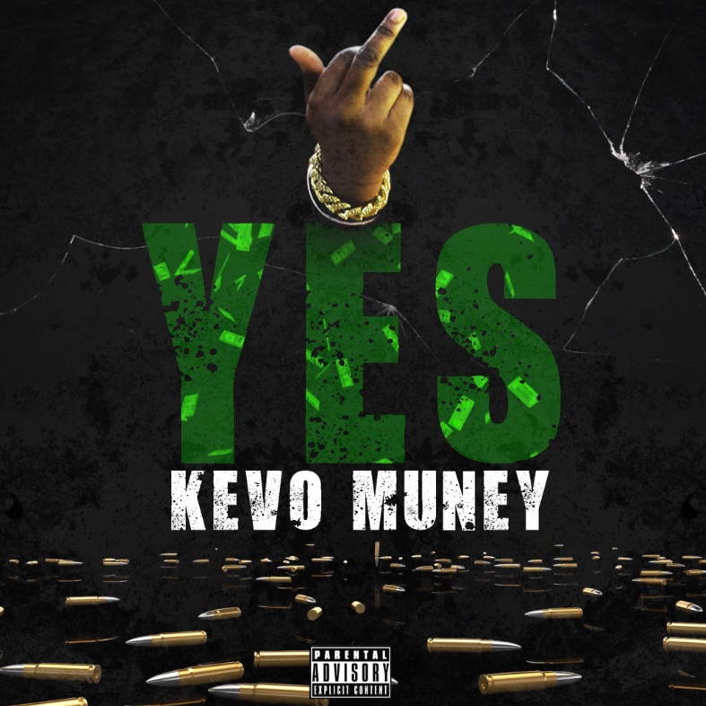
DL press photos here

Memphis Rapper Kevo Muney, who recently received a stamp from Lil Baby, releases new single “YES”
following last month’s “Amen” (ft. Kevin Gates) music video release. Listen HERE. With “YES,” Kevo wanted to go back to his roots of South Memphis with some “deep down south sound.” His favorite line in the song is “Momma use to hold me in ha arms, I’m the last son, Ruthie last baby.” On the song Kevo says, “When my fans hear this, I want them to know that the time is now and we’re going up from here...”

Last month, Kevo Muney released the official music video for spiritual track “Amen” (ft Kevin Gates). The video features both artists and can be watched here.

20-year-old Atlantic Records rapper Kevo Muney fulfilled his vow to “bring soul back to rap” in December with the release of his mixtape, BABY G.O.A.T. The tape also sparked a viral moment online for its radical cover art, which had both DJ Akademiks and WorldStarHipHop suggesting it was “the best mixtape cover art of the year.” Most recently, mixtape track “4 A.M.” received a refresh from fellow Atlantic Records rapper Jucee Froot, who added her fearless bars on the “4 A.M. Remix.” Kevo Muney has earned acclaim and radio play in his native Memphis as well as early co-signs from heavyweights like Chief Keef, Kevin Gates, Gunna, Tay Keith, BlocBoy JB, and others, with Memphis hip-hop legend Don Trip declaring him “a breath of fresh air.” Before Baby G.O.A.T., Kevo released Who Am I: Reloaded, whose tracks have accumulated over 20 million views on YouTube.

CONNECT WITH KEVO MUNEY
INSTAGRAM | YOUTUBE | TWITTER | FACEBOOK | PRESS SITE

Kevo Muney Press contact: Corey.brewer@atlanticrecords.com

