LIL DURK JUMPS ON KEVO MUNEY’S SMASH HIT
“LEAVE SOME DAY” FOR NEW CUT

ORIGINAL VERSION HAS RACKED UP ALMOST 35M US STREAMS

LISTEN HERE: https://kevomuney.lnk.to/LeaveSomeDayRmx

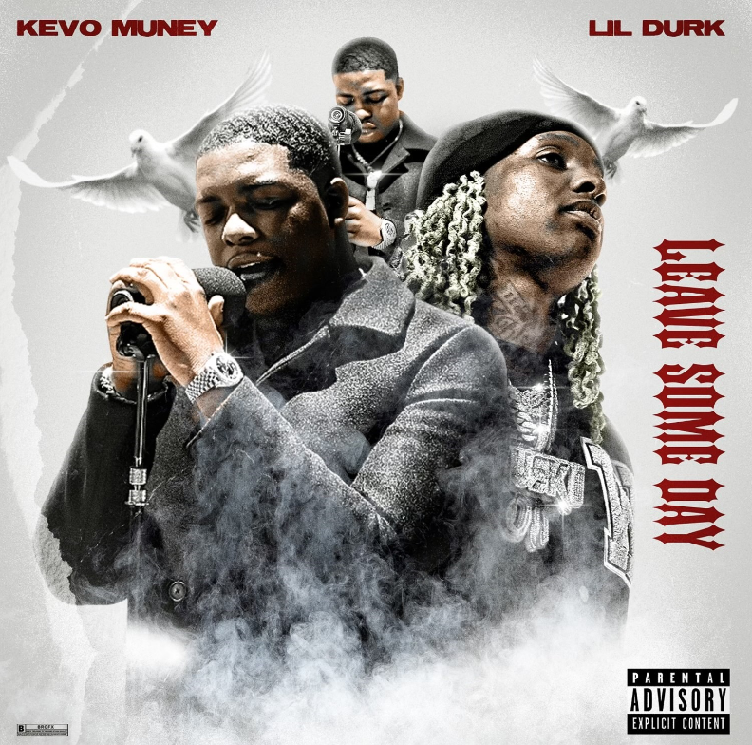
DL press photos here

Lil Durk joins Memphis trap soul singer/rapper Kevo Muney for a new version of Muney’s emotional hit “Leave Some Day,” which has racked up over 35M US streams since its February 2020 release and charted on Apple Music singles (all genres), US Spotify Viral Chart, Soundcloud Top 50 and US Shazam Top 200. Listen HERE.

“’Leave Some Day” (produced by Real Red) means coming to reality and accepting and understanding that we unfortunately all have to leave here at some point,” says Kevo. “It’s not just another pain record, it’s a story about people out there who may think that life is always great and that they’ll be here forever. But that’s far from the truth- we all must prepare ourselves to ‘Leave Some Day.’”

20-year old Memphis rapper Kevo Muney has come a long way from busking on Memphis’ famed Beale Street. Receiving co-signs from heavyweights like Lil Baby, Chief Keef, Kevin Gates, Gunna, Tay Keith, BlocBoy JB and others, Kevo dubbed himself the “baby G.O.A.T.” His rapid-fire success is holding that title high. Kevo dropped his Atlantic Records mixtape, BABY G.O.A.T., on December 13, 2019. The tape sparked a viral moment online for its radical cover art, which had both DJ Akademiks and WorldStarHipHop suggesting it was “the best mixtape cover art of the year.” Muney went on to release singles “Amen” (ft. Kevin Gates), “YES,” “2021,” and “Leave Some Day,” the later becoming viral, racking up over 36M Global streams since its February 2020 release and charting on Apple Music singles (all genres), US Spotify Viral Chart, Soundcloud Top 50 and US Shazam Top 200. Despite all of his early-on success, don’t expect Kevo Muney to rest on his laurels. He remains focused on taking his craft seriously and hopes fans will respect his dedication. “When you hyped up, that means you lose being humble,” Muney says. “I don’t want to be hyped up. Just throw me out there and watch what I do.”

CONNECT WITH KEVO MUNEY
INSTAGRAM | YOUTUBE | TWITTER | FACEBOOK | PRESS SITE

Kevo Muney Press contact: Corey.brewer@atlanticrecords.com

