LIL SKIES SHOWCASES HIS MELODIC FLOW ON LATEST TRACK “FIDGET”

FOLLOW UP TO SINGLE “HAVIN MY WAY” (FEAT. LIL DIRK)

MIXTAPE LIFE OF A DARK ROSE AND SINGLE “I” ARE NOW RIAA CERTIFIED PLATINUM

LISTEN TO “FIDGET” HERE
WATCH “FIDGET” HERE

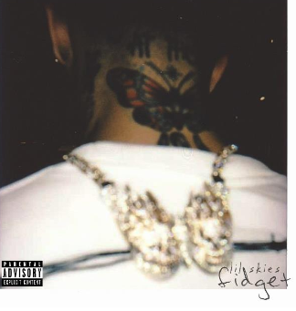

Meteoric rapper Lil Skies follows his latest single “Havin My Way” (Feat. Lil Dirk) with his next track, “Fidget,” available today via All We Got Ent/Atlantic Records HERE. “Fidget” features Lil Skies standout melodic flow, which is highlighted by a trap beat and angelic harp woven throughout. The track follows his 2019 debut album Shelby, featuring the now RIAA Certified Platinum single “i”. “Fidget” is accompanied by an official video, streaming now via YouTube HERE.

Released March 2019, Shelby made an explosive debut at #5 on the SoundScan/Billboard 200 – Lil Skies’ second consecutive top 10 release following his RIAA Certified Platinum 2018 breakthrough, Life Of A Dark Rose. Named for the Waynesboro, PA-based rapper’s mom, Shelby is highlighted by the RIAA Certified Platinum hit, “i,” which boasts over 350 million global streams. “i” was Lil Skies’ first top 40 success on Billboard’s “Hot 100” and highest charting single to date. The track is joined by an equally successful companion video, directed by Cole Bennett (Juice Wrld, Blueface, Slump God), now boasting over 60 million views via YouTube alone HERE. In addition, a documentary exploring the making of Shelby has earned over 1 million views HERE.

With almost 3 billion streams under his belt, Lil Skies has quickly built a massive fan following with his distinctive brand of high-energy hip hop. The PA-based rapper made his striking major label debut with 2018’s RIAA Certified Platinum mixtape LIFE OF A DARK ROSE, offering ample evidence of his angst-ridden, high-energy power. The project spawned a trio of Certified Platinum singles including “Lust,” joined by a massively popular visual now with close to 140 million views via YouTube HERE. “Red Roses” and “Nowadays” from the mixtape arrived alongside Cole Bennett-directed clips which have earned over 443 million combined views via Lyrical Lemonade.
Along with Shelby, Lil Skies has unleashed a long series of tracks and videos such as “Havin My Way (feat. Lil Durk),” “Real Ties,” “Name in the Sand,” “I Know You (Feat. Young Pinch), “No Rest” and “More Money More Ice.” 2019 also saw such singles as “Going Off” (now boasting over 9 million views via YouTube HERE) and “Magic,” featured on EA’s hugely successful Madden NFL 20.
Hailed by Rolling Stone, Billboard, Complex, and many more as a milestone new artist, Lil Skies is just as powerful on stage as he is in the studio. The past two years have seen him lighting it up on his own U.S. headline tour along with a support role on Wiz Khalifa and Rae Sremmurd's “Dazed & Blazed” amphitheater tour and festival appearances as Made In America, Rolling Loud NY, Rolling Loud LA, Rolling Loud Hong Kong, and more. Additional dates will be announced soon.

CONNECT WITH LIL SKIES
LILSKIES.COM
SOUNDCLOUD | FACEBOOK | TWITTER |INSTAGRAM | YOUTUBE | PRESS TOOLS
Press contact: corey.brewer@atlanticrecords.com

