EXPLOSIVE ENTERTAINER LIL SKIES ANNOUNCES AN EXCLUSIVE ONE NIGHT ONLY LIVE VIRTUAL SHOW, IN PARTNERSHIP WITH SONGKICK PRESENTS

FANS WILL EXPERIENCE A ONE OF KIND SHOW WITH SKIES PERFORMING UNRELEASED FAN FAVORITES + A FEW SURPRISES, LIVE WITH A FULL BAND

“HIGH AND UNBOTHERED (LIVE WITH LIL SKIES & FRIENDS)” TO CELEBRATE THIS YEAR’S 4/20 & SHOWCASE HIS EXTENSIVE CATALOG

TICKET PRE-SALES AVAILABLE NOW VIA SPOTIFY & SONGKICK PRESENTS, GENERAL ON-SALE LAUNCHING ON 3/29 VIA LILSKIES.COM & SONGKICKPRESENTS.COM

NEW “TAKE 5” VIDEO FROM ‘UNBOTHERED’ ALSO OUT NOW WITH OVER
HALF-A-MILLION VIEWS IN 24 HRS

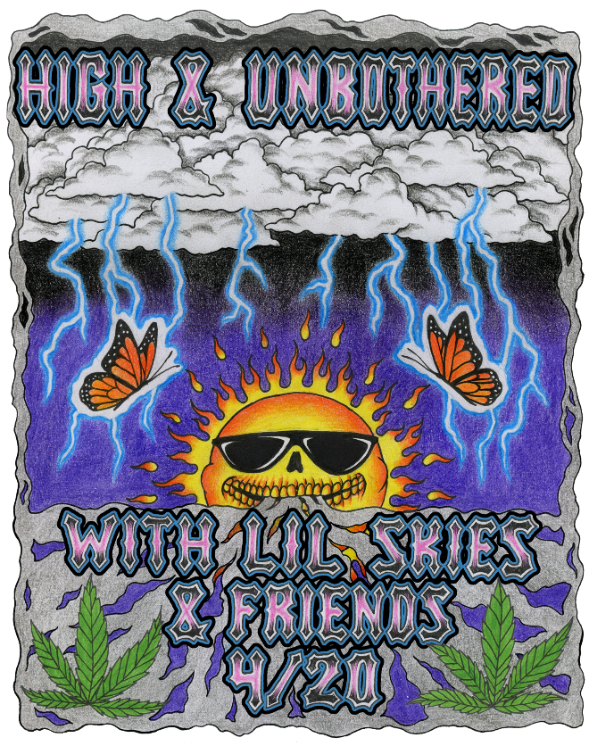
DL flyer

It’s the moment that Skies fans have been waiting for…Platinum-rapper and rockstar live performer, Lil Skies has announced his High and Unbothered (LIVE with Lil Skies & Friends) livestream show, set for Tuesday, 4/20 at 8p EST. The show was produced in collaboration with Atlantic Records as part of Songkick Presents, a series of easily accessible international livestream events powered by the leading music discovery platform. Fans won’t want to miss this one-time-only live show as Lil Skies will be performing never-before-performed unreleased tracks as well as popular album cuts and one-off fan favorites, all backed by a full band for the first time. Lil Skies will also be joined by some of his closest friends and surprise guests as part of this ultimate 4/20 celebration.

Spotify, Songkick Presents and day 1 fans of Skies will have access to a special pre-sale, beginning today at 12pm EST, with the general on-sale on 3/29 at 9am EST via www.lilskies.com & songkickpresents.com. Pre-sale ticket prices start at $15 and $17.50 for the general on-sale. Special VIP packages will be available on 3/25 along with the pre-sale on the Lil Skies web store only, pricing and package details below:

-Unbothered VIP Package - Ticket + Signed Poster ($80)
-Ice Water VIP Package - Ticket + Signed Poster + T-shirt ($115)
-The Smokers Room VIP Package- Group M&G ($200)

ABOUT LIL SKIES
Minted as a rising star, Skies named his 2019 chart-topping and now RIAA certified GOLD debut album, ‘Shelby,’ after his mother. As a father himself now, the multiplatinum Waynesboro, PA rapper goes harder than ever in 2021 on his second full-length offering, ‘Unbothered,’ which was released January 2021 and delivers heightened storytelling in addition to catchy and combustible bars underpinned by charisma and emotion, all at once. Paving the way for the ‘Unbothered,’ Skies dropped official videos for album singles “Havin My Way” [feat. Lil Durk] and “Riot,” and the tracks have impressively gained over 237M global streams since their release. Post album release, Skies also released official videos for “Dead Broke” and “Take 5.”

Receiving praise from Rolling Stone, Billboard, Complex, Noisey, Hypebeast and many more as a milestone artist, Lil Skies is just as powerful on stage as he is in the studio. The past few years have seen him lighting it up on his own U.S. headline tour along with a support role on Wiz Khalifa and Rae Sremmurd's “Dazed & Blazed” amphitheater tour and festival appearances as Made In America, Rolling Loud, and more.

ABOUT SONGKICK
Songkick has been a trusted home for live music since 2007. We’ve set about making it as easy, fun and fair as possible for you to see your favorite artists live. Right now, more than 16 million music fans across the globe use Songkick to track their favorite artists, discover concerts and buy tickets with confidence. While live music is on hiatus in many markets, we’re here powering livestreams to help continue to connect artists and fans. Songkick is a part of the Warner Music Group family.

‘UNBOTHERED’ TRACKLISTING

- Fade Away
- Take 5
- Excite Me featuring Wiz Khalifa
- Havin’ My Way featuring Lil Durk
- OK
- Dead Broke
- On Sight
- Think Deep Don’t Sink
- Red Wine & Jodeci
- Locked Up
- Trust Nobody
- Riot
- Sky High
- Mhmmm

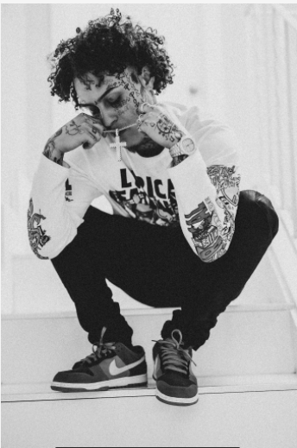
DL press photo here

CONNECT WITH LIL SKIES
LILSKIES.COM
SOUNDCLOUD | FACEBOOK | TWITTER |INSTAGRAM | YOUTUBE | PRESS TOOLS

Press contact: corey.brewer@atlanticrecords.com

