LIZZO’S DEBUT ALBUM CUZ I LOVE YOU DEBUTS AT #6
ON BILLBOARD TOP 200 CHART

CUZ I LOVE YOU IS THE #1 POP ALBUM, #1 DIGITAL ALBUM
AND #1 NEW RELEASE AND #2 BILLBOARD TOP ALBUMS

FALL NORTH AMERICAN TOUR “CUZ I LOVE YOU TOO” DATES OFFICIALLY SOLD OUT
NEW DATES ADDED IN SELECT MARKETS

“CUZ I LOVE YOU TOUR” CURRENTLY UNDERWAY

DEBUT ALBUM CUZ I LOVE YOU AVAILABLE NOW

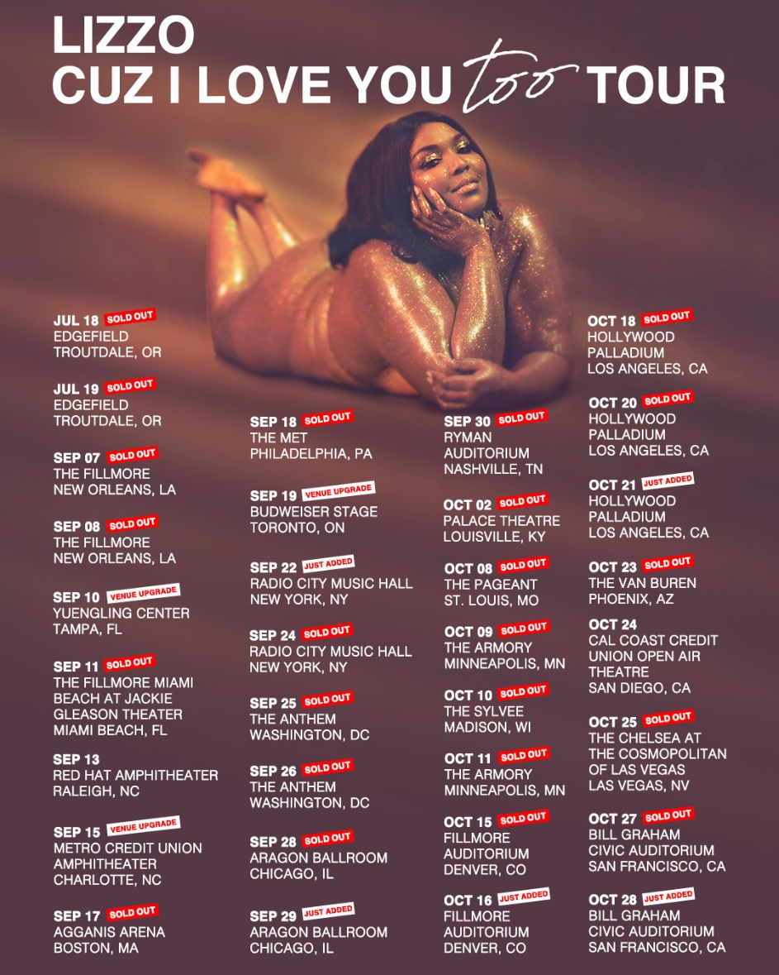

Just last week, Lizzo announced her fall North American tour, “Cuz I Love You Too,” and now all dates on the tour have been completely sold out. Additional dates have been added in select markets to the Live Nation produced tour; including a second night at New York City’s Radio City Music Hall, as well as a third night at Los Angeles’ Hollywood Palladium and additional night at the Bill Graham Civic Auditorium in San Francisco, CA.

Lizzo is currently on the road having recently kicked off her “Cuz I Love You Tour,” which is also fully sold out. Dates continue throughout May including a tour-closing headline date at New York City’s Terminal 5 set for May 23rd. Support throughout comes from Atlantic Records labelmate Tayla Parx. For complete details and ticket information, please visit www.lizzomusic.com/tour.

Lizzo released her Nice Life Recording Company/Atlantic Records debut album, CUZ I LOVE YOU to much on April 19th critical acclaim and now the album has debuted at #6 on the Billboard Top 200 Albums chart, which marks her first Billboard 200 entry. CUZ I LOVE YOU is also the #1 Pop album, #1 Digital album, #1 new release debut album and #2 on the Billboard Top Albums chart.

Lizzo has marked the arrival of CUZ I LOVE YOU with a number of high profile TV appearances, including performances on the nationally syndicated Ellen DeGeneres Show, NBC’s The Tonight Show Starring Jimmy Fallon and TODAY, and ABC’s Jimmy Kimmel Live! and HBO’s 2 Dope Queens, as well as visits to Comedy Centrals The Daily Show with Trevor Noah and Bravo’s Watch What Happens Live with Andy Cohen as well as E! News’ Busy Tonight.

In addition, Lizzo has been featured in a remarkable range of worldwide media outlets and national publications, spanning The New York Times, GQ, Billboard, TIME, Entertainment Weekly and Playboy to the covers of New York Magazine's Spring Fashion Issue, Allure, and more.

CONNECT WITH LIZZO
LIZZOMUSIC.COM
FACEBOOK
TWITTER
INSTAGRAM
YOUTUBE

LIZZO
CUZ I LOVE YOU
WORLD TOUR 2019

APRIL
22 – San Francisco, CA – The Warfield SOLD OUT
24 – San Francisco, CA – The Warfield SOLD OUT
26 – Portland, OR – Roseland Theater SOLD OUT
27 – Portland, OR – Roseland Theater SOLD OUT
28 – Seattle, WA – Showbox SoDo SOLD OUT
30 – Salt Lake City, UT – The Union Event Center SOLD OUT

MAY
1 – Denver, CO – The Ogden Theatre SOLD OUT
3 – Chicago, IL – Riviera Theater SOLD OUT
4 – Chicago, IL – Riviera Theater SOLD OUT
5 – St. Paul, MN – Palace Theatre SOLD OUT
7 – Nashville, TN – Cannery Ballroom SOLD OUT
9 – Atlanta, GA – Tabernacle SOLD OUT
10 – Raleigh, NC – Ritz Raleigh SOLD OUT
12 – Brooklyn, NY – Brooklyn Steel SOLD OUT
13 – Brooklyn, NY – Brooklyn Steel SOLD OUT
15 – Detroit, MI – St. Andrew’s Hall SOLD OUT
16 – Toronto, ON – The Danforth Music Hall SOLD OUT
18 – Philadelphia, PA – TLA SOLD OUT
19 – Washington, DC – 9:30 Club SOLD OUT
20 – Washington, DC – 9:30 Club SOLD OUT
22 – Boston, MA – House of Blues Boston SOLD OUT
23 – New York, NY – Terminal 5 SOLD OUT
26 – Manchester, UK – O2 Ritz Manchester SOLD OUT
27 – London, UK – O2 Forum Kentish Town SOLD OUT
29 – Paris, FR – L’Alhambra SOLD OUT
31 – Nimes, FR – This Is Not A Love Song *

JUNE
1 – Barcelona, ES – Primavera Sound *
2 – Beekse Bergen, Hilvarenbeek, NL – Best Kept Secret *
7– Minneapolis, MN – KDWB Star Party +
8 – Indianapolis, IN – Indy Pride Festival +
9 – Sacramento, CA – SacPride +
19 – Covington, KY – KISS 107.1 Loud & Proud + SOLD OUT
21 – Kansas City, MO – Mix 93.3 Red, White, & Boom +
22 – Houston, TX – Houston LGBT Pride Celebration® 2019 at Houston City Hall+
27 – Milwaukee, WI – Summerfest*
29 – Worthy Farm, UK – Glastonbury Festival*
30 – Belgium – Rock Werchter

JULY
2 – Amsterdam, NL – Paradiso Noord SOLD OUT
3 – Amsterdam, NL – Paradiso Noord SOLD OUT
5 – Arras, FR – Main Square Festival *
6 – Roskilde, DK – Roskilde Festival *
11 – Montreux, CH – Montreux Jazz Festival *
13 – Gunnersbury Park, UK – Lovebox Festival *
14 – Boulogne-Billancourt, FR – AFROPUNK FEST Paris *
20 – Seattle, WA – Capitol Hill Block Party *
25 – Baltimore, MD – Z104.3 Summer Concert Series + SOLD OUT
27 – Detroit, MI – Mo Pop Festival 2019 *

AUGUST
17 – Omaha, NE – MAHA Festival

* FESTIVAL PERFORMANCE
+ RADIO PERFORMANCE

CUZ I LOVE YOU TOO
U.S. FALL TOUR 2019
www.lizzomusic.com

JULY
18 – Troutdale, OR – Edgefield SOLD OUT
19 – Troutdale, OR – Edgefield SOLD OUT

SEPTEMBER
7 – New Orleans, LA – The Filmore SOLD OUT
8 – New Orleans, LA – The Filmore SOLD OUT
10 – Tampa, FL – Yuengling Center *VENUE UPGRADE
11 – Miami Beach, FL – The Fillmore Miami at Jackie Gleason Theater SOLD OUT
13 – Raleigh, NC – Red Hat Amphitheater
15 – Charlotte, NC – Metro Credit Union Amphitheater *VENUE UPGRADE
17 – Boston, MA – Agganis Arena SOLD OUT
18 – Philadelphia, PA – The Met SOLD OUT
19 – Toronto, ON – Budweiser Stage *VENUE UPGRADE
22 – New York, NY – Radio City Music Hall JUST ADDED
24 – New York, NY – Radio City Music Hall SOLD OUT
25 – Washington, DC – The Anthem SOLD OUT
26 – Washington, D.C. – The Anthem SOLD OUT
28 – Chicago, IL – Aragon Ballroom SOLD OUT
29 – Chicago, IL – Aragon Ballroom JUST ADDED
30 – Nashville, TN – Ryman Auditorium SOLD OUT

OCTOBER
2 – Louisville, KY – Palace Theatre SOLD OUT
8 -Saint Louis, MO – The Pageant SOLD OUT
9 – Minneapolis, MN – The Armory SOLD OUT
10 – Madison, WI – The Sylvee SOLD OUT
11 – Minneapolis, MN – The Armory SOLD OUT
15 – Denver, CO – Fillmore Auditorium SOLD OUT
16 – Denver, CO – Fillmore Auditorium JUST ADDED
18 – Los Angeles, CA – Hollywood Palladium SOLD OUT
20 – Los Angeles, CA – Hollywood Palladium SOLD OUT
21 – Los Angeles, CA – Hollywood Palladium JUST ADDED
23 – Phoenix, AZ – The Van Buren SOLD OUT
24 – San Diego, CA – Cal Coast Credit Union Open Air Theatre
25 – Las Vegas, NV – The Chelsea at the Cosmopolitan of Las Vegas SOLD OUT
27 – San Francisco, CA – Bill Graham Civic Auditorium SOLD OUT
28 – San Francisco, CA – Bill Graham Civic Auditorium JUST ADDED

About Live Nation Entertainment:
Live Nation Entertainment (NYSE: LYV) is the world’s leading live entertainment company comprised of global market leaders: Ticketmaster, Live Nation Concerts, and Live Nation Sponsorship. For additional information, visit www.livenationentertainment.com.

Lizzo Press Contacts:
Ashley Kalmanowitz
Ashley.Kalmanowitz@atlanticrecords.com
212.707.2051

Tour/Online
Jessica Nall
Jessica.Nall@atlanticrecords.com
(818)-238-6835

Live Nation U.S. Concerts Contacts:
Emily Bender
EmilyBender@livenation.com

Monique Sowinski
MoniqueSowinski@livenation.com

